PowerMatcher i3 as a Service

Installation and Configuration

Authors: Carlo Haverkamp (IBM)



Release: 0.5



Document version: 3
Date: 9-10-2012
(page intentionally left blank)

Table of Contents
1. Introduction 8
2. PowerMatcher as a Service overview 9
2.1 PowerMatcher as a service components 9
2.2 Runtime environments 9
3. Provisioning 10
3.1 Apache Ace Provisioning concept 10
3.2 Setup provisioning server 10
3.3 Setup the provisioning repository 10
3.3.1 Adding an artefacts to the ACE repository 10
3.3.2 Required artefacts for PowerMatcher as a Service 11
3.3.3 PowerMatcher distributions and nodes 13
3.4 Setup the OSGi runtime for ACE provisioning 13
3.5 Creating a central runtime 14
3.6 Creating a remote runtime 14
3.7 Remote node deployment 14
3.7.1 Deployment preparation 14
3.7.2 Deployment and setup 15
3.7.3 Start script 15
3.7.4 Stop script 15
3.7.5 Run script 15
3.7.6 Platform properties 16
3.7.7 Setup configuration password at first run 16
3.7.8 Start and stop the daemon automatically 16
4. PowerMatcher database 18
4.1 Creating the PowerMatcher database 18
4.2 Defining PowerMatcher authorizations 18
4.3 Creating the tables for Telemetry and Monitoring 18
4.4 Defining Telemetry and Monitoring table authorizations 19
4.5 Data model 19
4.5.1 PowerMatcher data model 19
4.5.2 Telemetry Data model 19
4.5.3 Telemetry Meta data model 20
5. Node configuration service 22
5.1 Concept 22
5.2 Data model 22
5.2.1 Conceptual data model 22
5.2.2 Physical data model 24
5.3 Creating the database tables 24
5.4 ConfigManager Web application deployment 24
5.5 ConfigManager Web application security 26
5.6 Configuration Management agent invoking the service 27
5.7 Viewing a configuration 28
5.8 Update trigger 29
6. Creating a PowerMatcher as a Service configuration 31
6.1 Server node configuration 31
6.2 Bridge configuration 32
6.3 Creating a simple configuration 33
6.4 Creating a configuration for a distributed cluster 34
7. Development environment setup and configuration 36
7.1 Install a Java JDK 36
7.2 RAD install and setup 36
7.3 Installing the Bndtools plug-in 37
7.4 Install Lotus Expeditor Client 37
7.5 Retrieving the source code and IDE setup 37
7.6 Importing the sources 39
7.7 Defining a Websphere server instance 40
7.8 Deploying the server applications 40
8. Data capture 42
8.1 Concept 42
8.2 Deployment units and configuration 42
8.3 Data source dependency 43
8.4 Deployment 43
9. Websphere MQ installation 44
9.1 Installation preparation 44
9.2 Installation 44
9.3 Verifying installation and first setup queue managers 44
9.4 Configuring WebSphere MQ for PowerMatcher 45
9.4.1 Enable remote administration 45
9.4.2 Configure a PlainText channel for client user id authorization 45
9.4.3 Configure the PlainText channel for LDAP authentication 46
9.4.4 Configure a Secure channel with LDAP authentication 47
9.4.5 Configure a new PowerMatcher cluster for MQ Telemetry 47
10. Websphere Application Server installation and configuration 50
10.1 Installation 50
10.2 Configuration 51
10.2.1 Init scripts 51
10.2.2 Configuring WebSphere MQ as JMS Provider 51
10.2.3 Configuring JMS Resources 51
10.2.4 Configure WebSphere Application Server for LDAP security 52
10.2.5 Configure IBM HTTP Server and security 53
11. Appendix: Database scripts 55
11.1 Creating the PowerMatcher database 55
11.2 Defining PowerMatcher authorizations 57
11.3 Routines for Cognos reporting drill-down 58
11.4 Creating the tables for Telemetry and Monitoring 59
11.5 Defining Telemetry and Monitoring table authorizations 77
11.6 Configuration Manager database 81
11.7 Configuration Manager database authorizations 83
12. Appendix: Configuration examples 84
12.1 Sample configuration 84
12.2 Sample distributed configuration: central node 88
12.3 Sample distributed configuration: remote node 91
12.4 Example platform.properties file 94
13. References 96

Table of Figures
Figure 1. Apache ACE web interface. 11
Figure 2. Apache ACE 'Add artefact' dialog. 11
Figure 3 PowerMatcher event data physical data model. 19
Figure 4 The physical data model of the CPSS or Telemetry event data. 20
Figure 5 The physical data model of the CPSS or Telemetry meta data. 20
Figure 6. Node Configuration data model. 23
Figure 7. Node Configuration physical data model. 24
Figure 8. Generating and propagating the HTTP server plug-in. 25
Figure 9. Search for the configuration group for accessing the web application. 26
Figure 10. Mapping the group to the 'configmanageraccess' role. 26
Figure 11. Saving the changed settings in the Master repository of Websphere. 27
Figure 12. Specifying the configuration properties of the Configuration Management Agent. 28
Figure 13. Viewing a configuration and triggering update processing. 29
Figure 14. Confirmation after sending the update trigger message. 29
Figure 15 Changing the JRE. 37
Figure 16 Bndtools wizard for creating a configuration project named ‘cnf’. 38
Figure 17 Select the Stand Configuration template for the 'cnf' project. 38
Figure 18 The 'cnf' project created by Bndtools prefilled with common bundles. 39
Figure 19 Defining a new Websphere Application Server instance. 40
Figure 20 The Server perspective. 40
Figure 21 Deploying a JEE applications using the Add/Remove dialog of RAD. 41

Version History

Version | Description | Author
1 | PowerMatcher release version 0.5 | C. Haverkamp (IBM)
2 | PowerMatcher release version 0.5. Revised and extended document. | C. Haverkamp (IBM)
3 | Added WebSphere MQ configuration instructions | A.H. Eisma (IBM)

Introduction
PowerMatcher as a Service takes the PowerMatcher Core functionality a step or, maybe a leap, further. It offers the following features:

- Rapid setup of PowerMatcher clusters:
New projects can be delivered in a relative short time, only requiring configuration an developing device agents.
- Flexibility:
You can distribute your environment over different nodes and configurations are stored and maintained in a central database. Platforms can be shared by different clusters, while configuration and data capture is handled centrally.
- Continuity:
Configuration updates and updates of PowerMatcher components can be managed and deployed from a central location. The updates can be distributed without switching off the system.

This document describes the installation and configuration of the PowerMatcher as a Service components.

PowerMatcher as a Service overview

PowerMatcher as a service components
PowerMatcher as a Service extends PowerMatcher Core[1] with the following features:

- Configuration Database
All configuration data of different clusters are stored and maintained in a central configuration database.
- Configuration Management Service
Settings of multiple nodes can be retrieved from the database using the an http based service that returns the configuration in XML format. The Configuration Management Agent that runs in a (remote) PowerMatcher OSGi runtime can be configured to call this service periodically.
- Data capture in a central database
The telemetry and status data that are sent by the agents and other components in a PowerMatcher cluster can be processed and stored in a central database. Data of different projects can be stored in different databases.

Runtime environments

A PowerMatcher as a Service system requires the following environment:

- PowerMatcher node
The node is a PowerMatcher OSGi runtime environment that runs one more PowerMatcher components, an Apache ACE management agent and a Configuration Management Agent. The node is part of a cluster and a cluster can be distributed over different nodes. For example a central cluster can run only the auctioneer and the data capture modules and remote node can host a concentrator and several device agents.
- Websphere Application Server
The application server will host the Configuration Management Service and the data capture modules (Java EE MDB’s).
- MQTT message bus
All communication is implemented using messaging via publish- subscribe on a message bus using the MQTT protocol.

Provisioning

Apache Ace Provisioning concept
Apache ACE is a software distribution framework that allows you to centrally manage and distribute software components, configuration data and other artefacts to target systems. It is built using OSGi and can be deployed in different topologies. The target systems are usually also OSGi based, but don't have to be[2].

For more information on Apache ACE read [3].

Setup provisioning server
Follow the next steps to setup the Apache ACE provisioning server:

- Download the Apache ACE (org.apache.ace.target.devserver) from the Apache ACE web site[2]. The version that is used for this document is the ‘devserver’ version 0.8.1.
- Unzip org.apache.ace.target.devserver-0.8.1-incubator-distribution.zip to a directory, for example /opt/apache. Find and execute run script (run.bat/run.sh) in the extracted folder from the command line to start the provisioning server, as explained in the ACE Getting Started[3]. Note that run.bat uses Pax Runner to start the Apace Felix OSGi runtime. See [4] for an introduction.
- Pax Runner starts Felix by default with the Gogo shell. Type help, or for example lb. See http://felix.apache.org/site/apache-felix-framework-usage-documentation.html for more information.
- Open http://localhost:8080/ace/ and log in with user d and password f.
- Click on 'Retrieve' to get the initial version of the repository. It will look as if nothing's happened, but you have now in fact retrieved the first, empty version of the repository and can start manipulating it.
- Create and build a simple Hello bundle in Eclipse (using Eclipse Bndtools or PDE tooling), and import the bundle jar as artefact. Also import the Felix Shell and Shell TUI bundles into ACE from bnd\cnf\repo in your workspace.
- Follow the Getting Started instructions to create a feature and a distribution.
- Open http://localhost:8080/obr/repository.xml and inspect the OBR that the ACE server is running. The contents can be found in the file system at /opt/apache/ace-devserver/store.

The provisioning server is now ready to operate, however its repository has to be filled artefacts to run PowerMatcher based systems. This will be described in the next section.

Setup the provisioning repository
The bundles that need to be uploaded can be found in the cnf project in you workspace. However, as explained in PowerMatcher Core Installation and Configuration[1] you first need to build the cnf project in your workspace. Besides the PowerMatcher bundles, you need also other required bundles to the repository. After that you can start defining the distributions and targets.

Read the next subsections to setup you ACE repository contents.

Adding an artefacts to the ACE repository
Adding or updating an artefact to Apache is using the Web console is very simple. For example we have a bundle jar for a

- Open the Web console and login.
- Retrieve the current contents of the ACE provisioning repository by clicking the Retrieve button.
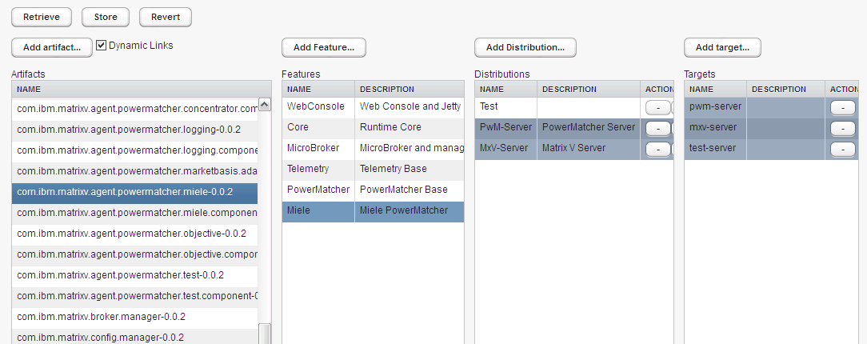
Figure 1. Apache ACE web interface.
- Click Add artefact:
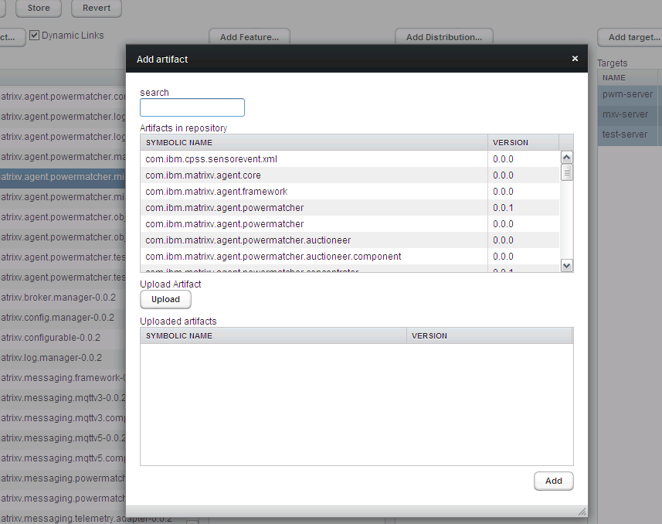
Figure 2. Apache ACE 'Add artefact' dialog.
- Click Upload and locate the bundle.
- Click the Store button to save the bundle to the repository.

Required artefacts for PowerMatcher as a Service
The following Features must be defined in the ACE server, with the following bundle jars as Artefacts associated with it.

- Core
- osgi.cmpn-4.2.0 (or newer, open source)
- ch.qos.logback.core-1.0.0 (Logback Core Module-1.0.0, open source)
- ch.qos.logback.classic-1.0.0 (Logback Classic Module-1.0.0, open source)
- slf4j.api-1.6.4 (open source)
- org.apache.commons.codec-1.6.0 (Commons Codec-1.6.0, open source)
- org.apache.felix.scr-1.6.0 (Apache Felix Declarative Services-1.6.0, open source)
- biz.aQute.bnd-1.51.1 (or newer, bnd - Bundle Tool-1.51.0, open source)
- biz.aQute.junit-1.0. (biz.aQute.junit-1.0.0, open source)
- org.eclipse.paho.client.mqttv3-1.0.0 (MQTTv3_Client Plug-in-1.0.0, open source)
- com.ibm.matrixv.xml.standard.parser-0.0.2 (project deliverable)
- com.ibm.matrixv.log.manager-0.0.2 (project deliverable)
- com.ibm.matrixv.config.manager-0.0.2 (project deliverable)
- com.ibm.matrixv.configurable-0.0.2 (project deliverable)
- com.ibm.matrixv.adapter-0.0.2 (project deliverable)
- com.ibm.matrixv.messaging.framework-0.0.2 (project deliverable)
- com.ibm.matrixv.messaging.mqttv3-0.0.2 (project deliverable)
- com.ibm.matrixv.messaging.mqttv3.component-0.0.2 (project deliverable)
- WebConsole
- org.apache.felix.metatype-1.0.4 (Apache Felix Metatype Service-1.0.4, open source)
- org.apache.felix.http.jetty-2.2.0 (Apache Felix Http Jetty-2.2.0, open source)
- org.apache.felix.webconsole-3.1.8 (Apache Felix Web Management Console-3.1.8, open source)
- MicroBroker (licensed per client installation)
- org.eclipse.equinox.util-1.0.300 (open source)
- org.eclipse.equinox.common-3.6.0 (open source)
- org.eclipse.equinox.preferences-3.4.1 (open source)
- com.ibm.micro-3.0.2.jar (MicroBroker-3.0.2.0-20100701, licensed from Lotus Expeditor Client)
- com.ibm.micro.admin-3.0.2 (MicroBrokerAdminClient-3.0.2.0-20100701, licensed from Lotus Expeditor Client)
- com.ibm.micro.client-3.0.2 (MQTT V5 Client-3.0.2.0-20100701, licensed from Lotus Expeditor Client)
- com.ibm.mqttclient-3.0.2 (MqttClientFactory-3.0.2.0-20100701 (licensed from Lotus Expeditor Client)
- com.ibm.micro.utils-3.0.2 (MicroBrokerUtilities-3.0.2.0-20100701, licensed from Lotus Expeditor Client)
- com.ibm.micro.utils.extended-3.0.2 (MicroBrokerUtilitiesExtended-3.0.2.0-20100701, licensed from Lotus Expeditor Client)
- com.ibm.matrixv.broker.manager-0.0.2 (project deliverable)
- com.ibm.matrixv.messaging.mqttv5-0.0.2 (project deliverable)
- com.ibm.matrixv.messaging.mqttv5.component-0.0.2 (project deliverable)
- Telemetry (all project deliverables)
- com.ibm.cpss.sensorevent.xml-0.0.2 (project deliverable)
- com.ibm.matrixv.messaging.telemetry.adapter-0.0.2 (project deliverable)
- com.ibm.matrixv.messaging.telemetry.adapter.component-0.0.2 (project deliverable)
- PowerMatcher (all project deliverables)
- com.ibm.matrixv.agent.powermatcher-0.0.2
- com.ibm.matrixv.agent.powermatcher.auctioneer-0.0.2
- com.ibm.matrixv.agent.powermatcher.auctioneer.component-0.0.2
- com.ibm.matrixv.agent.powermatcher.concentrator-0.0.2
- com.ibm.matrixv.agent.powermatcher.concentrator.component-0.0.2
- com.ibm.matrixv.agent.powermatcher.logging-0.0.2
- com.ibm.matrixv.agent.powermatcher.logging.component-0.0.2
- com.ibm.matrixv.agent.powermatcher.objective-0.0.2
- com.ibm.matrixv.agent.powermatcher.objective.component-0.0.2
- com.ibm.matrixv.agent.powermatcher.marketbasis.adapter-0.0.2
- com.ibm.matrixv.agent.powermatcher.marketbasis.adapter.component-0.0.2
- com.ibm.matrixv.messaging.powermatcher.adapter-0.0.2
- com.ibm.matrixv.messaging.powermatcher.adapter.component-0.0.2
- com.ibm.matrixv.agent.powermatcher.test -0.0.2
- com.ibm.matrixv.agent.powermatcher.test.component-0.0.2
- Device Agents, for example for Miele equipment (all project deliverables)
- com.ibm.matrixv.miele.gateway-0.0.2
- com.ibm.matrixv.agent.powermatcher.miele-0.0.2
- com.ibm.matrixv.agent.powermatcher.miele.component-0.0.2

PowerMatcher distributions and nodes
Distributions and targets have to be created for provisioning the PowerMatcher nodes. A typical PowerMatcher setup is to have a central node and a remote node. Suppose the central server already hosts a messaging infrastructure that supports the MQTT protocol, like Websphere MQ with the MQTT feature pack. The remote node does not have this facility so it requires a MicroBroker manager component to setup a local MQTT bus. The PowerMatcher cluster components will be distributed over the central and remote runtime. The central node hosts only an Auctioneer and a CSV logging agent while the remote node runs several device agents that connect to a local concentrator. Messages between the agents in the remote node and the auctioneer on the central node require a connection between the two messaging buses. This remote node will be connected via a MicroBroker Bridge component that connects the remote MQTT bus and with the central bus.

The example scenario demands different distributions for the two targets (remote and central). In this situation the following distributions need to be defined in the ACE Server, with the following Features associated with it:

- Stand-alone or central server distribution
- Core
- WebConsole
- Telemetry
- PowerMatcher
- Remote server distribution
- Core
- WebConsole
- MicroBroker
- Telemetry
- PowerMatcher
- Device agents

Depending on your PowerMatcher cluster design you may need to create your own distributions and targets.

Setup the OSGi runtime for ACE provisioning
In PowerMatcher Core Installation and Configuration[1] is explained how to set up a PowerMatcher OSGi runtime environment. The application bundles were manually added by copying them to the ‘bundles’ directory. In PowerMatcher as a Service this task is taken over by the automatic provisioning using Apache ACE.

First you set up an OSGi environment as explained in the PowerMatcher Core document, but omit the step of copying the application bundles. The OSGi runtime will download the bundles from the ACE provisioning server using the Apache Ace management bundle. Perform the following steps to setup the node:

- Create a Pax-Runner OSGi environment as explained in the PowerMatcher Core – Installation and Configuration, omitting the step where you copy the application bundles. Use for example a target directory ‘/opt/apache/pax-target’.
- Edit platform.properties to change the http port to 8081.
Add the following lines to identify the node and how to connect to the ACE dev-server, to locate the local configuration directory and the ACE updater interval for checking distribution changes:
-Dorg.apache.ace.configurator.CONFIG_DIR=conf
-Didentification=my-powermatcher-node
-Ddiscovery=https://cpssvn14.cpss.smarterplatform.com:8443
-Dsyncinterval=60000
This requires there has been at least one distribution created that is mapped on a target named ‘my-powermatcher-node’ created on the Apache ACE provisioning server.
- Edit run.bat and change the pax-runner arguments to:
--ups --workingDirectory=. --noConsole scan-dir:required-bundles scan-file:file:platform.properties %1 %2 %3
- Download[2] and copy org.apache.ace.managementagent-0.8.1-incubator.jar into /opt/apache/pax-target/required-bundles.
- To start the runtime execute the run script.

If you start the OSGi runtime using the run script the ACE management agent will send a request for the distribution for my-remote-node as configured in the ACE dev-server. If it is configured it will download the bundles and deploy them in the OSGi runtime.

Creating a central runtime
Suppose you want to create a distributed environment where the central node will host only an auctioneer and a CSV logging agent. Do the following steps to setup a Central runtime:

- Open the Apache ACE web console and logon.
- In the ACE web console create a distribution that includes at least the packages for the auctioneer and the CSV logging agent.
- Create a target in the ACE web console named ‘my-central-node’.
- Map the distribution to the target using the drag-and-drop feature of the ACE web console.
- Set up an OSGi runtime using Pax-Runner as described in paragraph 3.4.
- Edit the platform properties and modify the identification property:
-Didentification=my-central-node

The node is now ready to be provisioned with the PowerMatcher components as configured in the Apache ACE web console. When you start Pax-Runner it will connect the provisioning server and download the bundles of the distribution. However, for a PowerMatcher application your central node still needs a configuration for the components. This is explained in chapter 6.

The next part of creating a distributed runtime is described in the next section where the remote runtime is created.

Creating a remote runtime
The remote node will run a local MQTT message bus, a concentrator, local CSV logging agent, the device agents and a MicroBroker bridge. Perform the following steps:

- Open the Apache ACE web console and logon.
- In the ACE web console create a distribution that includes at least the packages for the concentrator, the Broker Manager, the Bridge Manager, the CSV logging agent and the device agents.
- Create a target in the ACE web console named ‘my-remote-node-A’.
- Map the distribution to the target using the drag-and-drop feature of the ACE web console.
- Set up an OSGi runtime using Pax-Runner as described in paragraph 3.4.
- Edit the platform properties and modify the identification property:
-Didentification=my-remote-node-A

The node is now ready to be provisioned with the PowerMatcher components as configured in the Apache ACE web console. When you start Pax-Runner it will connect the provisioning server and download the bundles of the distribution. Your remote node also needs a configuration for the PowerMatcher components which is explained in chapter 6.

Remote node deployment

The deployment of the OSGi runtime environment for a PowerMatcher remote node basically requires the deployment of a minimal Pax-Runner installation, a 'keystore file', an Apache ACE management agent bundle and a configuration file containing the environment properties. This section describes the steps how to deploy, setup, start and stop the node.

Deployment preparation
Create a deployment directory for example:

/opt/apache/ace-target

Deployment and setup
Perform the following steps to deploy to a remote node:

- Copy the Pax-Runner library (pax-runner-1.7.6.jar) to the deployment directory.
- Create required bundles directory in the deployment directory:
mkdir required-bundles:
- Copy the Apache ACE bundle (org.apache.ace.managementagent-0.8.1-incubator.jar) to the required bundles directory
- Create a platform.properties file (see section 3.7.6).
- Copy the java keystore file (key.jks) to the deployment directory. This key file is required to access and download the components from the ACE provisioning server and to connect to the PowerMatcher central node (pwm-server).
- Create a script for starting the Pax-Runner daemon (see section 3.7.3)
- Create a script for stopping the Pax-Runner daemon (see section 3.7.4)
- Create a run script for testing purposes (Optional; see section 3.7.5).

The OSGi environment for the remote node is now ready to run. Read section Error: Reference source not found on how to start and stop the node.

Note that when the PowerMatcher server has a connection to the Internet it is able to download the required Equinox libraries for the OSGi runtime environment. If this is not the case you will have to copy the Equinox jar to the required-bundles directory.

Start script
The server node can be started as a daemon using the following script:
# Use readlink to determine script directory otherwise symbolic links to this script will fail when executed.
cd `dirname "$(readlink -f $0)"`

echo Starting demo application in background
exec java -cp pax-runner-1.7.6.jar org.ops4j.pax.runner.daemon.DaemonLauncher --startd --org.ops
4j.pax.runner.daemon.shutdown.port=8010 --platform=equinox --version=3.7.1 --noConsole --ups --wo
rkingDirectory=. scan-dir:required-bundles scan-file:file:platform.properties

The file attributes have to be changed to make the script executable. Suppose the script is named startd.sh type the command in the deployment directory:

chmod +x node-start.sh

Stop script
Similar to the start script you can also create a stop script stopd.sh:

# Use readlink to determine script directory otherwise symbolic links to this script will fail when executed.
cd `dirname "$(readlink -f $0)"`

java -cp pax-runner-1.7.6.jar org.ops4j.pax.runner.daemon.DaemonLauncher --stop --org.ops4j.pax.runner.daemon.shutdown.port=8010

This script will stop all components in the OSGi runtime and the Pax-Runner environment. Like the start script it has to be made executable.

Run script
The following run script run.sh will start the server node and will display output to the console in contrast to the node-start.sh script that starts the node as a daemon:
java -jar pax-runner-1.7.6.jar --platform=equinox --version=3.7.1 --ups --workingDirectory=. scan-dir:required-bundles scan-file:file:platform.properties

The script will start also a console where you can issue commands on the ‘osgi>’ command prompt. In order to close the OSGi-server properly before logging off, issue the ‘exit’ command on the osgi command prompt .

Platform properties
The properties file name platform.properties that will provide the environment settings required for the start-up of the mxv-server node contains the following:
# Environment properties file for the MatrixV mxv-server node
-Dorg.apache.ace.configurator.CONFIG_DIR=conf
-Dorg.apache.felix.http.nio=true
-Dorg.apache.felix.http.enable=true
-Dorg.osgi.service.http.port=8081
-Dorg.apache.felix.https.enable=true
-Dorg.osgi.service.http.port.secure=8444
-Dorg.apache.felix.http.debug=false
-Dorg.apache.felix.https.keystore=key.jks
-Dorg.apache.felix.https.keystore.password=changeit
-Dfelix.webconsole.username=admin
-Dfelix.webconsole.password=admin
-Didentification=mxv-server
-Ddiscovery=https://my-provisioningserver.com:8443
-Dcom.ibm.matrixv.config.manager.id=remote-config-agent-id
-Dcom.ibm.matrixv.config.manager.node.id=my-remote-server
-Dcom.ibm.matrixv.config.manager.configuration.data.url=https://my-configserver.com
:8443/configservice/nodeconfiguration
-Dcom.ibm.matrixv.config.manager.configuration.data.username=my-configuser-id
-Dcom.ibm.matrixv.config.manager.configuration.data.password=my-configuser-id-password
-Dcom.ibm.matrixv.config.manager.cluster.id=MyCluster
-Dcom.ibm.matrixv.config.manager.update.interval=300
The location of the file is in the mxv-server deployment directory.

Setup configuration password at first run
When you start the Pax-Runner OSGi runtime for the first time it will ask to enter a password for the configuration:
ibm-mxv@ibm-mxv:/opt/ibm-mxv$ ./mxv-start.sh
Starting demo application in background
-> Password for this configuration is not set.
-> Please enter a new password:
This password will be required to stop the Pax Runner from a remote location. After typing the password twice, Pax-Runner will create a directory named ‘.pax’ in the home directory of the user. To repeat this initial start-up process you will have to remove this directory (rm –rf $HOME/.pax).

Start and stop the daemon automatically
If the PowerMatcher node has to be started automatically when the server starts (i.e. ‘start as a daemon process’) you have to create an init script and place it in the directory ‘/etc/init.d’. For example if we want to name the daemon ‘ace-target’ the we can create a file ace-target in that directory with the following contents:

#!/bin/sh
#
# ace-target: Starts an Apache ACE target runtime
#
# chkconfig: 345 98 02
# description: This is a daemon for an Apache ACE target runtime.
#
#

# Source function library.
. /etc/rc.d/init.d/functions

start() {
su -s /bin/bash - ace-target -c /opt/apache/ace-target/startd.sh
}

stop() {
cd /opt/apache/ace-target
su -s /bin/bash - ace-target -c /opt/apache/ace-target/stopd.sh
}

# See how we were called.
case "$1" in
start)
start
;;
stop)
stop
;;
restart)
stop
start
;;
*)
echo $"Usage: $0 {start|stop|restart}"
exit 1
esac
exit $RETVAL

The PowerMatcher node will now be started automatically when the server starts in run level 3, 4 or 5. The process has start priority 98 (100 is lowest) and stop priority 2. It can also be started manually using this script:

/etc/init.d/ace-target start

or stop the daemon process:

/etc/init.d/ace-target stop

PowerMatcher database
In PowerMatcher Core all configuration data was stored in property files or XML files. Data capturing was done by the CSV Logging agent (which is still useful for some situations, like testing your setup). In PowerMatcher as a Server data, configuration and captured or logging data, will be stored in a database.

This section describes how to setup the database.

Creating the PowerMatcher database
The database is created by the ‘PWM Database.ddl’ script that is located in the data project named ‘com.ibm.matrixv.powermatcher.db’.

To execute the script:
- Logon as a the DB2 instance user, db2inst1.
- From the command prompt execute:
db2 –tvf ‘PWM Database.ddl’
Check the console output for any errors. As an alternative you can also use the DB2 Command Center to execute the statements in the script.

The table will create the PowerMatcher tables BidData, MarketBasisData and PriceData in the PWMEVENT schema.

Defining PowerMatcher authorizations
The authorizations on tables and views will be defined using the script named ‘PWM PWMDEV Database Authorizations.ddl’ in the project ‘com.ibm.matrixv.powermatcher.db’.

To execute the script:
- Logon as a the DB2 instance user, db2inst1.
- From the command prompt execute:
db2 –tvf ‘PWM PWMDEV Database Authorizations.ddl’
Check the console output for any errors. As an alternative you can also use the DB2 Command Center to execute the statements in the script.

The script will grant read and update access to the task user PWMUSER. Read access will be granted to the PWMREPORTING group for reporting purposes.

Creating the tables for Telemetry and Monitoring
The Telemetry tables for are created by the script named ‘CPSS DC Database.ddl’ in the data project named ‘com.ibm.cpss.sensorevent.db’. The script will create the CPSS Telemetry and Telemetry meta data in the schemas CPSS and CPSSMETA respectively.

To execute the script:
- Logon as a the DB2 instance user, db2inst1.
- From the command prompt execute:
db2 –tvf ‘CPSS DC Database.ddl’
Check the console output for any errors. As an alternative you can also use the DB2 Command Center to execute the statements in the script.

Defining Telemetry and Monitoring table authorizations
The authorizations on tables and views will be defined using the script named ‘CPSS PWMDEV Database Authorizations.ddl’ in the project ‘com.ibm.cpss.sensorevent.db’.

To execute the script:
- Logon as a the DB2 instance user, db2inst1.
- From the command prompt execute:
db2 –tvf ‘CPSS PWMDEV Database Authorizations.ddl’
Check the console output for any errors. As an alternative you can also use the DB2 Command Center to execute the statements in the script.

The script will grant read and update access to the task user PWMUSER. Read access will be granted to the PWMREPORTING group for reporting purposes.

Data model
This section shows the data model for the PowerMatcher, Telemetry and Monitoring data capturing.

PowerMatcher data model
The data model for the PowerMatcher event data in Figure 3.

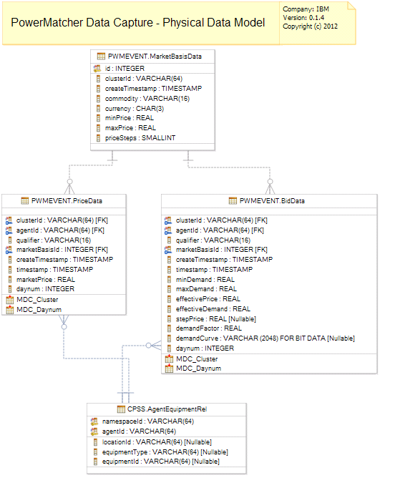
Figure 3 PowerMatcher event data physical data model.

Telemetry Data model
The physical data model of the CPSS or Telemetry data is shown in Figure 4.
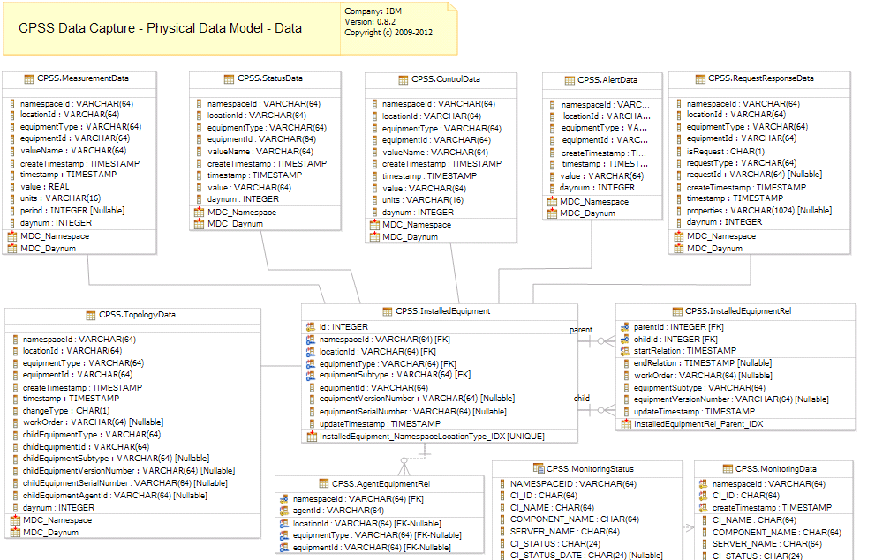
Figure 4 The physical data model of the CPSS or Telemetry event data.

Telemetry Meta data model
The meta data model of the Telemetry messages is show in Figure 5.
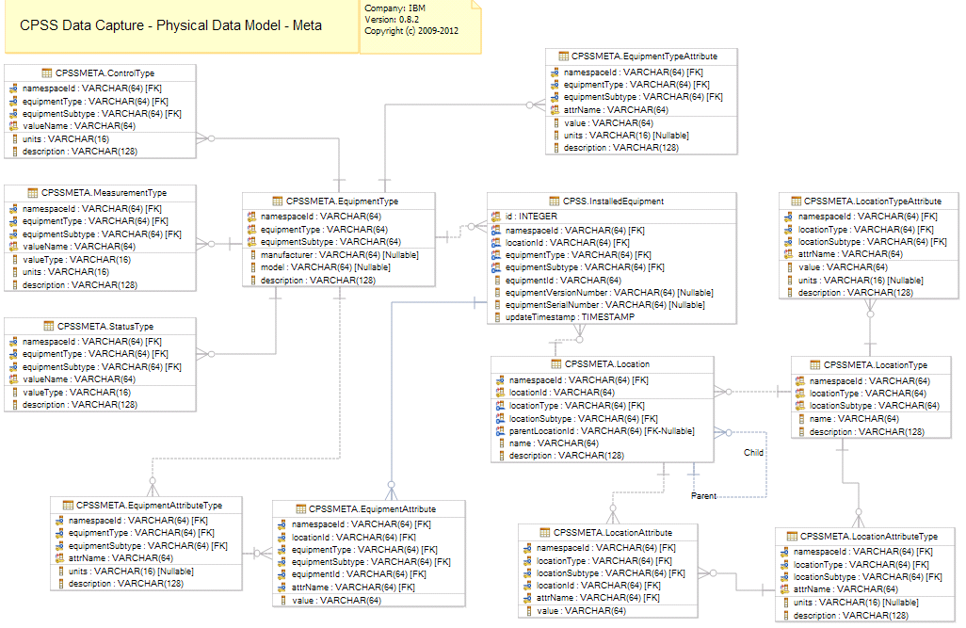
Figure 5 The physical data model of the CPSS or Telemetry meta data.

Node configuration service
Before a component can be activated within the OSGi container it requires a configuration record containing the specific properties for that component. Configuration records can be created using the Configuration Admin service. The Apache Felix Web console can be used to create configuration records and it does this by invoking the Configuration Admin service. The Configuration Management Agent, sometimes referred to as ConfigManager, developed for PowerMatcher as a Service facilitates the configuration of your components in the OSGi container using an XML resource.

In PowerMatcher Core[1] the section Configuration using XML explained the Configuration Management Application concept and how to create a configuration using XML. PowerMatcher as a Service goes one step further by providing a feature to centrally manage and store the configurations and support remote retrieval.

This chapter explains the concepts, design and practical usage of the Node Configuration Service.

Concept
The configuration of a node may need to change after some time. In a PowerMatcher system that includes many nodes it would could a lot of effort to maintain the XML files for all the nodes on the remote runtimes. Also the manual creation or update of the XML configuration files will be error prone.

PowerMatcher as a Service stores the configuration data in a database which enables central maintenance and control. This also matches with the PowerMatcher components which are also stored in and retrieved from a single location, a.k.a. the provisioning server.

The implementation of the concept on the database level is a few database tables in a DB2 database. There is an additional table for storing authorization information. The data is retrieved from a web application, called the ConfigManager web application, that produces jdbc queries using the JPA framework. A configuration for a node can be retrieved by sending a http request that will invoke a servlet in the web application which performs a database request. The servlet’s response is a text string in XML format. In other words the Node Configuration Service is a servlet that sends a node configuration in XML when it is invoked.

Instead of a static XML file, the Configuration Management Agent that runs in an OSGi runtime can be configured to call the servlet. Which configuration is requested is indicated by adding a ’nodeid’ parameter to the request. This procedure will be repeated periodically and is configurable.

Data model
This section describes the Node Configuration logical and physical data model.

Conceptual data model
The conceptual data model consists of four entities:

- Node Configuration
- Configuration
- Property
- Authorization

The following E-R model displays their relationships:

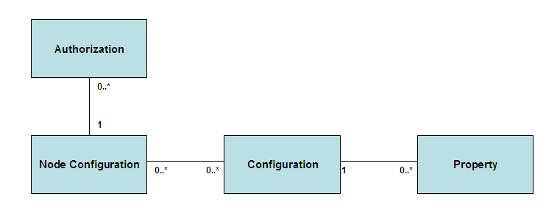
Figure 6. Node Configuration data model.

Node configuration entity
This entity defines the configuration of the component instances of a runtime environment that is identified by a node id. The actual specification of the configuration of the instances is in the collection of Configuration entities that the Node Configuration refers to.

The Node Configuration has the following attributes:

- Node ID : The unique identifier for the Node Configuration.
- Name : The name of the configuration.
- Description: The description of the configuration.
- Updated : Indicator if the configuration has recently been updated.

Configuration entity
In generic terms a Configuration entity defines the specifics for a configuration record of a certain component type. The property values in the components configuration record are determined by the collection of Properties contained by the configuration.

The configuration entity has the following attributes:

- Cluster ID: Identifies the logical group, or cluster, the configuration belongs to.
- ID: A unique id within the cluster that identifies the configuration.
- PID: Persistent Identifier. Indentifies the component, equal to the component name.
- Type: The type of configuration; group, singleton or factory.
- Template: Indicator if the configuration is a template.

Property entity
This entity defines the value for a property of a component instance. The property is associated with a Configuration. A configuration has the following attributes:

- Name: The name of the property.
- Value: The value of the property.
- Type: The data type of the property value.

Authorization entity
Which user can access the data of a specific Node Configuration is defined by the Authorization entity. It has the following attributes:

- User ID: Identifies the user.
- Node ID: Identifies which Node Configuration the user is entitled to see.

Physical data model
The image below depicts the physical data model for the Configuration Manager data:

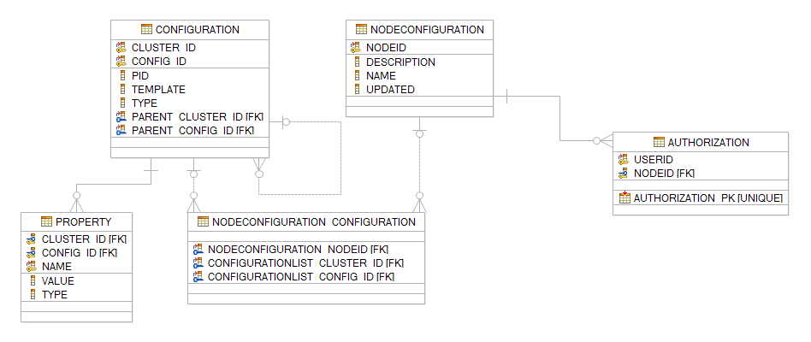
Figure 7. Node Configuration physical data model.

You can see in the data model that the relation of a Configuration to other (child) Configurations is realized by referring to the parent configuration. In case the Configuration has no parent the parent id columns contain null values.

The relation between a Node Configuration and Configuration has to be implemented by a link table because different Node Configurations can refer to the same Configuration.

Creating the database tables
The tables for the Node Configuration service are created by executing a database script. Before

ConfigManager Web application deployment
The ConfigManager web application can be deployed on Websphere Application Server using the Eclipse or Rational development environment or you can export it to an .ear file and deploy it using the Websphere console (ICS or Integrated Solutions Console). In this section we describe the deployment using the development environment. Perform the following steps:

- Open the Server perspective and configure the server where you want to deploy (refer to the Eclipse or Rational documentation).
- Select the Server and from the context menu select ‘Add/Remove’.
- Select the com.ibm.matrixv.config.ear entry and click the ‘Add’ button and then Finish. The deployment should start now. You can see this also in the Console view in the IDE.

After deployment the applications have to be deployed to the Http server and the web server plug-in has to be regenerated and then propagated. Now the web applications can be accessed via the Http Server.

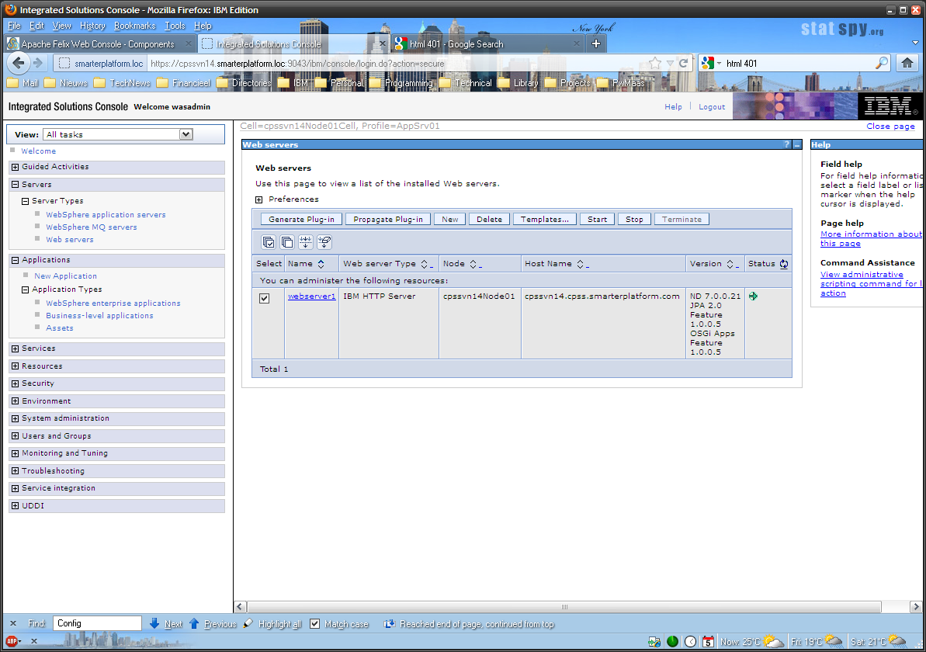
Figure 8. Generating and propagating the HTTP server plug-in.

ConfigManager Web application security
The ConfigManager web application is secured with basic authentication. User that want to access the http service need to authenticate using basic authentication. If the user is authorized is configured by mapping the pwmconfigaccess role to the userid or the group it belongs to. Perform these steps:

- Logon to Websphere Console (ICS) as administrator.
- Change security settings:
Navigate to the application (Applications -> Application Types ->Websphere enterprise applications -> com.ibm.matrixv.config.ear -> Security role to user/group mapping).
- Select the checkbox ‘configmanageraccess’. Then select ‘Map groups…’. Type ‘pwmconfigaccess’ in the ‘Search string’ text box and click Search. After some seconds (approx. 20) the group should appear in the ‘Available’ list box.
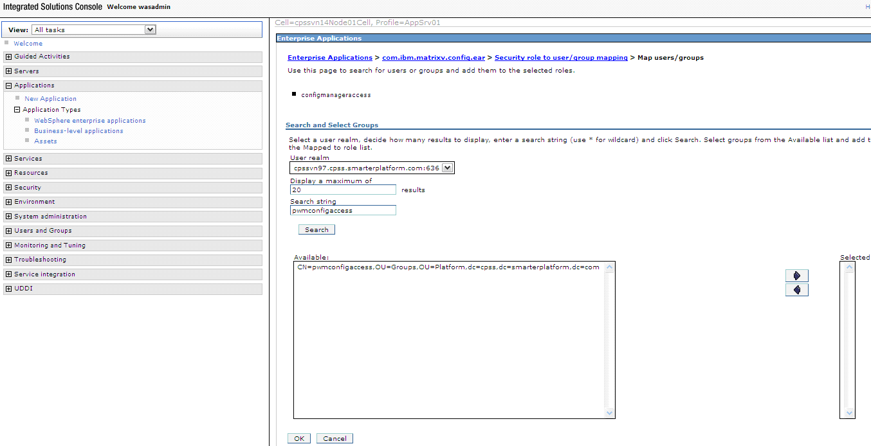
Figure 9. Search for the configuration group for accessing the web application.
- Select the entry and click the Add button. It will now in the ‘Selected’ list box. Click OK to save the change.
- The Security role mapping now displays the ‘pwmconfigaccess’ group:
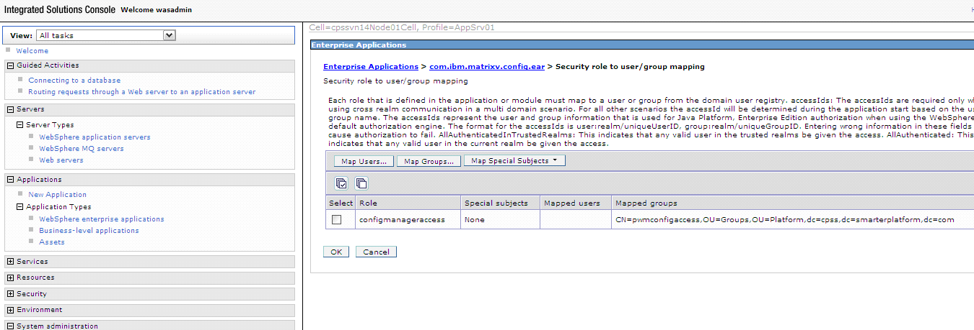
Figure 10. Mapping the group to the 'configmanageraccess' role.
- Click OK to Confirm the change.
- Save to the Master configuration by clicking the link in the Message dialog:
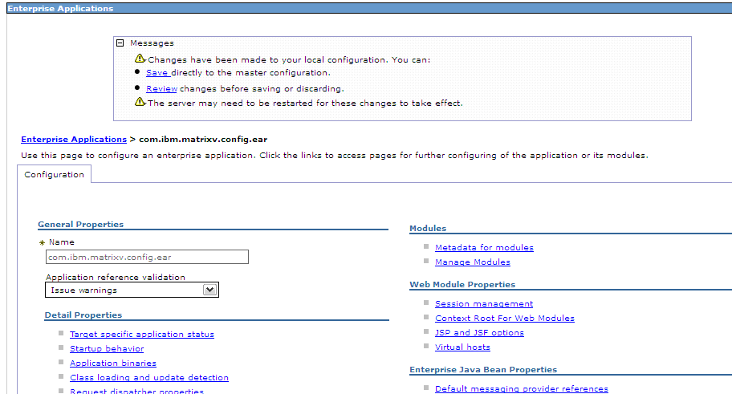
Figure 11. Saving the changed settings in the Master repository of Websphere.

Configuration Management agent invoking the service
In PowerMatcher i3 Core - Installation and Configuration the Configuration Management Agent component was configured using file containing the XML configuration. This file could be located on the local server or on a remote location. In PowerMatcher as a Service the configurations are stored in a database and can be accessed through the Configuration Management Service, an http-based web service.

The service is secured with basic authentication and requires a username and password which can be specified via the configuration properties of the Configuration Management Agent that runs in a PowerMatcher runtime in OSGi. The agent also needs to be configured with the URL to access the configuration service. This URL has the following syntax:

<protocol>://<hostname>:<port>/configservice/nodeconfiguration?nodeid=<nodeid>

Where hostname is the name of the host where the Configuration Management web application is deployed and the nodeid the node id of the configuration the database. The port can be the port of you Websphere Application Server instance, for example 9080, or another port number if requests are routed via an HTTP server. The protocol can be http or https depending on the security settings that you configure.

You can specify the URL in the configuration of the Configuration Management Agent using the Apache Web Console, the same way as specifying a configuration XML file:
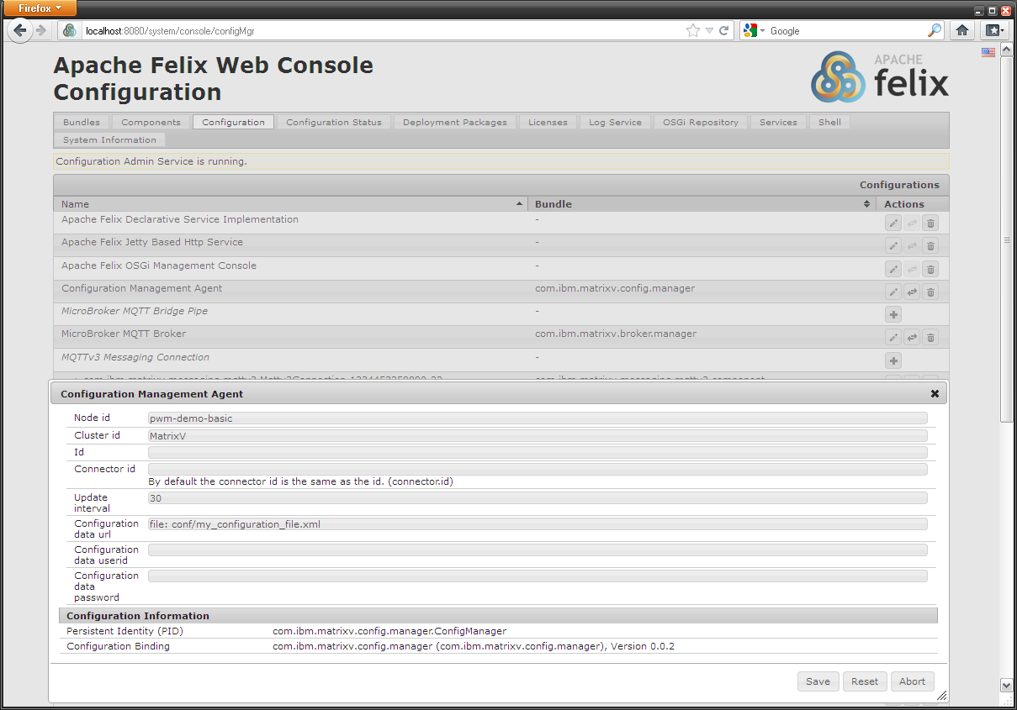
Figure 12. Specifying the configuration properties of the Configuration Management Agent.

A better and persistent method is adding the properties to the platform.properties file. Edit this file and add the following settings:

-Dcom.ibm.matrixv.config.manager.id=my-remote-config-agent
-Dcom.ibm.matrixv.config.manager.node.id=my-remote-server
-Dcom.ibm.matrixv.config.manager.configuration.data.url=https://myconfigserver:
8443/configservice/nodeconfiguration
-Dcom.ibm.matrixv.config.manager.configuration.data.username=configuser
-Dcom.ibm.matrixv.config.manager.configuration.data.password=configuserpwd
-Dcom.ibm.matrixv.config.manager.cluster.id=my_cluster
-Dcom.ibm.matrixv.config.manager.update.interval=300

In the example above the connection is secured using SSL, hence the node configuration service is invoked using the secure HTTPS protocol which requires a username and password. Modify the settings according to your environment.

Viewing a configuration
The Configuration Management web application provides also a web page to view a configuration. The syntax URL is:
http://<hostname>:<port>/configservice

Where hostname is the host where the Configuration Management web application is deployed.

The user needs to login first and then can select in the ‘View node Configuration’ section select the node configuration. Click ‘Get Configuration’ and the XML configuration will be returned to the browser.

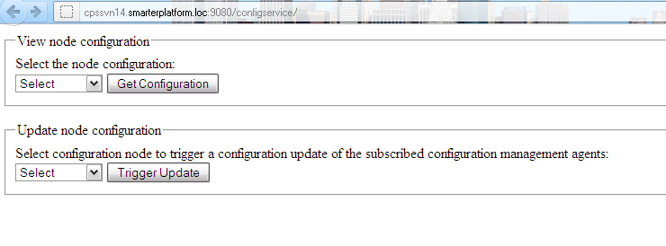
Figure 13. Viewing a configuration and triggering update processing.

Update trigger
The Configuration Management Agent that is deployed on a node will check periodically if the configuration has been updated. This interval is configurable but may be too long in some circumstances. The Configuration Management Service provides an Update trigger service to inform the node that the configuration has been updated. This trigger can be accessed via the following URL:

http://<hostname>:<port>/configservice

Where hostname is the host where the Configuration Management Web Application is deployed.

The user needs to login first and then can select in the ‘Update node configuration’ section select the node configuration. Click ‘Trigger Update’ and the service will send a message to a topic to which the node is subscribed. The node’s Configuration Management Agent will then retrieves and process the updated configuration.

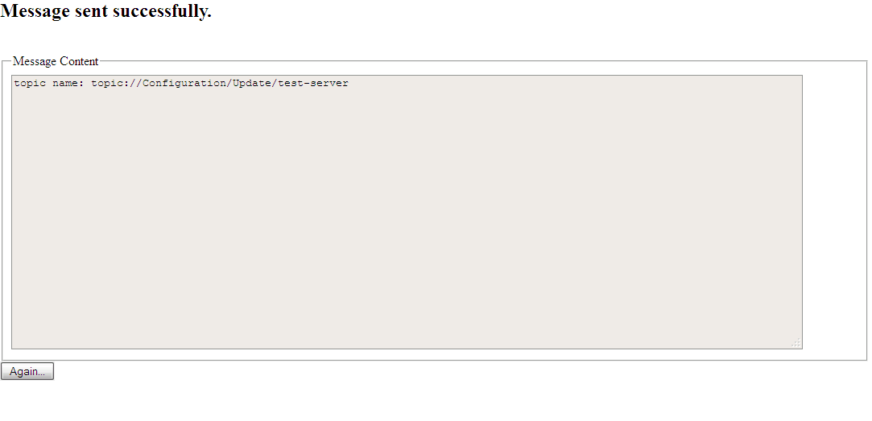
Figure 14. Confirmation after sending the update trigger message.

Configuration Management agent needs an MQTT connection to subscribe to the topic. In order to connect it needs an MQTT connection adapter that is configured with the same id. For example, suppose that in the node ‘my-remote-config-agent’ the platform.properties contains the following lines:
-Dcom.ibm.matrixv.config.manager.id=my-remote-config-agent
-Dcom.ibm.matrixv.config.manager.node.id=my-remote-server
Then the node configuration should include an MQTT connection adapter configuration with id ‘my-remote-server’. In case you use the MQTT version 3 protocol, the XML returned by the Configuration Management Service should include:
<configuration type="factory" cluster="my_cluster"
pid="com.ibm.matrixv.messaging.mqttv3.Mqttv3Connection" id=" my-remote-config-agent ">
<property name="id" value="matrixv_remote_config_agent" type="String"/>
</configuration>

Creating a PowerMatcher as a Service configuration

Server node configuration
In PowerMatcher as a Service configurations are created by inserting configuration properties in the database:

For example the following database statements create an auctioneer using the component defaults:
-- -------------------------------------------
-- Demo Configuration PowerMatcher AAS
-- -------------------------------------------

-- Configuration Group PowerMatcher Basic
INSERT INTO CONFMGR.CONFIGURATION (CLUSTER_ID, CONFIG_ID, TEMPLATE, "TYPE") VALUES ('test', ‘pwm_service_demo’’, 0, 2);

-- Configuration Group Global Properties
INSERT INTO CONFMGR.PROPERTY (CLUSTER_ID, CONFIG_ID, NAME, VALUE, "TYPE") VALUES ('test', ‘pwm_service_demo’, 'commodity', 'electricity', 0);
INSERT INTO CONFMGR.PROPERTY (CLUSTER_ID, CONFIG_ID, NAME, VALUE, "TYPE") VALUES ('test', ‘pwm_service_demo’, 'currency', 'EUR', 0);
INSERT INTO CONFMGR.PROPERTY (CLUSTER_ID, CONFIG_ID, NAME, VALUE, "TYPE") VALUES ('test', ‘pwm_service_demo’, 'update.interval', '10', 2);
INSERT INTO CONFMGR.PROPERTY (CLUSTER_ID, CONFIG_ID, NAME, VALUE, "TYPE") VALUES ('test', ''pwm_central_test ', 'cluster.id', 'MatrixV', 0);

-- ----------------
-- Demo Auctioneer
-- ----------------

-- Auctioneer Group
INSERT INTO CONFMGR.CONFIGURATION (CLUSTER_ID, CONFIG_ID, TEMPLATE, "TYPE", PARENT_CLUSTER_ID, PARENT_CONFIG_ID ) VALUES ('test', 'auctioneer1_grp', 0, 2, 'test', ‘pwm_service_demo’);

-- Auctioneer Config
INSERT INTO CONFMGR.CONFIGURATION (CLUSTER_ID, CONFIG_ID, PID, TEMPLATE, "TYPE", PARENT_CLUSTER_ID, PARENT_CONFIG_ID ) VALUES ('test', 'auctioneer1', 'com.ibm.matrixv.agent.powermatcher.auctioneer.Auctioneer', 0, 0, 'test', 'auctioneer1_grp');

-- Auctioneer Config Properties
INSERT INTO CONFMGR.PROPERTY (CLUSTER_ID, CONFIG_ID, NAME, VALUE, "TYPE") VALUES ('test', 'auctioneer1', 'id', 'auctioneer1', 0);

-- Auctioneer Market Basis Adapter Config
INSERT INTO CONFMGR.CONFIGURATION (CLUSTER_ID, CONFIG_ID, PID, TEMPLATE, "TYPE", PARENT_CLUSTER_ID, PARENT_CONFIG_ID ) VALUES ('test', 'auctioneer1MarketBasisAdapter', 'com.ibm.matrixv.agent.powermatcher.marketbasis.adapter.MarketBasisAdapter', 0, 0, 'test', 'auctioneer1_grp');

-- Auctioneer Market Basis Adapter Config Properties
INSERT INTO CONFMGR.PROPERTY (CLUSTER_ID, CONFIG_ID, NAME, VALUE, "TYPE") VALUES ('test', 'auctioneer1MarketBasisAdapter', 'id', 'auctioneer1', 0);

INSERT INTO CONFMGR.PROPERTY (CLUSTER_ID, CONFIG_ID, NAME, VALUE, "TYPE") VALUES ('test', 'auctioneer1AgentAdapter', 'price.info.topic.suffix', 'UpdatePriceInfo', 0);

-- Auctioneer Agent Matcher Messaging Adapter Config
INSERT INTO CONFMGR.CONFIGURATION (CLUSTER_ID, CONFIG_ID, PID, TEMPLATE, "TYPE", PARENT_CLUSTER_ID, PARENT_CONFIG_ID ) VALUES ('test', 'auctioneer1MatcherAdapter', 'com.ibm.matrixv.messaging.powermatcher.adapter.MatcherProtocolAdapter', 0, 0, 'test', 'auctioneer1_grp');

-- Auctioneer Matcher Adapter Config Properties
INSERT INTO CONFMGR.PROPERTY (CLUSTER_ID, CONFIG_ID, NAME, VALUE, "TYPE") VALUES ('test', 'auctioneer1MatcherAdapter', 'id', 'auctioneer1', 0);

-- MQTT V3 Connection Component Config
INSERT INTO CONFMGR.CONFIGURATION (CLUSTER_ID, CONFIG_ID, PID, TEMPLATE, "TYPE", PARENT_CLUSTER_ID, PARENT_CONFIG_ID ) VALUES ('test', 'auctioneer1MqttConnection', 'com.ibm.matrixv.messaging.mqttv3.Mqttv3Connection', 0, 0, 'test', 'auctioneer1_grp');

-- MQTT V3 Connection Component Config Properties
INSERT INTO CONFMGR.PROPERTY (CLUSTER_ID, CONFIG_ID, NAME, VALUE, "TYPE") VALUES ('test',

These SQL statements will insert the configuration groups into the database and create a configuration hierarchy that momentarily only contains an auctioneer and its required adapters. The following statement will create node configuration named ‘demo-node’ that can be retrieved by the Configuration Management Agent of a PowerMatcher runtime:

-- PowerMatcher demo node (demo-node)
INSERT INTO CONFMGR.NODECONFIGURATION (NODEID, NAME, DESCRIPTION, UPDATED) VALUES ('demo-node', 'PwM Core Demo node', 'PowerMatcher core demo node', 0);
INSERT INTO CONFMGR.NODECONFIGURATION_CONFIGURATION (NODECONFIGURATION_NODEID, CONFIGURATIONLIST_CLUSTER_ID, CONFIGURATIONLIST_CONFIG_ID) VALUES ('demo-node', 'test', ‘pwm_service_demo’);

Adding the configurations for the other components like Concentrator or Objective agent goes similarly.

Bridge configuration
Clusters that are distributed over different nodes each have their own message bus. They can be connected using the PowerMatcher Bridge component. The following table shows the Bridge component’s properties:

Component: Broker Manager |  |  |  | Type: factory
Class: com.ibm.matrixv.broker.manager.Pipe
Dependencies:
Microbroker libraries
Property | Type | Req. | Default |  | Description
id | String | Y | - |  | Component instance id e.g. ‘auctioneer1’
cluster.id | String | N | MatrixV |  | Cluster id or sometimes also referred to as namespace id.
pipe.name | String | N | - |  | Maximum message size that is allowed on the created MQTT bus.
in.topics | String | N | PowerMatcher/${cluster.id}/+/UpdatePriceInfo,Configuration/Update/+ |  | Defines allowed incoming (from the remote host) messages.
in.target.topic | String | N | 10 |  | If specified incoming topics will be put on this topic on the (local) host.
out.topics | String | N | PowerMatcher/${cluster.id}/+/+/UpdateBid\\,PowerMatcher/${cluster.id}/+/+/Log\\,CPSS/#\\,Status/# |  | Defines allowed outgoing (to the remote host) messages.
out.target.topic | String | N | 1883 |  | If specified outgoing messages will be put on this topic on the remote host.
keep.alive.secs | short | N | 60 |  | Defines interval for the ‘keep alive’ signal.
remote.host | long | Y | - |  | Hostname of target MQTT bus.
remote.port | int | N | 1883 |  | Port number of target MQTT bus.
remote.secure | boolean | N | false |  | Enforce secure connection.
remote.username | String | N | - |  | Remote user for authentication secure connection.
remote.password | String | N | - |  | Remote password for authentication secure connection.
notification.enabled | boolean | N | true |  | Send notification messages.
host.name | String | N | - |  | Host name of Bridge start MQTT bus.
component.name | String | N | - |  | Component name.
notification.topic | String | N | Status/Bridge |  | Topic name of notification message.
notification.connected.message | String | N | CONNECTED\\,I\\,${cluster.id}\\,${id}\\,${pipe.name}\\,${component.name}\\,${host.name} |  | Format of notification message.
notification.cleandisconnected.message | String | N | CLEANDISCONNECTED\\,I\\,${cluster.id}\\,${id}\\,${pipe.name}\\,${component.name}\\,${host.name} |  | Format of clean disconnect message.
notification.disconnected.message | String | N | DISCONNECTED\\,W\\,${cluster.id}\\,${id}\\,${pipe.name}\\,${component.name}\\,${host.name} |  | Format of disconnect message caused by an exception.

For example suppose you want connect a local MQTT message bus to a remote central node at centralhost.pwm.mydomain.com on port 8883 using a secure connection the local node needs to have a bridge configuration element its node configuration that is similar to this:

<configuration type="factory" cluster="MyCluster"
pid="com.ibm.matrixv.broker.manager.Pipe" id="MicroBrokerBridge">
<property name="remote.secure" value="false" type="Boolean" />
<property name="remote.host" value="centralhost.pwm.mydomain.com" type="String" />
<property name="pipe.name" value="bridge_to_centralhost" type="String" />
<property name="notification.enabled" value="true" type="Boolean" />
<property name="remote.port" value="8883" type="Integer" />
<property name="keep.alive.secs" value="60" type="Short" />
<property name="in.topics"
value="PowerMatcher/MyCluster/+/UpdatePriceInfo,Configuration/Update/#" type="String" />
<property name="id" value="dummy_id" type="String" />
<property name="out.topics"
value="PowerMatcher/MyCluster/+/+/Log,PowerMatcher/MyCluster/auctioneer1/+/UpdateBid, CPSS/#,Status/#" type="String" />
<property name="remote.secure" value="true" type="Boolean" />
<property name="remote.password" value="password" type="String" />
<property name="remote.username" value="pwmbridge" type="String" />
</configuration>

Creating a simple configuration
The PowerMatcher Core document explained how to create a simple configuration for a PowerMatcher environment using mainly the defaults. In this section we will repeat this for PowerMatcher as a Service. The configuration will now be created in the configuration manager database and the configuration for the node will be retrieved via http.

The following table taken from the PowerMatcher Core Installation and Configuration document shows the overview of the components and adapters and the properties that have to be defined. The table has been extended with an optional MQTT adapter configuration manager which is required when you want that the Configuration Manager listens for Update Trigger messages.

The ACE Scheduler is required for correct functioning of the Apache ACE update and auditing function.

Component | Required OSGi configurations (name/class name) | Set property
Broker | MicroBroker MQTT Broker / com.ibm.matrixv.broker.manager.BrokerManager | -
Auctioneer | PowerMatcher Auctioneer /  com.ibm.matrixv.agent.powermatcher.auctioneer.Auctioneer | id: auctioneer1
Auctioneer | PowerMatcher Matcher Messaging Protocol Adapter /  com.ibm.matrixv.messaging.powermatcher.adapter.MatcherProtocolAdapter | id: auctioneer1
Auctioneer | PowerMatcher Market Basis Adapter / com.ibm.matrixv.agent.powermatcher.marketbasis.adapter.MarketBasisAdapter | id: auctioneer1
Auctioneer | MQTTv3 Messaging Connection / com.ibm.matrixv.messaging.mqttv3.Mqttv3Connection | id: auctioneer1
Concentrator | PowerMatcher Concentrator / com.ibm.matrixv.powermatcher.concentrator.Concentrator | id: concentrator1
Concentrator | PowerMatcher Matcher Messaging Protocol Adapter /  com.ibm.matrixv.messaging.powermatcher.adapter.MatcherProtocolAdapter | id: concentrator1
Concentrator | PowerMatcher Agent Messaging Protocol Adapter / com.ibm.matrixv.messaging.powermatcher.adapter.AgentProtocolAdapter | id: concentrator1, matcher.id: auctioneer1
Concentrator | MQTTv3 Messaging Connection / com.ibm.matrixv.messaging.mqttv3.Mqttv3Connection | id: concentrator1
Objective Agent | PowerMatcher Objective Agent / com.ibm.matrixv.agent.powermatcher.objective.ObjectiveAgent | id: objectiveagent1  objective.agent: (64,0);(64,-1000.0)
Objective Agent | PowerMatcher Matcher Messaging Protocol Adapter /  com.ibm.matrixv.messaging.powermatcher.adapter.MatcherProtocolAdapter | Id: objectiveagent1, matcher.listener.id: auctioneer1
Objective Agent | PowerMatcher Agent Messaging Protocol Adapter / com.ibm.matrixv.messaging.powermatcher.adapter.AgentProtocolAdapter | id: objectiveagent1, matcher.id auctioneer1
Objective Agent | Telemetry Messaging Adapter / com.ibm.matrixv.messaging.telemetry.adapter.TelemetryAdapter | id: objectiveagent1
Objective Agent | MQTTv3 Messaging Connection / com.ibm.matrixv.messaging.mqttv3.Mqttv3Connection | id: objectiveagent1
CSV Logging Agent | PowerMatcher CSV logging Agent / com.ibm.matrixv.agent.powermatcher.logging.CSVLoggingAgent | id: csvloggingagent1
CSV Logging Agent | Telemetry Messaging Adapter / com.ibm.matrixv.messaging.telemetry.adapter.TelemetryAdapter | id: csvloggingagent1
CSV Logging Agent | MQTTv3 Messaging Connection / com.ibm.matrixv.messaging.mqttv3.Mqttv3Connection | id: csvloggingagent1
CSV Logging Agent | Log Listener Adapter / com.ibm.matrixv.messaging.powermatcher.adapter.LogListenerAdapter | id: csvloggingagent1
Test Agent | PowerMatcher Test Agent / com.ibm.matrixv.agent.powermatcher.framework.test.TestAgent | id: testagent1
Test Agent | PowerMatcher Agent Messaging Protocol Adapter / com.ibm.matrixv.messaging.powermatcher.adapter.AgentProtocolAdapter | id: testagent1, matcher.id: concentrator1
Test Agent | Telemetry Messaging Adapter / com.ibm.matrixv.messaging.telemetry.adapter.TelemetryAdapter | id: testagent1
Test Agent | MQTTv3 Messaging Connection / com.ibm.matrixv.messaging.mqttv3.Mqttv3Connection | id: testagent1
Configuration Management Agent | MQTTv3 Messaging Connection / com.ibm.matrixv.messaging.mqttv3.Mqttv3Connection | id: configmanager1
Apache ACE update scheduler | Apache ACE Scheduler /  org.apache.ace.scheduler | -
Table 1 Component properties to be defined for a basic PowerMatcher Core runtime

First a distribution and a target needs to created in the Apache ACE web console. Create a distribution that includes all the PowerMatcher bundles and map it to a target named ‘my-sample-node’. Modify the platform.properties (see also section 3.4):

-Dcom.ibm.matrixv.config.manager.id=configmanager1
-Dcom.ibm.matrixv.config.manager.node.id=my-sample-server
-Dcom.ibm.matrixv.config.manager.configuration.data.url=https://myconfigserver:
8443/configservice/nodeconfiguration

Then a configuration has to be created in the database by first editing and executing an SQL script. The complete contents for the sample configuration SQL script can be found in paragraph 12.1. Execute the script via the Eclipse data perspective, DB2 Control Center or DB2 command window.

Creating a configuration for a distributed cluster
The sample configuration of the previous section can be also be transformed into a configuration for a distributed PowerMatcher environment of a central node and a remote node. For example, suppose we create the following distributed environment:

A central node named ‘my-central-node’, running the following components:

- Auctioneer
- Objective agent
- CSV logging agent
- Configuration Management Agent

A remote node named ‘my-remote-node’ containing:
- Broker manager
- MicroBroker bridge
- Concentrator
- Test agent
- CSV logging agent
Let’s assume the central node has already an infrastructure containing an MQTT message bus that requires authentication. The remote node will run an MQTT message bus locally which is connected to the central message bus with a MicroBroker bridge. Since the message bus of the central node is secured, the bridge has to be configured with a username and password for authentication.

Both nodes need an OSGi runtime configuration as described in 3.4 and the platform.properties file needs to be modified with the node id to identify the node. Also the specified user id should be authorized to retrieve the configuration for that node.

The platform.properties file of the central node will contain the following lines:

-Dcom.ibm.matrixv.config.manager.id= configmanager_central
-Dcom.ibm.matrixv.config.manager.node.id=my-central-node
-Dcom.ibm.matrixv.config.manager.configuration.data.url=
http://localhost:9080/configservice/nodeconfiguration
-Dcom.ibm.matrixv.config.manager.configuration.data.username=pwmcentraluser
-Dcom.ibm.matrixv.config.manager.configuration.data.password=password123

For the remote node the following lines need to be modified:

-Dcom.ibm.matrixv.config.manager.id= configmanager_remote1
-Dcom.ibm.matrixv.config.manager.node.id=my-remote-node
-Dcom.ibm.matrixv.config.manager.configuration.data.url=
https://cpssvn14.cpss.smarterplatform.com:8443/configservice/nodeconfiguration
-Dcom.ibm.matrixv.config.manager.configuration.data.username=pwmremoteuser
-Dcom.ibm.matrixv.config.manager.configuration.data.password=password123

For each node a configuration has to be created that can be derived from the sample configuration of the previous section and making a few modifications and some additions. For example a bridge configuration needs to be added to the remote configuration (see also paragraph 6.2).

The SQL scripts for the configurations of the distributed sample environment can be found in 12.2 and 12.3.

Development environment setup and configuration

The PowerMatcher as a Service framework has been developed in the java programming language and uses Java EE technology. For the development the Eclipse based IBM Rational Application Developer (RAD) IDE (Integrated Development Environment) was used. This is a commercial product that requires a license.

The IDE was extended with the Bndtools plug-in which facilitates the development of OSGi components. The Bndtools plug-in is available at no cost. Since PowerMatcher as a Service also includes Java enterprise application modules (web applications, MDB’s) you need to install the an Java EE enabled application server. PowerMatcher as a Service was tested on Websphere Application Server version 7.0.

Install a Java JDK
A Java JDK will be required for building the PowerMatcher Core sources. Download a Java 6 compatible version from the Internet and install it.

RAD install and setup
IBM Rational Application Developer for WebSphere Software V8.0.4 (licensed product, CRG7UML) is the IBM Software Delivery Platform product for the development of the server-side components for PowerMatcher as a Service.

The following set of disk images must be downloaded and installed for Rational Application Developer V8 with the WebSphere Test Environment V7.
- IBM Rational Application Developer for WebSphere Software V8.0.4 Multiplatform Multilingual Set Up Master (CI3Q8ML)
- IBM Rational Application Developer for WebSphere Software V8.0.4 Multiplatform Multilingual Core Part 1 (CI3Q9ML)
- IBM Rational Application Developer for WebSphere Software V8.0.4 Multiplatform Multilingual Core Part 2 (CI3QAML)
- IBM Rational Application Developer for WebSphere Software V8.0.4 Multiplatform Multilingual Core Part 3 (CI3QBML)
- IBM Rational Application Developer for WebSphere Software V8.0.4 Multiplatform Multilingual Core Part 4 (CI3QCML)
- IBM Rational Application Developer for WebSphere Software V8.0.4 Multiplatform Multilingual Core Part 5 (CI3QDML)
- IBM Rational Application Developer for WebSphere Software V8.0.4 Multiplatform Multilingual Core Part 6 (CI3QEML)
- IBM Rational Application Developer for WebSphere Software V8.0.4 Multiplatform Multilingual Core Part 7 (CI3QFML)
- IBM Rational Application Developer for WebSphere Software V8.0.4 Multiplatform Multilingual Core Part 8 (CI4GZML)
- IBM Rational Application Developer for WebSphere Software V8.0.4 Multiplatform Multilingual Core Part 9 (CI4H0ML)
- IBM Rational Application Developer for WebSphere Software V8.0.4 Multiplatform Multilingual Core Part 10 (CI4H1ML)
- IBM Rational Application Developer for WebSphere Software V8.0.4 Multiplatform Multilingual - WebSphere Application Server Test Environment 32 bit V7.0.0.19 - Part 1 (Optional) (CI3WBML)
- IBM Rational Application Developer for WebSphere Software V8.0.4 Multiplatform Multilingual - WebSphere Application Server Test Environment 32 bit V7.0.0.19 - Part 2 (Optional) (CI3WCML)
- IBM Rational Application Developer for WebSphere Software V8.0.4 Multiplatform Multilingual - WebSphere Application Server Test Environment 32 bit V7.0.0.19 - Part 3 (Optional) (CI3WDML)
- IBM Rational Application Developer for WebSphere Software V8.0.4 Multiplatform Multilingual - WebSphere Application Server Test Environment 32 bit V7.0.0.19 - Part 4 (Optional) (CI3WEML)
- IBM Rational Application Developer for WebSphere Software V8.0.4 Multiplatform Multilingual - WebSphere Application Server Test Environment 32 bit V7.0.0.19 - Part 5 (Optional) (CI3WFML)
- IBM Rational Application Developer for WebSphere Software V8.0.4 Multiplatform Multilingual - WebSphere Application Server Test Environment 32 bit V7.0.0.19 - Part 6 (Optional) (CI3WGML)

Of the optional components, only the WebSphere Application Server V7 Feature Pack for OSGi Applications and Java Persistence API 2.0 should be selected for the WebSphere Test Environment.

Follow the installation and configuration instructions from the product installation manual.

After installation change in the Preferences (from the Window menu) the JRE settings. Add the JDK that you installed in the previous step. Select the checkbox to make it the default JRE:

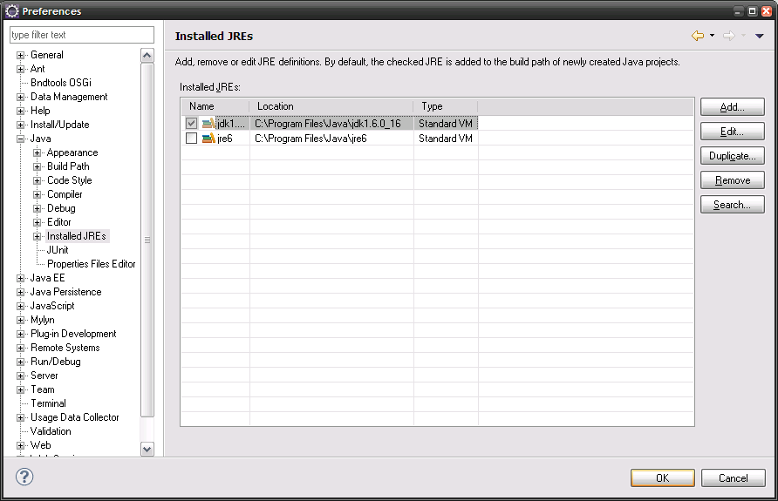
Figure 15 Changing the JRE.

Installing the Bndtools plug-in
The installation of the Bndtools plug-in in RAD is similar to the installation in Eclipse. Follow the steps described in PowerMatcher Core Installation and Configuration.

Install Lotus Expeditor Client
The Lotus Expeditor Client is not required for the PowerMatcher server components. However, if you also want to run components from PowerMatcher Core, for example for testing, it is required. Follow the steps described in PowerMatcher Core Installation and Configuration.

Retrieving the source code and IDE setup
The source code of PowerMatcher as a Service is delivered as compressed Eclipse project archive. The file only contains the code for the components that extend PowerMatcher Core. If you also want the Core components read the ‘Development environment setup’ section of PowerMatcher Core Installation and Configuration document. Note that the archive file of PowerMatcher as a Service contains projects that are also part of the Core archive. These projects are required for building the server components.

Download the zip file using sftp from the server using the following data:

Hostname | <to-do>
IP address | <to-do>
Port | 22 (sftp)
Username | <to-do>
Directory | /opt/ibm-mxv/source
File names | pwmaas_source.zip

First create a workspace named for example ‘pwmaasworkspace’ when you open RAD:

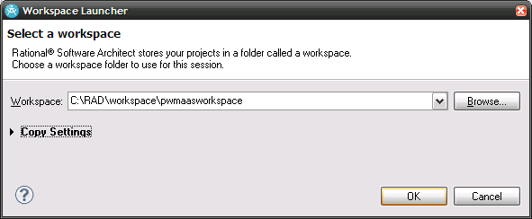

Open the Bndtools perspective (). When you open this for the first time the Bndtools will launch a Wizard to create a configuration project named ‘cnf’ to store its local bundle repository and build settings. Select ‘Create a configuration project’ and click Next.

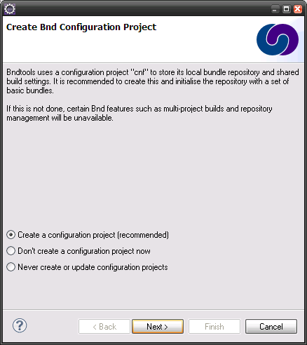
Figure 16 Bndtools wizard for creating a configuration project named ‘cnf’.

In the next screen select the ‘Standard Configuration’ template and click Finish.

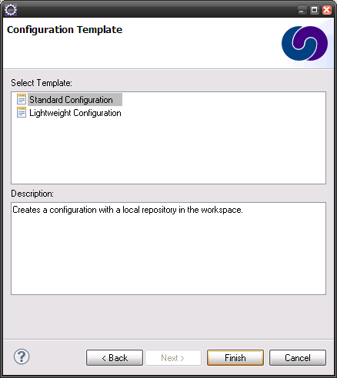
Figure 17 Select the Stand Configuration template for the 'cnf' project.

Bndtools will create ‘cnf’ project and add a set of libraries that are common in developing OSGi components:
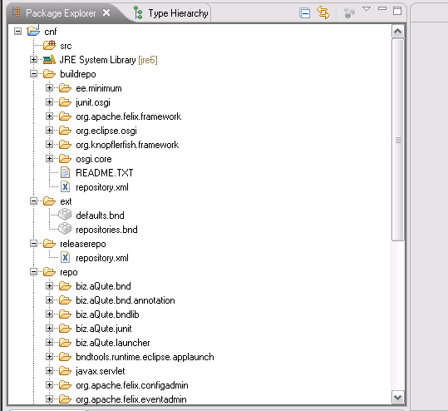
Figure 18 The 'cnf' project created by Bndtools prefilled with common bundles.

The Eclipse Paho MQTT client bundle needs to be added to the Local repository. In the Bndtools perspective navigate to the Repositories view and select Local repository. Click the icon of the ‘Add bundles to repository’ and add the jar file listed in Table 1.

Function | Required JAR file for PowerMatcher as a Service
MQTT client | org.eclipse.paho.client.mqttv3-1.0.0.jar
Table 1 Required bundle(s) for PowerMatcher as a Service server components.

Importing the sources
Unzip the PowerMatcher as a Service archive file to a directory and import the projects into the workspace. First switch off the automatic build option by de-selecting ‘Build automatically…’ in the Project menu. Use the Import… wizard and select ‘Import existing projects into workspace’ and point the wizard to the folder where you exported the project archive file. Select all projects and check ‘Copy projects into workspace’ and import the projects by clicking the Finish button.

In case you have already the PowerMatcher Core projects loaded in your workspace you do not have to replace them with the ones in the PowerMatcher as a Service archive because they contain the same sources.

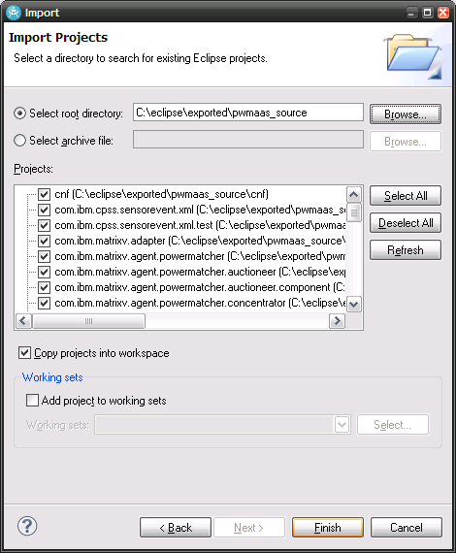

After the import completed restart the workbench (File -> Restart). The cnf repository cache will now be cleared. From the message bar at the bottom of the window you can see when this task is running. If the task is completed check the ‘Build automatically…’ option or hit Ctrl-B (i.e. Build All). All projects should now compile successfully. If there are still errors try ‘Project > Clean… ‘ and select clean all projects, this will mostly solve the compile problems.

Defining a Websphere server instance
In RAD you can add an existing Websphere Application Server instance or you can create a new one if you installed the Websphere Application Server feature. From the Server perspective open the context menu and select New -> Server or use the wizard in via File->New->Other->Server->Server.

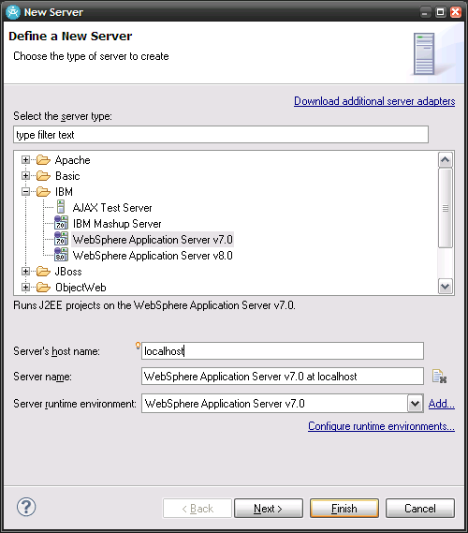
Figure 19 Defining a new Websphere Application Server instance.

Deploying the server applications

The PowerMatcher server applications (Enterprise applications, Web applications) can be deployed on Websphere Application Server using the Rational development environment In this section we describe the deployment using the development environment. Perform the following steps:

- Open the Server perspective and configure the server where you want to deploy (refer to the Rational documentation).
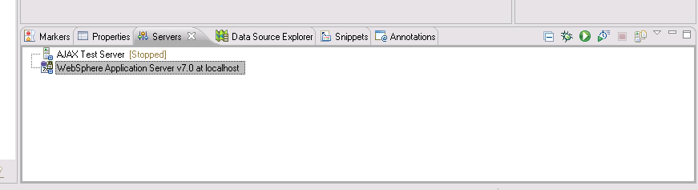
Figure 20 The Server perspective.

- Select the Server and from the context menu select ‘Add/Remove’.
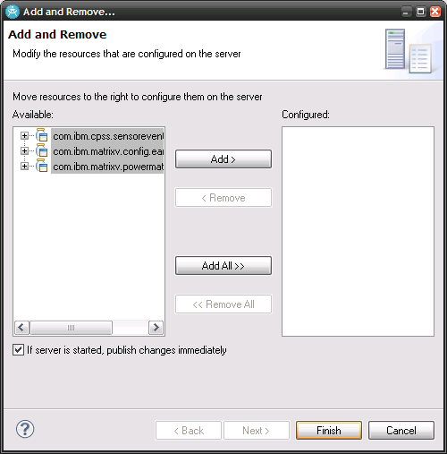
Figure 21 Deploying a JEE applications using the Add/Remove dialog of RAD.

- Select the an application for example com.ibm.matrixv.config.ear entry and click the ‘Add’ button and then Finish. The deployment should start now. You can see this also in the Console view in the IDE.

After the deployment of a web application the web server plug-in has to be regenerated and then propagated. Then the web applications can be accessed via the Http Server.

The applications can also be deployed using the Websphere console (ICS or Integrated Solutions Console). In that case the JEE applications need to be exported first as an .ear or .war file.

Data capture

Concept
Agents in a PowerMatcher cluster can be configured to send status messages, log messages for update bids and price info updates and measurement data. The messages are processed by modules (MDB’s or message driven beans) running in the application server.

The messages are processed and stored in a database. Messages from a cluster can be stored in their own database.

The event logging in PowerMatcher as a Service can be divided in the following categories:

- PowerMatcher data logging
These include the logging of BidInfoLog messages that contains Update Bid Info data and PriceInfoLog messages that contain Update Price Info data.
- Telemetry data logging
Logging of telemetry messages from agents that send data like measurements and device status.
- Monitoring data logging
PowerMatcher components have an MQTT connection adapter that can be configured to send notification events (component started, connection lost etc).

Deployment units and configuration
The PowerMatcher central environment runs a Websphere Application server instance that hosts the modules, or actually Message Driven Beans (MDB’s), that process the event logging messages that are sent by the agents of the different PowerMatcher clusters.

Each MDB is activated by a so called Activation Specification which is mapped to a topic pattern. In case a message arrives on a topic that matches the topic pattern the MDB is triggered to process the message. The MDB retrieves the message from the topic, parses it and stores it in the database.

The following table shows the data capture deployment units and the JMS configuration settings that need to be defined in the Websphere Application Server instance.

Event log category | Message | MDB Deployment unit | JMS
PowerMatcher events | BidInfoLog | com.ibm.matrixv.powermatcher.tasks.ear | Activation specification:  JNDI name : jms/PowerMatcherPattern  Topic: PowerMatcher/#  Topic subscription:  JNDI name: jms/PowerMatcherTopic, Topic: PowerMatcher  Default agent publishing topic:  PowerMatcher/<clusterid>/<agent_id>/UpdateBid/Log  PowerMatcher/<clusterid>/<agent_id>/UpdatePriceInfo/Log
PowerMatcher events | PriceInfoLog | com.ibm.matrixv.powermatcher.tasks.ear
Telemetry events | TelemetryData | com.ibm.cpss.sensorevent.tasks.ear | Activation specification:  JNDI name : jms/CPSSPattern  Topic: CPSS/#  Topic subscription:  JNDI name: jms/CPSSTopic  Topic: CPSS  Default agent publishing topic:  CPSS/<cluster_id>/<agent_id>
Monitoring events | MonitoringData | com.ibm.cpss.sensorevent.tasks.ear | Activation specification:  JNDI name : jms/StatusPattern  Topic: Status/#  Topic subscription:  JNDI name: jms/StatusTopic  Topic: Status  Default component publishing topic:  Status/<cluster_id>/<component_id>
Table 2 Data capture deployment units and JMS configuration settings.

Data source dependency
A reference to the database to store the captured data is retrieved via a Data Source definition in Websphere Application server. The data source name is deducted from the cluster id where the message came from. The name is prefixed by the common JDBC prefix ‘jdbc/’. For example, suppose the message was send from a cluster with cluster id ‘MatrixV’ then there should be a data source defined with the following JNDI name:
jdbc/MatrixV

Each MDB expects that the data source for a cluster is defined, otherwise the message is logged and then skipped.

Therefore when a new cluster is added a corresponding data source definition should be added also.

Deployment
The Message Driven Beans for data capturing can be deployed on Websphere Application Server using the Eclipse or Rational development environment or you can export it to them .ear file and deploy it using the Websphere console (ICS or Integrated Solutions Console). In this section we describe the deployment using the development environment. Perform the following steps:

- Open the Server perspective and configure the server where you want to deploy (refer to the Eclipse or Rational documentation).
- Select the Server and from the context menu select ‘Add/Remove’.
- Select the deployment unit of the MDB and click the ‘Add’ button and then Finish. The deployment should start now. You can see the progress in the Console view in the IDE.

Websphere MQ installation
This chapter describes the installation of Websphere MQ version 7.1 on a Linux 64-bit server. You will need WebSphere MQ V7.1 for Linux on x86 64bit Multilingual (CI3CNML).

Installation preparation

First create user group and user id:

- Become root user:
sudo su -
- Add mqm group
groupadd mqm
- Create the user id mqm and set the home directory to /var/mqm.
useradd -c "MQ user" -d /var/mqm -g mqm -m mqm
Note: the -m flag forces the creation of the home directory.
- Set the password for the mqm user
passwd mqm
And type the password.

Installation
Follow the next steps to install WebSphere MQ server on Linux:

- Extract the archive CI3CNML (WebSphere MQ V7.1 for Linux on x86 64bit Multilingual):
tar -xvzf CI3CNML.tar.gz
- Become root user:
sudo su -
- Set your current directory to the location of the installation file (directory where you extracted the archive CI3CNML.tar.gz).
- Run the mqlicense.sh script.
- To install all components to the default location use the following command:
rpm -ivh MQSeries*.rpm

Verifying installation and first setup queue managers
Verify the installation and perform a first setup by following the next steps:

- Logon as user mqm
su – mqm
- The installation does not create a /var/mqm/bin directory which links to the /opt/mqm/bin directory.
Create a symbolic link:
ln -s /opt/mqm/bin /var/mqm/bin
- Start the MQExplorer utility. On the command line type:
MQExplorer
- Create a default configuration which will create a new queue manager and a default cluster. The utility will produce an output like this:
The following default setup configuration was created:
A default configuration will be set up.
The queue manager name is 'QM_cpssvn14'
Remote administration of the queue manager:
Allowed
Joining the default cluster DEFAULT_CLUSTER
Location of repository for cluster:
This computer ('cpssvn14')
- Open the Welcome to MQ Telemetry page.
To use an existing queue manager, click on IBM WebSphere MQ\Queue Managers\qMgrName\Telemetry folder to open the Welcome to MQ Telemetry page.
- From the Welcome to MQ Telemetry page in WebSphere MQ Explorer, click Define sample configuration.
If this link is not present, and instead you see the text, "The sample configuration has been set up for this queue manager", then telemetry has already been configured. Proceed to step 9. If you clicked Define sample configuration, the page opens, and lists actions that are to be performed as part of the sample configuration.
- Leave Launch MQTT client utility checked, if you want to automatically start the MQTT client utility. The check box is selected by default.
- Click Finish.

Configuring WebSphere MQ for PowerMatcher
After WebSphere MQ has been installed according to the instructions above, it is ready to be configured for PowerMatcher.

Enable remote administration
By default, remote administration is blocked. For a development and test setup, open WebSphere MQ Explorer to edit the “Block User List” Channel Authentication Record. Replace “*MQADMIN” by “nobody” to enable remote administrative access from MQ Explorer on the development workstation.

Configure a PlainText channel for client user id authorization
- To configure WebSphere MQ Telemetry there is a define sample configuration wizard that can be run from WebSphere MQ Explorer. The wizard runs through a series of steps, including defining and starting the telemetry service, setting up the default transmission queue, and configuring a telemetry channel. See http://publib.boulder.ibm.com/infocenter/wmqv7/v7r1/topic/com.ibm.mq.doc/tt30200_.htm
- Next, go to step 4 in Configuring a queue manager for telemetry (http://publib.boulder.ibm.com/infocenter/wmqv7/v7r1/topic/com.ibm.mq.doc/tt40050_.htm) to authorize MQ clients.
- If neither the MCA user ID and Use client ID properties are set for the Telemetry Channel, the user name and password from the client are used and the user name is authenticated by JAAS using the password. Run the MQ Explorer (mqstrcfg) and edit the Telemetry channel (named PlainText by default) properties to blank the MCA user ID, if it is set (the wizard sets it to “nobody” by default on Linux).
- From this point on it is not possible to use the MQTT Utility anymore because the utility does not support providing credentials. Instead, use /com.ibm.matrixv.agent.framework.test/SimpleTestAgent.launch to run a simple pub/sub test. Any user/password should be able to connect and publish at this point.
- Create a local user on Linux to test this. This user will also be used for remote connections from WebSphere Application Server on the development workstation.
- Create a local user “pwmuser” on Linux. Note that this is a user for test- and development purposes only; for operating systems connected to LDAP this can also be an LDAP user.
sudo useradd -s /sbin/nologin pwmuser
sudo chage -M -1 pwmuser
sudo passwd pwmuser
test2012pwm
- Give pwmuser the required authorization to connect to the queue manager and the server connection channel (inherited by S_cpssvn14)
setmqaut -m QM_cpssvn14 -t qmgr -p pwmuser -all
setmqaut -m QM_cpssvn14 -t qmgr -p pwmuser +connect +inc
- Revoke the following default authorizations for group “nobody” and rerun the SimpleTestAgent. The test should fail.
setmqaut -m QM_cpssvn14 -n “SYSTEM.MQTT.TRANSMIT.QUEUE” -t q -g nobody -put
setmqaut -m QM_cpssvn14 -t topic -n SYSTEM.BASE.TOPIC -g nobody -pub –sub
Note that it is also possible to manage object authorities for system objects in the MQ Explorer; view system objects must be enabled in the explorer.
- Authorize the pwmuser as follows and rerun the SimpleTestAgent. The test should succeed. Only the pwmuser can now pub/sub to any topic.
setmqaut -m QM_cpssvn14 -n “SYSTEM.MQTT.TRANSMIT.QUEUE” -t q -p pwmuser -remove
setmqaut -m QM_cpssvn14 -n “SYSTEM.MQTT.TRANSMIT.QUEUE” -t q -p pwmuser +put
setmqaut -m QM_cpssvn14 -t topic -n SYSTEM.BASE.TOPIC -p pwmuser -all +pub +sub
At this point it is shown that the authorization for the local pwmuser is in effect, but authentication is not active, any password can be used.
- Afterwards, delete the authorization for pwmuser to pub/sub to any topic again.
setmqaut -m QM_cpssvn14 -n “SYSTEM.MQTT.TRANSMIT.QUEUE” -t q -p pwmuser -remove

Configure the PlainText channel for LDAP authentication
RHEL on cpssvn14 is configured against the Active Directory LDAP Server on cpssvn97.
We will set up MQ Telemetry to authenticate and authorize against LDAP.
- In the Active Directory on cpssvn97, create new Organizational Units, a group and a user under the cpss.smarterplatform.com domain, and assign the group and the user to the NIS domain cpss to make them available under Linux.
MQTT
+------- Groups
| +------- pwmadmins
+------- Users
+------- pwmadmin (non-expiring, with password test2012pwm)
- Make pwmadmin member of group pmwadmins and of group cpssnologin (as this is an application user id that is not intended for interactive Windows or Linux login)
- On cpssvn14, authorize the group pwmadmins as follows and rerun the SimpleTestAgent for LDAP user “pwmadmin” with any password. The test should succeed. User pwmadmin can now pub/sub to any topic.
setmqaut -m QM_cpssvn14 -t qmgr -g pwmadmins +connect +inc
setmqaut -m QM_cpssvn14 -n SYSTEM.MQTT.TRANSMIT.QUEUE -t q -g pwmadmins -remove
setmqaut -m QM_cpssvn14 -n SYSTEM.MQTT.TRANSMIT.QUEUE -t q -g pwmadmins +put
setmqaut -m QM_cpssvn14 -t topic -n SYSTEM.BASE.TOPIC -g pwmadmins -all +pub +sub
- As user mqm, edit /var/mqm/qmgrs/QM_cpssvn14/mqxr/jaas.config and add the following section:
CPSS {
com.ibm.security.auth.module.LdapLoginModule REQUIRED
userProvider="ldap://cpssvn97.cpss.smarterplatform.com/"
authIdentity="CN={USERNAME},OU=Users,OU=MQTT,DC=cpss, DC=smarterplatform,DC=com"
useSSL=true
debug=false;
};
- Edit /opt/mqm/java/jre64/jre/lib/security/java.security and verify the list of security providers. In the base MQ 7.1 installation this list is broken. It must be numbered sequentially and the CMS provider can be omitted, as follows:

security.provider.1=com.ibm.jsse2.IBMJSSEProvider2
security.provider.2=com.ibm.crypto.provider.IBMJCE
security.provider.3=com.ibm.security.jgss.IBMJGSSProvider
security.provider.4=com.ibm.security.cert.IBMCertPath
security.provider.5=com.ibm.security.sasl.IBMSASL
security.provider.6=com.ibm.xml.crypto.IBMXMLCryptoProvider
security.provider.7=com.ibm.xml.enc.IBMXMLEncProvider
security.provider.8=org.apache.harmony.security.provider.PolicyProvider
security.provider.9=com.ibm.security.jgss.mech.spnego.IBMSPNEGO
- chmod o+w /opt/mqm/java/jre64/jre/lib/security/cacerts
- Execute strmqikm to start the IBM Java Key Management utility (ikeyman), load the cacerts JDK store (default password is “changeit”), and add the CA certificate for the Active Directory server (currently a self-signed certificate exported to file cpssvn97-CA.cer). This is required for a valid certificate chain for the SSL connection to the Active Directory server.
- In the MQ Explorer set the JAAS Configuration name to “CPSS” for the MQ Telemetry channel.
- Restart the SYSTEM.MQXR.SERVICE.
- Rerun the SimpleTestAgent for LDAP user “pwmadmin”, but now the correct password must be used.
Note: all MQTT users must be defined under “OU=Users, OU=MQTT, DC=cpss, DC=smarterplatform, DC=com” for authentication to be successful. The reason is that the standard LdapLoginModule requires a full Distinguished Name for authIdentity.

Configure a Secure channel with LDAP authentication
- On cpssvn14 run strmqikm as user mqm to create a new JKS keystore:
- Create /var/mqm/qmgrs/QM_cpssvn14/mqxr/key.jks with password “changeit”
- Create a self-signed certificate labeled “mqxr_server” with default settings for cpssvn14.cpss.smarterplatform.com and make it valid for 3650 days.
- Extract the certificate to export it to cpssvn14_cert.arm
- Using the MQ Telemetry Explorer, create a new Telemetry Channel named “Secure”.
  - In the New Telemetry Channel wizard, select “Allow Anonymous Clients” on the second page (authentication will be based on userid, not on client certificate) and fill in /var/mqm/qmgrs/QM_cpssvn14/mqxr/key.jks with password “changeit”.
  - On the next page select “Check client supplied username and password” and fill in “CPSS” a for the JAAS config name.
  - On the next page select “Username provided for client” for client authorization.
- In the test environment where you are going to run the MQTT client code (for example your laptop or desktop), run the C:\Program Files\IBM\Java60\jre\bin\ikeyman utility (as administrator) to import cpssvn14_cert.arm into the default Java trust store C:\Program Files\IBM\Java60\jre\lib\security\cacerts (the security tab in the Java Control Panel can also be used for this).
- In the client code the broker URI can now be changed to ssl://cpssvn14.smarterplatform.loc:8883, and when the proper username and password are provided the secure connection is made.

Note that if anything is incorrectly set up, the MQXR daemon simply hangs up as soon as the MQTT client does anything that it is not authorized to, like for example publish or subscribe to an unauthorized topic. This is reported in the log and trace files on the server.

Configure a new PowerMatcher cluster for MQ Telemetry
Set up LDAP security group and application user(s).
- On cpssvn97, create new Organizational Units, a group and a user under the cpss.smarterplatform.com domain, and assign the group and the user to the NIS domain cpss to make them available under Linux.

MQTT
+------- Groups
| +------- clustergrpid
+------- Users
+------- clusterusrid1
+------- clusterusrid…
- Make clusterusrid… member of group clustergrpid and of group cpssnologin (as this is an application user id that is not intended for interactive login)

For MatrixV this looks as follows:
- Directory group: matrixv
- Directory user: ibm-mxv
- Cluster id in topic: MatrixV

Define topics using runmqsc:
DEFINE TOPIC('CPSS') TOPICSTR('CPSS')
DEFINE TOPIC('CPSS/MatrixV') TOPICSTR('CPSS/MatrixV')
DEFINE TOPIC('CPSS/MatrixVSim') TOPICSTR('CPSS/MatrixVSim')
DEFINE TOPIC('Telemetry') TOPICSTR('Telemetry')
DEFINE TOPIC('Telemetry/MatrixV') TOPICSTR('Telemetry/MatrixV')
DEFINE TOPIC('Telemetry/MatrixVSim') TOPICSTR('Telemetry/MatrixVSim')
DEFINE TOPIC('PowerMatcher') TOPICSTR('PowerMatcher')
DEFINE TOPIC('PowerMatcher/MatrixV') TOPICSTR('PowerMatcher/MatrixV')
DEFINE TOPIC('PowerMatcher/MatrixVSim') TOPICSTR('PowerMatcher/MatrixVSim')
DEFINE TOPIC('Status') TOPICSTR('Status')
DEFINE TOPIC('Configuration') TOPICSTR('Configuration')
END

Notes:
- names and topics are case sensitive, the single quotes are required!
- The CPSS topic is a legacy topic that is superseded by Telemetry.

Define authorizations:
setmqaut -m QM_cpssvn14 -t qmgr -g matrixv +connect +inc
setmqaut -m QM_cpssvn14 -n "SYSTEM.MQTT.TRANSMIT.QUEUE" -t q -g matrixv +put
setmqaut -m QM_cpssvn14 -t topic -n PowerMatcher -g cpssusers -remove
setmqaut -m QM_cpssvn14 -t topic -n PowerMatcher -p pwmuser -remove
setmqaut -m QM_cpssvn14 -t topic -n PowerMatcher -p pwmuser +pub +sub
setmqaut -m QM_cpssvn14 -t topic -n PowerMatcher/MatrixV -g cpssusers -remove
setmqaut -m QM_cpssvn14 -t topic -n PowerMatcher/MatrixV -g matrixv +pub +sub
setmqaut -m QM_cpssvn14 -t topic -n PowerMatcher/MatrixVSim -g cpssusers -remove
setmqaut -m QM_cpssvn14 -t topic -n PowerMatcher/MatrixVSim -g matrixv +pub +sub
setmqaut -m QM_cpssvn14 -t topic -n CPSS -g cpssusers -remove
setmqaut -m QM_cpssvn14 -t topic -n CPSS -p pwmuser -remove
setmqaut -m QM_cpssvn14 -t topic -n CPSS -p pwmuser +pub +sub
setmqaut -m QM_cpssvn14 -t topic -n CPSS/MatrixV -g cpssusers -remove
setmqaut -m QM_cpssvn14 -t topic -n CPSS/MatrixV -g matrixv +pub +sub
setmqaut -m QM_cpssvn14 -t topic -n CPSS/MatrixVSim -g cpssusers -remove
setmqaut -m QM_cpssvn14 -t topic -n CPSS/MatrixVSim -g matrixv +pub +sub
setmqaut -m QM_cpssvn14 -t topic -n Telemetry -g cpssusers -remove
setmqaut -m QM_cpssvn14 -t topic -n Telemetry -p pwmuser -remove
setmqaut -m QM_cpssvn14 -t topic -n Telemetry -p pwmuser +pub +sub
setmqaut -m QM_cpssvn14 -t topic -n Telemetry/MatrixV -g cpssusers -remove
setmqaut -m QM_cpssvn14 -t topic -n Telemetry/MatrixV -g matrixv +pub +sub
setmqaut -m QM_cpssvn14 -t topic -n Telemetry/MatrixVSim -g cpssusers -remove
setmqaut -m QM_cpssvn14 -t topic -n Telemetry/MatrixVSim -g matrixv +pub +sub
setmqaut -m QM_cpssvn14 -t topic -n Status -g cpssusers -remove
setmqaut -m QM_cpssvn14 -t topic -n Status -p pwmuser -remove
setmqaut -m QM_cpssvn14 -t topic -n Status -p pwmuser +pub +sub
setmqaut -m QM_cpssvn14 -t topic -n Status -g matrixv -remove
setmqaut -m QM_cpssvn14 -t topic -n Status -g matrixv +pub
setmqaut -m QM_cpssvn14 -t topic -n Configuration -g cpssusers -remove
setmqaut -m QM_cpssvn14 -t topic -n Configuration -p pwmuser -remove
setmqaut -m QM_cpssvn14 -t topic -n Configuration -p pwmuser +pub +sub
setmqaut -m QM_cpssvn14 -t topic -n Configuration -g matrixv -remove
setmqaut -m QM_cpssvn14 -t topic -n Configuration -g matrixv +sub

Note: the authority record that is created by default for group cpssusers when a new topic is created must be deleted explicitly.

Authorizations can also be defined using runmqsc:

SET AUTHREC PROFILE('SYSTEM.MQTT.TRANSMIT.QUEUE') OBJTYPE(TOPIC) GROUP('matrixv') AUTHADD(PUB,SUB)

DELETE AUTHREC PROFILE('PowerMatcher') OBJTYPE(TOPIC) GROUP('cpssusers')
DELETE AUTHREC PROFILE('PowerMatcher') OBJTYPE(TOPIC) USER('pwmuser')
SET AUTHREC PROFILE('PowerMatcher') OBJTYPE(TOPIC) USER('pwmuser') AUTHADD(PUB,SUB)

DELETE AUTHREC PROFILE('PowerMatcher/MatrixV') OBJTYPE(TOPIC) GROUP('cpssusers')
SET AUTHREC PROFILE('PowerMatcher/MatrixV') OBJTYPE(TOPIC) GROUP('matrixv') AUTHADD(PUB,SUB)

DELETE AUTHREC PROFILE('CPSS') OBJTYPE(TOPIC) GROUP('cpssusers')
DELETE AUTHREC PROFILE('CPSS') OBJTYPE(TOPIC) USER('pwmuser')
SET AUTHREC PROFILE('CPSS') OBJTYPE(TOPIC) USER('pwmuser') AUTHADD(PUB,SUB)

DELETE AUTHREC PROFILE('CPSS/MatrixV') OBJTYPE(TOPIC) GROUP('cpssusers')
SET AUTHREC PROFILE('CPSS/MatrixV') OBJTYPE(TOPIC) GROUP('matrixv') AUTHADD(PUB,SUB)

DELETE AUTHREC PROFILE('Status') OBJTYPE(TOPIC) GROUP('cpssusers')
DELETE AUTHREC PROFILE('Status') OBJTYPE(TOPIC) USER('pwmuser')
SET AUTHREC PROFILE('Status') OBJTYPE(TOPIC) USER('pwmuser') AUTHADD(PUB,SUB)
SET AUTHREC PROFILE('Status') OBJTYPE(TOPIC) GROUP('matrixv') AUTHADD(PUB)

DELETE AUTHREC PROFILE('Configuration') OBJTYPE(TOPIC) GROUP('cpssusers')
DELETE AUTHREC PROFILE('Configuration') OBJTYPE(TOPIC) USER('pwmuser')
SET AUTHREC PROFILE('Configuration') OBJTYPE(TOPIC) USER('pwmuser') AUTHADD(PUB,SUB)
SET AUTHREC PROFILE('Configuration') OBJTYPE(TOPIC) GROUP('matrixv') AUTHADD(SUB)

Websphere Application Server installation and configuration

Installation
Add the following to the end of /etc/security/limits.conf:

# Added for WebSphere
* soft nofile 8192
* hard nofile 65535

Download the IBM WebSphere Application Server V7.0 for Linux on x86-64 bit, Multilingual eAssembly (CR77RML):
- Quick Start Guide for IBM WebSphere Application Server V7.0, Multilingual (CZ0KHML)
- IBM WebSphere Application Server V7.0 for Linux on x86-64 bit, Multilingual (C1FZ9ML)
- WebSphere Application Server V7.0 Supplements for Linux on x86, 32-bit, Multilingual (1 of 2) (IBM HTTP Server, Web Server Plug-ins and Update Installer) (C1FZ7ML​)
- Optional: IBM WebSphere Application Server V7.0 Supplements (1 of 2) for Linux on x86-64 bit (IBM HTTP Server, Web Server Plug-ins and Update Installer) Multilingual (C1G00ML)

Alternatively, the Network Deployment version of WAS can be downloaded and used for a stand-alone server installation. As this material had already been downloaded on CPSS, this is used.
- WebSphere Application Server Network Deployment V7.0 Quick Start Guide​ (C1F8ZML)
- IBM WebSphere Application Server Network Deployment V7.0 for Linux on x86, 64-bit (C1G35ML)
- WebSphere Application Server Network Deployment V7.0 Supplements for Linux on x86 32-bit (1 of 2)​ (C1G33ML)
- Optional: WebSphere Application Server Network Deployment V7.0 Supplements for Linux on x86 64-bit (1 of 2)​ (IBM HTTP Server, Web Server Plug-ins and Update Installer) (C1G36ML)

Install WAS as a stand alone server.
Leave security disabled initially to connect it to the directory server later on.

Install the 32-bit HTTP Server and Plug-Ins from C1FZ7ML​ or C1G33ML. The reason for installing the 32-bit Plug-Ins in the 64-bit environment is that, on cpssvn14, the Cognos Gateway will also have to be installed on the HTTP Server, and no 64-bit version of the Cognos Gateway is available.
- For IHS, do not create an administration server user at this point. The administration server will be set up from the command line later.
- During the IHS installation specify a username and password for the administrator (for /opt/IBM/HTTPServer/conf/admin.passwd).
User: httpadmin
Password: httpadminpassword

Do not install the Update Installer from any of the above e-Assemblies, but download and install the latest Update Installer and 64/32-bit Fix Packs (7.0.0.21) from http://www.ibm.com/software/webservers/appserv/was/support/download.html (required)

Download and install the latest IBM Installation Manager V1.4.4 from http://www.ibm.com/support/docview.wss?rs=180&uid=swg24023498 (required)

Download the feature pack and import repositories from the Feature Pack for OSGi Applications and Java Persistence API 2.0 Web site http://www.ibm.com/software/webservers/appserv/was/featurepacks/

- was.7.0.import.zip (needed for import of WAS 7.0.0.21)
- ariesjpa_and_import_repositories.zip (Feature pack 1.0.0.0)
- ariesjpa.1.0.import.zip (Needed for install of fixpack from local repository)
- ariesjpa.1.0.0.5.fp.zip (Upgrade to feature pack 1.0.0.5)

Using the Installation Manager, add the local repositories from the zip files listed above, import the WAS 7 installation, and install the OSGi/JPA feature pack 7.0.0.5.

Next, make sure the server is stopped and augment the stand-alone (=default) AppSrv01 profile for JPA 2.0 and OSGi.

./manageprofiles.sh -augment -profileName AppSrv01 -templatePath /opt/IBM/WebSphere/AppServer/profileTemplates/aries/default.ariesfep
./manageprofiles.sh -augment -profileName AppSrv01 -templatePath /opt/IBM/WebSphere/AppServer/profileTemplates/JPA/default.jpafep

./manageprofiles.sh -listAugments -profileName AppSrv01

Configuration

Init scripts
- Create init script for WAS.
cd /opt/IBM/WebSphere/AppServer/bin/
./wasservice.sh -add "AppSrv01" -servername server1 -profilePath /opt/IBM/WebSphere/AppServer/profiles/AppSrv01/ -logRoot /opt/IBM/WebSphere/AppServer/profiles/AppSrv01/logs/server1
- Create init scripts for IHS (ihs70 and ihs70admin).
- Configure the IHS administration server to run as user adm in group adm:
cd /opt/IBM/HTTPServer/bin
./setupadm -usr adm -grp adm -cfg /opt/IBM/HTTPServer/conf/httpd.conf -plg /opt/IBM/HTTPServer/Plugins/config/webserver1/plugin-cfg.xml -adm /opt/IBM/HTTPServer/conf/admin.conf
- Verify that WAS, IHS and IHS admin can be started using the init scripts.
- Verify that the WAS console opens: http://cpssvn14.smarterplatform.loc:9060/ibm/console
- Verify that the WAS default application runs:
- http://cpssvn14.smarterplatform.loc:9080/hitcount
- Verify that the IBM HTTP server opens: http://cpssvn14.smarterplatform.loc
- Verify that the WAS default application runs via IHS:
- http://cpssvn14.smarterplatform.loc/hitcount

Configuring WebSphere MQ as JMS Provider
Configure the WebSphere MQ messaging provider in WAS with native libraries information, see
http://publib.boulder.ibm.com/infocenter/wasinfo/v7r0/index.jsp?topic=/com.ibm.websphere.base.doc/info/aes/ae/tmj_adm33.html
On the 64-bit server the path is /opt/mqm/java/lib64.

If the WAS run user is not authorized, native MQ ‘bindings’ connections cannot be made later on. On cpssvn14 the run user is root. Execute ‘usermod -G mqm root’ to add the WAS run user to mqm.

WAS must be restarted two times after this.

See Connecting WebSphere Application Server to WebSphere MQ for background info:
http://publib.boulder.ibm.com/infocenter/prodconn/v1r0m0/index.jsp?topic=%2Fcom.ibm.scenarios.wmqwas101.doc%2Ftopics%2Fins_wascfg.htm

Configuring JMS Resources

Connection Authorization
For remote access from WAS to MQ with the Client connection type, define JAAS - J2C authentication data named PwMUser for user pwmuser. This is not necessary when WAS and MQ are installed on the same server and the Bindings connection type is used.

Connection Factories
Connection Factories are used for publishing messages to queues or topics.
In the WebSphere Administrative Console, create a JMS Connection Factory for the WebSphere MQ messaging provider named “PowerMatcherMQCF” for JNDI name ‘jms/PowerMatcherMQCF’. On the test server the factory is created at the Cell level. This could be Node or Server level, depending on deployment configuration.

Supply the following connection details:
Queue manager: QM_cpssvn14
Connection type: Bindings for local access, Client for remote access.
Host name: cpssvn14.smarterplatform.loc (only for remote access with Client connection type)
Port: 1414 (only for Client connection type)
Server connection channel: S_cpssvn14 (only for Client connection type)
Do NOT use channel SYSTEM.DEF.SVRCONN, as this will result in authentication errors:
The inbound channel 'SYSTEM.DEF.SVRCONN' was blocked from address
'192.168.3.114' because the active values of the channel matched a record
configured with USERSRC(NOACCESS). The active values of the channel were
'CLNTUSER()'.

The connection factory must be set to broker version 1 (which is the default). If it is set to broker version 2, the parameter “?brokerVersion=1” is added to the topic name internally, and this then (incorrectly) passed in the topic name to MQTT.

Topics
Define the following topic (pattern) destinations in the WebSphere Administrative Console:
- JNDI name: jms/CPSSTopic, Topic: CPSS
- JNDI name: jms/CPSSPattern, Topic: CPSS/#
- JNDI name: jms/PowerMatcherTopic, Topic: PowerMatcher
- JNDI name: jms/PowerMatcherPattern, Topic: PowerMatcher/#
- JNDI name: jms/StatusTopic, Topic: Status
- JNDI name: jms/StatusPattern, Topic: Status/#

Activation Specifications
Define the following Activation Specifications in the WebSphere Administrative Console, for the WebSphere MQ messaging provider:
- jms/CPSSAS, topic destination: jms/CPSSPattern, nondurable.
- jms/PowerMatcherAS, topic destination: jms/CPSSPattern, nondurable.
- jms/StatusAS, topic destination: jms/StatusPattern, nondurable.
Afterwards, edit the Broker Properties of the Activation Specifications to change:
- Capabilities to ‘Version 2 broker’
- Message selection in broker.
- Subscription wildcard to ‘Topic level wildcards’.
Note: the connection factory used for publishing requires the ‘Version 1 broker’ setting, here version 2 is possible and preferred so that the message selection takes place in MQ instead of in WebSphere.

Configure WebSphere Application Server for LDAP security
- Open the WAS console at http://cpssvn14.smarterplatform.loc:9060/ibm/console
- Add the root certificate cpssvn97-CA.cer of the cpssvn97 Certificate Authority to the applicable SSL trust store for the middelware. For WAS, add it to the NodeDefaultTrustStore and restart WAS.
- Configure “Standalone LDAP registry” (cannot use the wizard because SSL must be enabled)
  - Primary administrative user name: wasadmin
  - Type of LDAP: Microsoft Active Directory
  - LDAP host: cpssvn97.cpss.smarterplatform.com
  - LDAP port: 636
  - Base DN: dc=cpss,dc=smarterplatform,dc=com
  - Bind DN: cn=cpssbind,ou=users,ou=platform,dc=cpss,dc=smarterplatform,dc=com
  - Bind password: cpssadm1n
  - SSL Enabled (ldaps).
- Set as current for “Standalone LDAP registry”.
- Check “Enable administrative security”, which automatically also checks “Enable application security” and “Use Java 2 security”. Uncheck “Use Java 2 security”.
- Restart WAS, and now open the console at https://cpssvn14.smarterplatform.loc:9043/ibm/console, and log in as user wasadmin with the password defined in the CPSS LDAP.
- Edit /opt/IBM/WebSphere/AppServer/profiles/AppSrv01/properties/soap.client.props and enable security with the following settings:
com.ibm.SOAP.securityEnabled=true
com.ibm.SOAP.authenticationTarget=BasicAuth
com.ibm.SOAP.loginUserid=wasadmin
com.ibm.SOAP.loginPassword={xor}...=
Replace … with the hashed password user wasadmin with the password defined in the CPSS LDAP. Make sure the file is not readable by others.

Configure IBM HTTP Server and security
- As root on cpssvn14, start /opt/IBM/HTTPServer/bin/ikeyman –x and open the JKS keystore /var/mqm/qmgrs/QM_cpssvn14/mqxr/key.jks (test password “changeit”), containing the self-signed certificate created for MQ Telemetry.
- Save the JKS keystore in the CMS format as /opt/IBM/HTTPServer/key.kdb (again, using test password “changeit”). Select to stash the password to a file.
- Make the self-signed certificate the default certificate.
- Edit /opt/IBM/HTTPServer/conf/httpd.conf and add the following to the end.
#
# Load additional modules for reverse proxying
#
#LoadModule actions_module modules/mod_actions.so
#LoadModule alias_module modules/mod_alias.so
#LoadModule autoindex_module modules/mod_autoindex.so
LoadModule deflate_module modules/mod_deflate.so
#LoadModule dir_module modules/mod_dir.so
#LoadModule env_module modules/mod_env.so
LoadModule expires_module modules/mod_expires.so
#LoadModule log_config_module modules/mod_log_config.so
#LoadModule mime_module modules/mod_mime.so
LoadModule negotiation_module modules/mod_negotiation.so
LoadModule proxy_module modules/mod_proxy.so
LoadModule proxy_connect_module modules/mod_proxy_connect.so
#LoadModule proxy_ftp_module modules/mod_proxy_ftp.so
LoadModule proxy_http_module modules/mod_proxy_http.so
LoadModule rewrite_module modules/mod_rewrite.so
#LoadModule setenvif_module modules/mod_setenvif.so
LoadModule vhost_alias_module modules/mod_vhost_alias.so

#
# Load additional modules for SSL
#
LoadModule ibm_ssl_module modules/mod_ibm_ssl.so

#
# Configure reverse proxy and SSL
#

# Reverse proxy for Apache ACE from http to http
<Location "/obr">
ProxyPass http://cpssvn14.smarterplatform.loc:8080/obr
ProxyPassReverse http://cpssvn04.smarterplatform.loc:8080/obr
Allow from All
ExpiresActive Off
</Location>
<Location "/deployment">
ProxyPass http://cpssvn14.smarterplatform.loc:8080/deployment
ProxyPassReverse http://cpssvn04.smarterplatform.loc:8080/deployment
Allow from All
ExpiresActive Off
</Location>
<Location "/auditlog">
ProxyPass http://cpssvn14.smarterplatform.loc:8080/auditlog
ProxyPassReverse http://cpssvn04.smarterplatform.loc:8080/auditlog
Allow from All
ExpiresActive Off
</Location>

<IfModule mod_ibm_ssl.c>
Listen 443
<VirtualHost *:443>
SSLEnable
SSLProtocolDisable SSLv2
SSLClientAuth None

# Reverse proxy for Apache ACE from https to http
<Location "/obr">
ProxyPass http://cpssvn14.smarterplatform.loc:8080/obr
ProxyPassReverse http://cpssvn04.smarterplatform.loc:8080/obr
Allow from All
ExpiresActive Off
</Location>
<Location "/deployment">
ProxyPass http://cpssvn14.smarterplatform.loc:8080/deployment
ProxyPassReverse http://cpssvn04.smarterplatform.loc:8080/deployment
Allow from All
ExpiresActive Off
</Location>
<Location "/auditlog">
ProxyPass http://cpssvn14.smarterplatform.loc:8080/auditlog
ProxyPassReverse http://cpssvn04.smarterplatform.loc:8080/auditlog
Allow from All
ExpiresActive Off
</Location>
</VirtualHost>
</IfModule>
SSLDisable
KeyFile /opt/IBM/HTTPServer/key.kdb

- Open the WAS Console https://cpssvn14.smarterplatform.loc:9043/ibm/console/ and:
- Add the IBM HTTP Server as webserver1, if this hasn’t been done yet.
- Under Plug-in properties for webserver1, click the ‘Copy to Web server key store directory’ button.
- Regenerate and deploy the web server plug-in configuration.
- Restart the IBM HTTP Server with /etc/init.d/ihs70 restart and verify the following URLs:
- https://cpssvn14.smarterplatform.loc/ (test SSL to HTTP server)
- https://cpssvn14.smarterplatform.loc/hitcount (test WebSphere plug-in configuration)
- http://cpssvn14.smarterplatform.loc/obr/repository.xml (test proxying to Apache ACE).

Appendix: Database scripts

Creating the PowerMatcher database
The script below creates the tables of the PowerMatcher as a Service database. Before executing the script create an empty database.

---------------------------------------
-- Create PowerMatcher event tables
---------------------------------------

--<ScriptOptions statementTerminator=";"/>

ALTER TABLE PWMEVENT.BidData DROP CONSTRAINT BidCurveData_MarketBasisData_FK;

ALTER TABLE PWMEVENT.BidData DROP CONSTRAINT BidData_AgentEquipmentRel_FK;

ALTER TABLE PWMEVENT.PriceData DROP CONSTRAINT PriceData_AgentEquipmentRel_FK;

ALTER TABLE PWMEVENT.PriceData DROP CONSTRAINT PriceData_MarketBasisData_FK;

ALTER TABLE PWMEVENT.MarketBasisData DROP CONSTRAINT MarketBasisData_PK;

DROP TABLE PWMEVENT.BidData;

DROP TABLE PWMEVENT.MarketBasisData;

DROP TABLE PWMEVENT.PriceData;

DROP SCHEMA PWMEVENT RESTRICT;

CREATE SCHEMA PWMEVENT;

CREATE TABLE PWMEVENT.BidData (
clusterId VARCHAR(64) NOT NULL,
agentId VARCHAR(64) NOT NULL,
qualifier VARCHAR(16) NOT NULL,
marketBasisId INTEGER NOT NULL,
createTimestamp TIMESTAMP NOT NULL DEFAULT CURRENT TIMESTAMP,
timestamp TIMESTAMP NOT NULL,
minDemand REAL NOT NULL,
maxDemand REAL NOT NULL,
effectivePrice REAL NOT NULL,
effectiveDemand REAL NOT NULL,
stepPrice REAL,
demandFactor REAL NOT NULL,
demandCurve VARCHAR (2048) FOR BIT DATA,
daynum INTEGER NOT NULL GENERATED ALWAYS AS ((INTEGER(DATE(createTimestamp))))
)
ORGANIZE BY DIMENSIONS (
(clusterId),
(daynum))
DATA CAPTURE NONE;

CREATE TABLE PWMEVENT.MarketBasisData (
id INTEGER NOT NULL GENERATED BY DEFAULT AS IDENTITY ( START WITH 1 INCREMENT BY 1 MINVALUE 1 MAXVALUE 2147483647 NO CYCLE CACHE 20),
clusterId VARCHAR(64) NOT NULL,
createTimestamp TIMESTAMP NOT NULL DEFAULT CURRENT TIMESTAMP,
commodity VARCHAR(16) NOT NULL,
currency CHAR(3) NOT NULL,
minPrice REAL NOT NULL,
maxPrice REAL NOT NULL,
priceSteps SMALLINT NOT NULL
)
DATA CAPTURE NONE;

CREATE TABLE PWMEVENT.PriceData (
clusterId VARCHAR(64) NOT NULL,
agentId VARCHAR(64) NOT NULL,
qualifier VARCHAR(16) NOT NULL,
marketBasisId INTEGER NOT NULL,
createTimestamp TIMESTAMP NOT NULL DEFAULT CURRENT TIMESTAMP,
timestamp TIMESTAMP NOT NULL,
marketPrice REAL NOT NULL,
daynum INTEGER NOT NULL GENERATED ALWAYS AS ((INTEGER(DATE(createTimestamp))))
)
ORGANIZE BY DIMENSIONS (
(clusterId),
(daynum))
DATA CAPTURE NONE;

ALTER TABLE PWMEVENT.MarketBasisData ADD CONSTRAINT MarketBasisData_PK PRIMARY KEY
(id);

ALTER TABLE PWMEVENT.BidData ADD CONSTRAINT BidCurveData_MarketBasisData_FK FOREIGN KEY
(marketBasisId)
REFERENCES PWMEVENT.MarketBasisData
(id)
ON DELETE RESTRICT;

ALTER TABLE PWMEVENT.BidData ADD CONSTRAINT BidData_AgentEquipmentRel_FK FOREIGN KEY
(clusterId,
agentId)
REFERENCES CPSS.AgentEquipmentRel
(clusterId,
agentId)
NOT ENFORCED;

ALTER TABLE PWMEVENT.PriceData ADD CONSTRAINT PriceData_AgentEquipmentRel_FK FOREIGN KEY
(clusterId,
agentId)
REFERENCES CPSS.AgentEquipmentRel
(clusterId,
agentId)
NOT ENFORCED;

ALTER TABLE PWMEVENT.PriceData ADD CONSTRAINT PriceData_MarketBasisData_FK FOREIGN KEY
(marketBasisId)
REFERENCES PWMEVENT.MarketBasisData
(id)
ON DELETE RESTRICT;

COMMENT ON COLUMN PWMEVENT.BidData.agentId IS
'ID of the agent that is sending the bid, or the matcher that is aggregating the bid, depending on qualifier.
The agent ID is unique within the cluster.';

COMMENT ON COLUMN PWMEVENT.BidData.clusterId IS
'ID of the PowerMatcher cluster.';

COMMENT ON COLUMN PWMEVENT.BidData.createTimestamp IS
'Timestamp when the row was created. The timestamp is in local time.';

COMMENT ON COLUMN PWMEVENT.BidData.daynum IS
'Generated column for multi-dimensional clustering by day number (YYYYMMDD) of createTimestamp.';

COMMENT ON COLUMN PWMEVENT.BidData.demandCurve IS
'A vector of small integers (one for each price step) in big endian order (most significant byte first) representing the bid curve.
Each value is multiplied by demandFactor to obtain the actual demand for the step in the bid curve.';

COMMENT ON COLUMN PWMEVENT.BidData.demandFactor IS
'The demand multiplication factor for the small integers in the demandCurve vector.';

COMMENT ON COLUMN PWMEVENT.BidData.effectiveDemand IS
'Demand at effectivePrice for the bid curve of this event.';

COMMENT ON COLUMN PWMEVENT.BidData.effectivePrice IS
'Market price in effect at the time of bid, as received by the agent.';

COMMENT ON COLUMN PWMEVENT.BidData.marketBasisId IS
'The identity of the MarketBasis row associated with this Bid.';

COMMENT ON COLUMN PWMEVENT.BidData.maxDemand IS
'Maximum demand (demand at minimum price) in the bid curve.';

COMMENT ON COLUMN PWMEVENT.BidData.minDemand IS
'Minimum demand (demand at maximum price) in the bid curve.';

COMMENT ON COLUMN PWMEVENT.BidData.qualifier IS
'Role associated with the bid, for example "agent" or "matcher".';

COMMENT ON COLUMN PWMEVENT.BidData.stepPrice IS
'If the bid curve can be represented as a single step from maxDemand to minDemand, this column represents the step price.
If stepPrice is null, the bid curve has multiple steps and cannot be represented as a single step.';

COMMENT ON COLUMN PWMEVENT.BidData.timestamp IS
'Source timestamp for the event, in UTC.';

COMMENT ON COLUMN PWMEVENT.MarketBasisData.clusterId IS
'ID of the PowerMatcher cluster.';

COMMENT ON COLUMN PWMEVENT.MarketBasisData.commodity IS
'Commodity for the market basis, for example "electricity".';

COMMENT ON COLUMN PWMEVENT.MarketBasisData.createTimestamp IS
'Timestamp when the row was created. The timestamp is in local time.';

COMMENT ON COLUMN PWMEVENT.MarketBasisData.currency IS
'3 character international currency code, for example "EUR".';

COMMENT ON COLUMN PWMEVENT.MarketBasisData.id IS
'Generated unique identity for the MarketBasis row.';

COMMENT ON COLUMN PWMEVENT.MarketBasisData.maxPrice IS
'Maximum price defined for this market basis.';

COMMENT ON COLUMN PWMEVENT.MarketBasisData.minPrice IS
'Minimum price defined for this market basis.';

COMMENT ON COLUMN PWMEVENT.MarketBasisData.priceSteps IS
'Number of price steps between minimum and maximum price.';

COMMENT ON COLUMN PWMEVENT.PriceData.agentId IS
'ID of the agent that is the receiving the price, or the matcher that is sending the price, depending on qualifier.
The agent ID is unique within the cluster.';

COMMENT ON COLUMN PWMEVENT.PriceData.clusterId IS
'ID of the PowerMatcher cluster.';

COMMENT ON COLUMN PWMEVENT.PriceData.createTimestamp IS
'Timestamp when the row was created. The timestamp is in local time.';

COMMENT ON COLUMN PWMEVENT.PriceData.daynum IS
'Generated column for multi-dimensional clustering by day number (YYYYMMDD) of createTimestamp.';

COMMENT ON COLUMN PWMEVENT.PriceData.marketBasisId IS
'The identity of the MarketBasis row associated with this Bid.';

COMMENT ON COLUMN PWMEVENT.PriceData.marketPrice IS
'The market price for the event.';

COMMENT ON COLUMN PWMEVENT.PriceData.qualifier IS
'Role associated with the price event, for example "agent" or "matcher".';

COMMENT ON COLUMN PWMEVENT.PriceData.timestamp IS
'Source timestamp for the event, in UTC.';

COMMENT ON TABLE PWMEVENT.BidData IS
'PowerMatcher Bid event data.';

COMMENT ON TABLE PWMEVENT.MarketBasisData IS
'PowerMatcher MarketBasis data associated with Price or Bid event.';

COMMENT ON TABLE PWMEVENT.PriceData IS
'PowerMatcher Price event data.';

Defining PowerMatcher authorizations
The following script creates the authorizations for the PowerMatcher tables:

--------------------------------------------
-- Authorization Statements on Tables/Views
--------------------------------------------

GRANT SELECT ON TABLE PWMEVENT.BidData TO GROUP PWMREPORTING ;

GRANT DELETE ON TABLE PWMEVENT.BidData TO USER PWMUSER ;

GRANT INSERT ON TABLE PWMEVENT.BidData TO USER PWMUSER ;

GRANT SELECT ON TABLE PWMEVENT.BidData TO USER PWMUSER ;

GRANT UPDATE ON TABLE PWMEVENT.BidData TO USER PWMUSER ;

GRANT SELECT ON TABLE PWMEVENT.MarketBasisData TO GROUP PWMREPORTING ;

GRANT DELETE ON TABLE PWMEVENT.MarketBasisData TO USER PWMUSER ;

GRANT INSERT ON TABLE PWMEVENT.MarketBasisData TO USER PWMUSER ;

GRANT SELECT ON TABLE PWMEVENT.MarketBasisData TO USER PWMUSER ;

GRANT UPDATE ON TABLE PWMEVENT.MarketBasisData TO USER PWMUSER ;

GRANT SELECT ON TABLE PWMEVENT.PriceData TO GROUP PWMREPORTING ;

GRANT DELETE ON TABLE PWMEVENT.PriceData TO USER PWMUSER ;

GRANT INSERT ON TABLE PWMEVENT.PriceData TO USER PWMUSER ;

GRANT SELECT ON TABLE PWMEVENT.PriceData TO USER PWMUSER ;

GRANT UPDATE ON TABLE PWMEVENT.PriceData TO USER PWMUSER ;

---------------------------------------
-- Authorization statements on routines
---------------------------------------

GRANT EXECUTE ON FUNCTION PWMEVENT.GETPRICEARRAY(VARCHAR(),VARCHAR(),VARCHAR(),TIMESTAMP) TO GROUP PWMREPORTING ;

GRANT EXECUTE ON FUNCTION PWMEVENT.GETDEMANDARRAY(VARCHAR(),VARCHAR(),VARCHAR(),TIMESTAMP) TO GROUP PWMREPORTING ;

GRANT USE OF TABLESPACE SYSTOOLSTMPSPACE TO PUBLIC ;

GRANT USE OF TABLESPACE USERSPACE1 TO USER PWMUSER ;

Routines for Cognos reporting drill-down
The following routines are used for enabling drill-down in Cognos reports:

--<ScriptOptions statementTerminator="%"/>

CREATE OR REPLACE TYPE PWMEVENT.realArray AS REAL ARRAY[1024] %

CREATE OR REPLACE FUNCTION PWMEVENT.getPriceArray
(IN clusterIdParam VARCHAR (64), IN agentIdParam VARCHAR (64), IN qualifierParam VARCHAR (16), IN tsParam TIMESTAMP)
RETURNS PWMEVENT.realArray
LANGUAGE SQL
NO EXTERNAL ACTION
BEGIN
declare minPrice, maxPrice, price REAL;
declare priceArray PWMEVENT.realArray;
declare priceSteps, step SMALLINT;

set priceSteps = (select mb.priceSteps from pwmevent.marketbasisdata mb, pwmevent.biddata as bid where bid.daynum = integer(date(tsParam)) and bid.clusterId = clusterIdParam and bid.agentId = agentIdParam and bid.qualifier = qualifierParam and bid.timestamp = timestamp(tsParam) and mb.id = bid.marketBasisId FETCH FIRST 1 ROW ONLY);
set minPrice = (select mb.minPrice from pwmevent.marketbasisdata mb, pwmevent.biddata as bid where bid.daynum = integer(date(tsParam)) and bid.clusterId = clusterIdParam and bid.agentId = agentIdParam and bid.qualifier = qualifierParam and bid.timestamp = timestamp(tsParam) and mb.id = bid.marketBasisId FETCH FIRST 1 ROW ONLY);
set maxPrice = (select mb.maxPrice from pwmevent.marketbasisdata mb, pwmevent.biddata as bid where bid.daynum = integer(date(tsParam)) and bid.clusterId = clusterIdParam and bid.agentId = agentIdParam and bid.qualifier = qualifierParam and bid.timestamp = timestamp(tsParam) and mb.id = bid.marketBasisId FETCH FIRST 1 ROW ONLY);
set step = 0;
while (step < priceSteps) do
set price = minPrice + ((maxPrice - minPrice) * step) / priceSteps;
set step = step + 1;
set priceArray[step] = price;
end while;
return priceArray;
END %

CREATE OR REPLACE FUNCTION PWMEVENT.getDemandArray
(IN clusterIdParam VARCHAR (64), IN agentIdParam VARCHAR (64), IN qualifierParam VARCHAR (16), IN tsParam TIMESTAMP)
RETURNS PWMEVENT.realArray
LANGUAGE SQL
NO EXTERNAL ACTION
BEGIN
declare demandCurve VARCHAR (2048) FOR BIT DATA;
declare demandFactor REAL;
declare demandArray PWMEVENT.realArray;
declare priceSteps, step SMALLINT;
declare value INTEGER;

set demandCurve = (select bid.demandCurve from pwmevent.biddata as bid where bid.daynum = integer(date(tsParam)) and bid.clusterId = clusterIdParam and bid.agentId = agentIdParam and bid.qualifier = qualifierParam and bid.timestamp = timestamp(tsParam) FETCH FIRST 1 ROW ONLY);
set demandFactor = (select bid.demandFactor from pwmevent.biddata as bid where bid.daynum = integer(date(tsParam)) and bid.clusterId = clusterIdParam and bid.agentId = agentIdParam and bid.qualifier = qualifierParam and bid.timestamp = timestamp(tsParam) FETCH FIRST 1 ROW ONLY);
set priceSteps = (select mb.priceSteps from pwmevent.marketbasisdata mb, pwmevent.biddata as bid where bid.daynum = integer(date(tsParam)) and bid.clusterId = clusterIdParam and bid.agentId = agentIdParam and bid.qualifier = qualifierParam and bid.timestamp = timestamp(tsParam) and mb.id = bid.marketBasisId FETCH FIRST 1 ROW ONLY);
set step = 0;
while (step < priceSteps) do
set value = ascii(substrb(demandCurve, step * 2 + 1, 1)) * 256 + ascii(substrb(demandCurve, step * 2 + 2, 1));
if value > 32767 then
set value = -65536 + value;
end if;
set step = step + 1;
set demandArray[step] = demandFactor * value;
end while;
return demandArray;
END %

SELECT * FROM PWMEVENT.biddata where daynum = 20120711 and agentid = 'concentrator1' and timestamp = '2012-07-11 11:17:36.926' %

CREATE VARIABLE price PWMEVENT.realArray %
CREATE VARIABLE demand PWMEVENT.realArray %
SET price = PWMEVENT.getPriceArray('MatrixV', 'concentrator1', 'matcher', timestamp('2012-07-11 11:17:36.926')) %
SET demand = PWMEVENT.getDemandArray('MatrixV', 'concentrator1', 'matcher', timestamp('2012-07-11 11:17:36.926')) %
SELECT t.index - 1 as step, t.price, t.demand from unnest(price, demand) WITH ORDINALITY AS t(price, demand, index) %
DROP VARIABLE price %
DROP VARIABLE demand %

Creating the tables for Telemetry and Monitoring
The following script creates the CPSS tables for telemetry, monitoring and meta data:

--<ScriptOptions statementTerminator=";"/>

ALTER TABLE CPSS.AgentEquipmentRel DROP CONSTRAINT AgentEquipmentRel_InstalledEquipment_FK;

ALTER TABLE CPSS.InstalledEquipment DROP CONSTRAINT InstalledEquipment_EquipmentType_FK;

ALTER TABLE CPSS.InstalledEquipment DROP CONSTRAINT InstalledEquipment_Location_FK;

ALTER TABLE CPSS.InstalledEquipmentRel DROP CONSTRAINT InstalledEquipmentRel_Child_FK;

ALTER TABLE CPSS.InstalledEquipmentRel DROP CONSTRAINT InstalledEquipmentRel_Parent_FK;

ALTER TABLE CPSSMETA.ControlType DROP CONSTRAINT ControlType_EquipmentType_FK;

ALTER TABLE CPSSMETA.EquipmentAttribute DROP CONSTRAINT EquipmentAttribute_EquipmentAttributeType_FK;

ALTER TABLE CPSSMETA.EquipmentAttribute DROP CONSTRAINT EquipmentAttribute_InstalledEquipment_FK;

ALTER TABLE CPSSMETA.EquipmentAttributeType DROP CONSTRAINT EquipmentAttributeType_EquipmentType_FK;

ALTER TABLE CPSSMETA.EquipmentTypeAttribute DROP CONSTRAINT EquipmentAttributes_EquipmentType_FK;

ALTER TABLE CPSSMETA.Location DROP CONSTRAINT Location_LocationType_FK;

ALTER TABLE CPSSMETA.Location DROP CONSTRAINT Location_Location_FK;

ALTER TABLE CPSSMETA.LocationAttribute DROP CONSTRAINT LocationAttribute_LocationAttributeType_FK;

ALTER TABLE CPSSMETA.LocationAttribute DROP CONSTRAINT LocationAttribute_Location_FK;

ALTER TABLE CPSSMETA.LocationAttributeType DROP CONSTRAINT LocationAttributeType_LocationType_FK;

ALTER TABLE CPSSMETA.LocationTypeAttribute DROP CONSTRAINT LocationTypeAttribute_LocationType_FK;

ALTER TABLE CPSSMETA.MeasurementType DROP CONSTRAINT MeasurementType_EquipmentType_FK;

ALTER TABLE CPSSMETA.StatusType DROP CONSTRAINT StatusType_EquipmentType_FK;

ALTER TABLE CPSS.AgentEquipmentRel DROP CONSTRAINT AgentEquipmentRel_PK;

ALTER TABLE CPSS.InstalledEquipment DROP CONSTRAINT InstalledEquipment_PK;

ALTER TABLE CPSS.InstalledEquipment DROP CONSTRAINT InstalledEquipment__UN;

ALTER TABLE CPSS.InstalledEquipmentRel DROP CONSTRAINT InstalledEquipmentRel_PK;

ALTER TABLE CPSS.MonitoringData DROP CONSTRAINT MonitoringData_PK;

ALTER TABLE CPSSMETA.ControlType DROP CONSTRAINT ControlType_PK;

ALTER TABLE CPSSMETA.EquipmentAttribute DROP CONSTRAINT EquipmentAttribute_PK;

ALTER TABLE CPSSMETA.EquipmentAttributeType DROP CONSTRAINT EquipmentAttributeType_PK;

ALTER TABLE CPSSMETA.EquipmentType DROP CONSTRAINT EquipmentType_PK;

ALTER TABLE CPSSMETA.EquipmentTypeAttribute DROP CONSTRAINT EquipmentTypeAttributes_PK;

ALTER TABLE CPSSMETA.Location DROP CONSTRAINT Location_PK;

ALTER TABLE CPSSMETA.LocationAttribute DROP CONSTRAINT LocationAttribute_PK;

ALTER TABLE CPSSMETA.LocationAttributeType DROP CONSTRAINT LocationAttributeType_PK;

ALTER TABLE CPSSMETA.LocationType DROP CONSTRAINT LocationType_PK;

ALTER TABLE CPSSMETA.LocationTypeAttribute DROP CONSTRAINT LocationTypeAttribute_PK;

ALTER TABLE CPSSMETA.MeasurementType DROP CONSTRAINT MeasurementType_PK;

ALTER TABLE CPSSMETA.StatusType DROP CONSTRAINT StatusType_PK;

DROP INDEX CPSS.InstalledEquipmentRel_Parent_IDX;

DROP INDEX CPSS.InstalledEquipment_NamespaceLocationType_IDX;

DROP INDEX CPSS.MonitoringData_createTimestamp_IDX;

DROP VIEW CPSS.InstalledEquipmentView;

DROP VIEW CPSS.MeasurementDataForToday;

DROP VIEW CPSS.MonitoringStatus;

DROP TABLE CPSS.AgentEquipmentRel;

DROP TABLE CPSS.AlertData;

DROP TABLE CPSS.ControlData;

DROP TABLE CPSS.InstalledEquipment;

DROP TABLE CPSS.InstalledEquipmentRel;

DROP TABLE CPSS.MeasurementData;

DROP TABLE CPSS.MonitoringData;

DROP TABLE CPSS.RequestResponseData;

DROP TABLE CPSS.StatusData;

DROP TABLE CPSS.TopologyData;

DROP TABLE CPSSMETA.ControlType;

DROP TABLE CPSSMETA.EquipmentAttribute;

DROP TABLE CPSSMETA.EquipmentAttributeType;

DROP TABLE CPSSMETA.EquipmentType;

DROP TABLE CPSSMETA.EquipmentTypeAttribute;

DROP TABLE CPSSMETA.Location;

DROP TABLE CPSSMETA.LocationAttribute;

DROP TABLE CPSSMETA.LocationAttributeType;

DROP TABLE CPSSMETA.LocationType;

DROP TABLE CPSSMETA.LocationTypeAttribute;

DROP TABLE CPSSMETA.MeasurementType;

DROP TABLE CPSSMETA.StatusType;

DROP SCHEMA CPSS RESTRICT;

DROP SCHEMA CPSSMETA RESTRICT;

CREATE SCHEMA CPSS;

CREATE SCHEMA CPSSMETA;

CREATE TABLE CPSS.AgentEquipmentRel (
namespaceId VARCHAR(64) NOT NULL,
agentId VARCHAR(64) NOT NULL,
locationId VARCHAR(64),
equipmentType VARCHAR(64),
equipmentId VARCHAR(64)
)
DATA CAPTURE NONE;

CREATE TABLE CPSS.AlertData (
namespaceId VARCHAR(64) NOT NULL,
locationId VARCHAR(64) NOT NULL,
equipmentType VARCHAR(64) NOT NULL,
equipmentId VARCHAR(64) NOT NULL,
createTimestamp TIMESTAMP NOT NULL DEFAULT CURRENT TIMESTAMP,
timestamp TIMESTAMP NOT NULL,
value VARCHAR(64) NOT NULL,
daynum INTEGER NOT NULL GENERATED ALWAYS AS ((INTEGER(DATE(createTimestamp))))
)
ORGANIZE BY DIMENSIONS (
(namespaceId),
(daynum))
DATA CAPTURE NONE
COMPRESS YES;

CREATE TABLE CPSS.ControlData (
namespaceId VARCHAR(64) NOT NULL,
locationId VARCHAR(64) NOT NULL,
equipmentType VARCHAR(64) NOT NULL,
equipmentId VARCHAR(64) NOT NULL,
valueName VARCHAR(64) NOT NULL,
createTimestamp TIMESTAMP NOT NULL DEFAULT CURRENT TIMESTAMP,
timestamp TIMESTAMP NOT NULL,
value VARCHAR(64) NOT NULL,
units VARCHAR(16) NOT NULL,
daynum INTEGER NOT NULL GENERATED ALWAYS AS ((INTEGER(DATE(createTimestamp))))
)
ORGANIZE BY DIMENSIONS (
(namespaceId),
(daynum))
DATA CAPTURE NONE
COMPRESS YES;

CREATE TABLE CPSS.InstalledEquipment (
id INTEGER NOT NULL GENERATED BY DEFAULT AS IDENTITY ( START WITH 1 INCREMENT BY 1 MINVALUE 1 MAXVALUE 2147483647 NO CYCLE CACHE 20),
namespaceId VARCHAR(64) NOT NULL,
locationId VARCHAR(64) NOT NULL,
equipmentType VARCHAR(64) NOT NULL,
equipmentSubtype VARCHAR(64) NOT NULL,
equipmentId VARCHAR(64) NOT NULL,
equipmentVersionNumber VARCHAR(64),
equipmentSerialNumber VARCHAR(64),
updateTimestamp TIMESTAMP NOT NULL DEFAULT CURRENT TIMESTAMP
)
DATA CAPTURE NONE;

CREATE TABLE CPSS.InstalledEquipmentRel (
parentId INTEGER NOT NULL,
childId INTEGER NOT NULL,
startRelation TIMESTAMP NOT NULL,
endRelation TIMESTAMP,
workOrder VARCHAR(64),
equipmentSubtype VARCHAR(64) NOT NULL,
equipmentVersionNumber VARCHAR(64),
updateTimestamp TIMESTAMP NOT NULL DEFAULT CURRENT TIMESTAMP
)
DATA CAPTURE NONE;

CREATE TABLE CPSS.MeasurementData (
namespaceId VARCHAR(64) NOT NULL,
locationId VARCHAR(64) NOT NULL,
equipmentType VARCHAR(64) NOT NULL,
equipmentId VARCHAR(64) NOT NULL,
valueName VARCHAR(64) NOT NULL,
createTimestamp TIMESTAMP NOT NULL DEFAULT CURRENT TIMESTAMP,
timestamp TIMESTAMP NOT NULL,
value REAL NOT NULL,
units VARCHAR(16) NOT NULL,
period INTEGER,
daynum INTEGER NOT NULL GENERATED ALWAYS AS ((INTEGER(DATE(createTimestamp))))
)
ORGANIZE BY DIMENSIONS (
(namespaceId),
(daynum))
DATA CAPTURE NONE
COMPRESS YES;

CREATE TABLE CPSS.MonitoringData (
namespaceId VARCHAR(64) NOT NULL,
CI_ID CHAR(64) NOT NULL,
CI_NAME CHAR(64) NOT NULL,
COMPONENT_NAME CHAR(64) NOT NULL,
SERVER_NAME CHAR(64) NOT NULL,
CI_STATUS CHAR(24) NOT NULL,
CI_STATUS_DATE TIMESTAMP NOT NULL,
CI_SEVERITY CHAR(1) NOT NULL,
createTimestamp TIMESTAMP NOT NULL DEFAULT CURRENT TIMESTAMP
)
DATA CAPTURE NONE
COMPRESS YES;

CREATE TABLE CPSS.RequestResponseData (
namespaceId VARCHAR(64) NOT NULL,
locationId VARCHAR(64) NOT NULL,
equipmentType VARCHAR(64) NOT NULL,
equipmentId VARCHAR(64) NOT NULL,
isRequest CHAR(1) NOT NULL,
requestType VARCHAR(64) NOT NULL,
requestId VARCHAR(64),
createTimestamp TIMESTAMP NOT NULL DEFAULT CURRENT TIMESTAMP,
timestamp TIMESTAMP NOT NULL,
properties VARCHAR(1024),
daynum INTEGER NOT NULL GENERATED ALWAYS AS ((INTEGER(DATE(createTimestamp))))
)
ORGANIZE BY DIMENSIONS (
(namespaceId),
(daynum))
DATA CAPTURE NONE
COMPRESS YES;

CREATE TABLE CPSS.StatusData (
namespaceId VARCHAR(64) NOT NULL,
locationId VARCHAR(64) NOT NULL,
equipmentType VARCHAR(64) NOT NULL,
equipmentId VARCHAR(64) NOT NULL,
valueName VARCHAR(64) NOT NULL,
createTimestamp TIMESTAMP NOT NULL DEFAULT CURRENT TIMESTAMP,
timestamp TIMESTAMP NOT NULL,
value VARCHAR(64) NOT NULL,
daynum INTEGER NOT NULL GENERATED ALWAYS AS ((INTEGER(DATE(createTimestamp))))
)
ORGANIZE BY DIMENSIONS (
(namespaceId),
(daynum))
DATA CAPTURE NONE
COMPRESS YES;

CREATE TABLE CPSS.TopologyData (
namespaceId VARCHAR(64) NOT NULL,
locationId VARCHAR(64) NOT NULL,
equipmentType VARCHAR(64) NOT NULL,
equipmentId VARCHAR(64) NOT NULL,
createTimestamp TIMESTAMP NOT NULL DEFAULT CURRENT TIMESTAMP,
timestamp TIMESTAMP NOT NULL,
changeType CHAR(1) NOT NULL,
workOrder VARCHAR(64),
childEquipmentType VARCHAR(64) NOT NULL,
childEquipmentId VARCHAR(64) NOT NULL,
childEquipmentSubtype VARCHAR(64),
childEquipmentVersionNumber VARCHAR(64),
childEquipmentSerialNumber VARCHAR(64),
childEquipmentAgentId VARCHAR(64),
daynum INTEGER NOT NULL GENERATED ALWAYS AS ((INTEGER(DATE(createTimestamp))))
)
ORGANIZE BY DIMENSIONS (
(namespaceId),
(daynum))
DATA CAPTURE NONE
COMPRESS YES;

CREATE TABLE CPSSMETA.ControlType (
namespaceId VARCHAR(64) NOT NULL,
equipmentType VARCHAR(64) NOT NULL,
equipmentSubtype VARCHAR(64) NOT NULL,
valueName VARCHAR(64) NOT NULL,
units VARCHAR(16) NOT NULL,
description VARCHAR(128) NOT NULL
)
DATA CAPTURE NONE;

CREATE TABLE CPSSMETA.EquipmentAttribute (
namespaceId VARCHAR(64) NOT NULL,
locationId VARCHAR(64) NOT NULL,
equipmentType VARCHAR(64) NOT NULL,
equipmentSubtype VARCHAR(64) NOT NULL,
equipmentId VARCHAR(64) NOT NULL,
attrName VARCHAR(64) NOT NULL,
value VARCHAR(64) NOT NULL
)
DATA CAPTURE NONE;

CREATE TABLE CPSSMETA.EquipmentAttributeType (
namespaceId VARCHAR(64) NOT NULL,
equipmentType VARCHAR(64) NOT NULL,
equipmentSubtype VARCHAR(64) NOT NULL,
attrName VARCHAR(64) NOT NULL,
units VARCHAR(16),
description VARCHAR(128) NOT NULL
)
DATA CAPTURE NONE;

CREATE TABLE CPSSMETA.EquipmentType (
namespaceId VARCHAR(64) NOT NULL,
equipmentType VARCHAR(64) NOT NULL,
equipmentSubtype VARCHAR(64) NOT NULL,
manufacturer VARCHAR(64),
model VARCHAR(64),
description VARCHAR(128) NOT NULL
)
DATA CAPTURE NONE;

CREATE TABLE CPSSMETA.EquipmentTypeAttribute (
namespaceId VARCHAR(64) NOT NULL,
equipmentType VARCHAR(64) NOT NULL,
equipmentSubtype VARCHAR(64) NOT NULL,
attrName VARCHAR(64) NOT NULL,
value VARCHAR(64) NOT NULL,
units VARCHAR(16),
description VARCHAR(128) NOT NULL
)
DATA CAPTURE NONE;

CREATE TABLE CPSSMETA.Location (
namespaceId VARCHAR(64) NOT NULL,
locationId VARCHAR(64) NOT NULL,
locationType VARCHAR(64) NOT NULL,
locationSubtype VARCHAR(64) NOT NULL,
parentLocationId VARCHAR(64),
name VARCHAR(64) NOT NULL,
description VARCHAR(128) NOT NULL
)
DATA CAPTURE NONE;

CREATE TABLE CPSSMETA.LocationAttribute (
namespaceId VARCHAR(64) NOT NULL,
locationType VARCHAR(64) NOT NULL,
locationSubtype VARCHAR(64) NOT NULL,
locationId VARCHAR(64) NOT NULL,
attrName VARCHAR(64) NOT NULL,
value VARCHAR(64) NOT NULL
)
DATA CAPTURE NONE;

CREATE TABLE CPSSMETA.LocationAttributeType (
namespaceId VARCHAR(64) NOT NULL,
locationType VARCHAR(64) NOT NULL,
locationSubtype VARCHAR(64) NOT NULL,
attrName VARCHAR(64) NOT NULL,
units VARCHAR(16),
description VARCHAR(128) NOT NULL
)
DATA CAPTURE NONE;

CREATE TABLE CPSSMETA.LocationType (
namespaceId VARCHAR(64) NOT NULL,
locationType VARCHAR(64) NOT NULL,
locationSubtype VARCHAR(64) NOT NULL,
name VARCHAR(64) NOT NULL,
description VARCHAR(128) NOT NULL
)
DATA CAPTURE NONE;

CREATE TABLE CPSSMETA.LocationTypeAttribute (
namespaceId VARCHAR(64) NOT NULL,
locationType VARCHAR(64) NOT NULL,
locationSubtype VARCHAR(64) NOT NULL,
attrName VARCHAR(64) NOT NULL,
value VARCHAR(64) NOT NULL,
units VARCHAR(16),
description VARCHAR(128) NOT NULL
)
DATA CAPTURE NONE;

CREATE TABLE CPSSMETA.MeasurementType (
namespaceId VARCHAR(64) NOT NULL,
equipmentType VARCHAR(64) NOT NULL,
equipmentSubtype VARCHAR(64) NOT NULL,
valueName VARCHAR(64) NOT NULL,
valueType VARCHAR(16) NOT NULL,
units VARCHAR(16) NOT NULL,
description VARCHAR(128) NOT NULL
)
DATA CAPTURE NONE;

CREATE TABLE CPSSMETA.StatusType (
namespaceId VARCHAR(64) NOT NULL,
equipmentType VARCHAR(64) NOT NULL,
equipmentSubtype VARCHAR(64) NOT NULL,
valueName VARCHAR(64) NOT NULL,
valueType VARCHAR(16) NOT NULL,
description VARCHAR(128) NOT NULL
)
DATA CAPTURE NONE;

CREATE INDEX CPSS.InstalledEquipmentRel_Parent_IDX
ON CPSS.InstalledEquipmentRel
(parentId ASC) PCTFREE 0
ALLOW REVERSE SCANS;

CREATE INDEX CPSS.MonitoringData_createTimestamp_IDX
ON CPSS.MonitoringData
(createTimestamp ASC) PCTFREE 0
ALLOW REVERSE SCANS;

CREATE UNIQUE INDEX CPSS.InstalledEquipment_NamespaceLocationType_IDX
ON CPSS.InstalledEquipment
(namespaceId ASC,
locationId ASC,
equipmentType ASC,
equipmentId ASC) PCTFREE 0
ALLOW REVERSE SCANS;

ALTER TABLE CPSS.AgentEquipmentRel ADD CONSTRAINT AgentEquipmentRel_PK PRIMARY KEY
(namespaceId,
agentId);

ALTER TABLE CPSS.InstalledEquipment ADD CONSTRAINT InstalledEquipment_PK PRIMARY KEY
(id);

ALTER TABLE CPSS.InstalledEquipment ADD CONSTRAINT InstalledEquipment__UN UNIQUE
(namespaceId,
locationId,
equipmentType,
equipmentId);

ALTER TABLE CPSS.InstalledEquipmentRel ADD CONSTRAINT InstalledEquipmentRel_PK PRIMARY KEY
(parentId,
childId,
startRelation);

ALTER TABLE CPSS.MonitoringData ADD CONSTRAINT MonitoringData_PK PRIMARY KEY
(namespaceId,
CI_ID,
createTimestamp);

ALTER TABLE CPSSMETA.ControlType ADD CONSTRAINT ControlType_PK PRIMARY KEY
(namespaceId,
equipmentType,
equipmentSubtype,
valueName);

ALTER TABLE CPSSMETA.EquipmentAttribute ADD CONSTRAINT EquipmentAttribute_PK PRIMARY KEY
(namespaceId,
equipmentType,
equipmentSubtype,
equipmentId,
attrName,
locationId);

ALTER TABLE CPSSMETA.EquipmentAttributeType ADD CONSTRAINT EquipmentAttributeType_PK PRIMARY KEY
(namespaceId,
equipmentType,
equipmentSubtype,
attrName);

ALTER TABLE CPSSMETA.EquipmentType ADD CONSTRAINT EquipmentType_PK PRIMARY KEY
(namespaceId,
equipmentType,
equipmentSubtype);

ALTER TABLE CPSSMETA.EquipmentTypeAttribute ADD CONSTRAINT EquipmentTypeAttributes_PK PRIMARY KEY
(namespaceId,
equipmentType,
equipmentSubtype,
attrName);

ALTER TABLE CPSSMETA.Location ADD CONSTRAINT Location_PK PRIMARY KEY
(namespaceId,
locationId);

ALTER TABLE CPSSMETA.LocationAttribute ADD CONSTRAINT LocationAttribute_PK PRIMARY KEY
(namespaceId,
locationId,
locationType,
locationSubtype,
attrName);

ALTER TABLE CPSSMETA.LocationAttributeType ADD CONSTRAINT LocationAttributeType_PK PRIMARY KEY
(namespaceId,
locationType,
locationSubtype,
attrName);

ALTER TABLE CPSSMETA.LocationType ADD CONSTRAINT LocationType_PK PRIMARY KEY
(namespaceId,
locationType,
locationSubtype);

ALTER TABLE CPSSMETA.LocationTypeAttribute ADD CONSTRAINT LocationTypeAttribute_PK PRIMARY KEY
(namespaceId,
locationType,
locationSubtype,
attrName);

ALTER TABLE CPSSMETA.MeasurementType ADD CONSTRAINT MeasurementType_PK PRIMARY KEY
(namespaceId,
equipmentType,
equipmentSubtype,
valueName);

ALTER TABLE CPSSMETA.StatusType ADD CONSTRAINT StatusType_PK PRIMARY KEY
(namespaceId,
equipmentType,
equipmentSubtype,
valueName);

ALTER TABLE CPSS.AgentEquipmentRel ADD CONSTRAINT AgentEquipmentRel_InstalledEquipment_FK FOREIGN KEY
(namespaceId,
locationId,
equipmentType,
equipmentId)
REFERENCES CPSS.InstalledEquipment
(namespaceId,
locationId,
equipmentType,
equipmentId)
ON DELETE RESTRICT;

ALTER TABLE CPSS.InstalledEquipment ADD CONSTRAINT InstalledEquipment_EquipmentType_FK FOREIGN KEY
(namespaceId,
equipmentType,
equipmentSubtype)
REFERENCES CPSSMETA.EquipmentType
(namespaceId,
equipmentType,
equipmentSubtype)
ON DELETE RESTRICT
NOT ENFORCED;

ALTER TABLE CPSS.InstalledEquipment ADD CONSTRAINT InstalledEquipment_Location_FK FOREIGN KEY
(namespaceId,
locationId)
REFERENCES CPSSMETA.Location
(namespaceId,
locationId)
ON DELETE RESTRICT
NOT ENFORCED;

ALTER TABLE CPSS.InstalledEquipmentRel ADD CONSTRAINT InstalledEquipmentRel_Child_FK FOREIGN KEY
(childId)
REFERENCES CPSS.InstalledEquipment
(id);

ALTER TABLE CPSS.InstalledEquipmentRel ADD CONSTRAINT InstalledEquipmentRel_Parent_FK FOREIGN KEY
(parentId)
REFERENCES CPSS.InstalledEquipment
(id);

ALTER TABLE CPSSMETA.ControlType ADD CONSTRAINT ControlType_EquipmentType_FK FOREIGN KEY
(namespaceId,
equipmentType,
equipmentSubtype)
REFERENCES CPSSMETA.EquipmentType
(namespaceId,
equipmentType,
equipmentSubtype)
ON DELETE RESTRICT;

ALTER TABLE CPSSMETA.EquipmentAttribute ADD CONSTRAINT EquipmentAttribute_EquipmentAttributeType_FK FOREIGN KEY
(namespaceId,
equipmentType,
equipmentSubtype,
attrName)
REFERENCES CPSSMETA.EquipmentAttributeType
(namespaceId,
equipmentType,
equipmentSubtype,
attrName)
ON DELETE RESTRICT;

ALTER TABLE CPSSMETA.EquipmentAttribute ADD CONSTRAINT EquipmentAttribute_InstalledEquipment_FK FOREIGN KEY
(namespaceId,
locationId,
equipmentType,
equipmentId)
REFERENCES CPSS.InstalledEquipment
(namespaceId,
locationId,
equipmentType,
equipmentId)
ON DELETE RESTRICT
NOT ENFORCED;

ALTER TABLE CPSSMETA.EquipmentAttributeType ADD CONSTRAINT EquipmentAttributeType_EquipmentType_FK FOREIGN KEY
(namespaceId,
equipmentType,
equipmentSubtype)
REFERENCES CPSSMETA.EquipmentType
(namespaceId,
equipmentType,
equipmentSubtype)
ON DELETE RESTRICT;

ALTER TABLE CPSSMETA.EquipmentTypeAttribute ADD CONSTRAINT EquipmentAttributes_EquipmentType_FK FOREIGN KEY
(namespaceId,
equipmentType,
equipmentSubtype)
REFERENCES CPSSMETA.EquipmentType
(namespaceId,
equipmentType,
equipmentSubtype)
ON DELETE CASCADE;

ALTER TABLE CPSSMETA.Location ADD CONSTRAINT Location_LocationType_FK FOREIGN KEY
(namespaceId,
locationType,
locationSubtype)
REFERENCES CPSSMETA.LocationType
(namespaceId,
locationType,
locationSubtype)
ON DELETE RESTRICT;

ALTER TABLE CPSSMETA.Location ADD CONSTRAINT Location_Location_FK FOREIGN KEY
(namespaceId,
parentLocationId)
REFERENCES CPSSMETA.Location
(namespaceId,
locationId)
ON DELETE RESTRICT
NOT ENFORCED;

ALTER TABLE CPSSMETA.LocationAttribute ADD CONSTRAINT LocationAttribute_LocationAttributeType_FK FOREIGN KEY
(namespaceId,
locationType,
locationSubtype,
attrName)
REFERENCES CPSSMETA.LocationAttributeType
(namespaceId,
locationType,
locationSubtype,
attrName)
ON DELETE RESTRICT;

ALTER TABLE CPSSMETA.LocationAttribute ADD CONSTRAINT LocationAttribute_Location_FK FOREIGN KEY
(namespaceId,
locationId)
REFERENCES CPSSMETA.Location
(namespaceId,
locationId)
ON DELETE RESTRICT;

ALTER TABLE CPSSMETA.LocationAttributeType ADD CONSTRAINT LocationAttributeType_LocationType_FK FOREIGN KEY
(namespaceId,
locationType,
locationSubtype)
REFERENCES CPSSMETA.LocationType
(namespaceId,
locationType,
locationSubtype)
ON DELETE RESTRICT;

ALTER TABLE CPSSMETA.LocationTypeAttribute ADD CONSTRAINT LocationTypeAttribute_LocationType_FK FOREIGN KEY
(namespaceId,
locationType,
locationSubtype)
REFERENCES CPSSMETA.LocationType
(namespaceId,
locationType,
locationSubtype)
ON DELETE CASCADE;

ALTER TABLE CPSSMETA.MeasurementType ADD CONSTRAINT MeasurementType_EquipmentType_FK FOREIGN KEY
(namespaceId,
equipmentType,
equipmentSubtype)
REFERENCES CPSSMETA.EquipmentType
(namespaceId,
equipmentType,
equipmentSubtype)
ON DELETE RESTRICT;

ALTER TABLE CPSSMETA.StatusType ADD CONSTRAINT StatusType_EquipmentType_FK FOREIGN KEY
(namespaceId,
equipmentType,
equipmentSubtype)
REFERENCES CPSSMETA.EquipmentType
(namespaceId,
equipmentType,
equipmentSubtype)
ON DELETE RESTRICT;

CREATE VIEW CPSS.InstalledEquipmentView (id, namespaceId, locationId, equipmentType, equipmentId, equipmentSubtype, equipmentVersionNumber, equipmentSerialNumber, updateTimestamp, parentId, parentLocationId, parentEquipmentType, parentEquipmentId) AS
SELECT EQ.ID, EQ.NAMESPACEID, EQ.LOCATIONID, EQ.EQUIPMENTTYPE, EQ.EQUIPMENTID, EQ.EQUIPMENTSUBTYPE, EQ.EQUIPMENTVERSIONNUMBER, EQ.EQUIPMENTSERIALNUMBER, EQ.UPDATETIMESTAMP, EQREL.PARENTID AS PARENTID, PARENTEQ.LOCATIONID AS PARENTLOCATIONID, PARENTEQ.EQUIPMENTTYPE AS PARENTEQUIPMENTTYPE, PARENTEQ.EQUIPMENTID AS PARENTEQUIPMENTID
FROM CPSS.INSTALLEDEQUIPMENT AS EQ LEFT OUTER JOIN CPSS.INSTALLEDEQUIPMENTREL AS EQREL ON EQ.ID = EQREL.CHILDID
LEFT OUTER JOIN CPSS.INSTALLEDEQUIPMENT AS PARENTEQ ON EQREL.PARENTID = PARENTEQ.ID
WHERE EQREL.ENDRELATION IS NULL;

CREATE VIEW CPSS.MeasurementDataForToday (namespaceId, locationId, equipmentType, equipmentId, valueName, createTimestamp, timestamp, value, units, period, daynum) AS
SELECT * FROM CPSS.MeasurementData WHERE daynum = INTEGER(CURRENT DATE);

CREATE VIEW CPSS.MonitoringStatus (NAMESPACEID, CI_ID, CI_NAME, COMPONENT_NAME, SERVER_NAME, CI_STATUS, CI_STATUS_DATE, CI_SEVERITY, LAST_MODIFIED) AS
SELECT ms.namespaceId AS namespaceId, ms.CI_ID AS CI_ID, ms.CI_NAME AS CI_NAME, ms.COMPONENT_NAME AS COMPONENT_NAME, ms.SERVER_NAME AS SERVER_NAME, ms.CI_STATUS AS CI_STATUS,
CAST(CONCAT(CONCAT(VARCHAR_FORMAT(ms.CI_STATUS_DATE,'YYYY-MM-DD'),'T'),CONCAT(VARCHAR_FORMAT(ms.CI_STATUS_DATE,'HH24:MI:SS.FF3'),'Z')) AS CHAR(24)) AS CI_STATUS_DATE,
ms.CI_SEVERITY AS CI_SEVERITY, ms.createTimestamp AS LAST_MODIFIED FROM CPSS.MonitoringData ms JOIN
(SELECT md.namespaceId, md.CI_ID, MAX(md.createTimestamp) AS latest FROM CPSS.MonitoringData md GROUP BY md.namespaceId, md.CI_ID) lastStatus
ON ms.namespaceId = lastStatus.namespaceId AND ms.CI_ID = lastStatus.CI_ID AND ms.createTimestamp = lastStatus.latest;

COMMENT ON COLUMN CPSS.AgentEquipmentRel.agentId IS
'Unique ID of the agent within the cluster.';

COMMENT ON COLUMN CPSS.AgentEquipmentRel.equipmentId IS
'The ID of the equipment.
The combination of equipmentType and equipmentId uniquely identify the equipment within the location.';

COMMENT ON COLUMN CPSS.AgentEquipmentRel.equipmentType IS
'The type of the equipment.
The combination of equipmentType and equipmentId uniquely identify the equipment within the location.';

COMMENT ON COLUMN CPSS.AgentEquipmentRel.locationId IS
'The logical or physical location of the equipment.
The location ID is unique within the namespace.';

COMMENT ON COLUMN CPSS.AgentEquipmentRel.namespaceId IS
'ID of the namespace the agent belongs to.';

COMMENT ON COLUMN CPSS.AlertData.createTimestamp IS
'Timestamp when the row was created. The timestamp is in local time.';

COMMENT ON COLUMN CPSS.AlertData.daynum IS
'Generated column for multi-dimensional clustering by day number (YYYYMMDD) of createTimestamp.';

COMMENT ON COLUMN CPSS.AlertData.equipmentId IS
'The ID of the equipment.
The combination of equipmentType and equipmentId uniquely identify the equipment within the location.';

COMMENT ON COLUMN CPSS.AlertData.equipmentType IS
'The type of the equipment.
The combination of equipmentType and equipmentId uniquely identify the equipment within the location.';

COMMENT ON COLUMN CPSS.AlertData.locationId IS
'The logical or physical location of the equipment.
The location ID is unique within the namespace.';

COMMENT ON COLUMN CPSS.AlertData.namespaceId IS
'The namespace that is the parent of the locations and equipment.';

COMMENT ON COLUMN CPSS.AlertData.timestamp IS
'Source timestamp for the event, in UTC.';

COMMENT ON COLUMN CPSS.AlertData.value IS
'The alert or notification message.';

COMMENT ON COLUMN CPSS.ControlData.createTimestamp IS
'Timestamp when the row was created. The timestamp is in local time.';

COMMENT ON COLUMN CPSS.ControlData.daynum IS
'Generated column for multi-dimensional clustering by day number (YYYYMMDD) of createTimestamp.';

COMMENT ON COLUMN CPSS.ControlData.equipmentId IS
'The ID of the equipment.
The combination of equipmentType and equipmentId uniquely identify the equipment within the location.';

COMMENT ON COLUMN CPSS.ControlData.equipmentType IS
'The type of the equipment.
The combination of equipmentType and equipmentId uniquely identify the equipment within the location.';

COMMENT ON COLUMN CPSS.ControlData.locationId IS
'The logical or physical location of the equipment.
The location ID is unique within the namespace.';

COMMENT ON COLUMN CPSS.ControlData.namespaceId IS
'The namespace that the locations and equipment belong to.';

COMMENT ON COLUMN CPSS.ControlData.timestamp IS
'Source timestamp for the event, in UTC.';

COMMENT ON COLUMN CPSS.ControlData.units IS
'The unit (for example "C") for the control setting.
This is a copy of the unit defined in the associated ControlType.';

COMMENT ON COLUMN CPSS.ControlData.value IS
'The new value for the control property.';

COMMENT ON COLUMN CPSS.ControlData.valueName IS
'The ID of the control point of which the setting is changed.';

COMMENT ON COLUMN CPSS.InstalledEquipment.equipmentId IS
'The ID of the equipment.
The combination of equipmentType and equipmentId uniquely identify the equipment within the location.';

COMMENT ON COLUMN CPSS.InstalledEquipment.equipmentSerialNumber IS
'The (optional) serial number of the equipment, in case the serial number is not used for the equipmentId.';

COMMENT ON COLUMN CPSS.InstalledEquipment.equipmentSubtype IS
'The subtype of the equipment.
The equipment type and subtype identify the make and model.';

COMMENT ON COLUMN CPSS.InstalledEquipment.equipmentType IS
'The type of the equipment.
The combination of equipmentType and equipmentId uniquely identify the equipment within the location.';

COMMENT ON COLUMN CPSS.InstalledEquipment.equipmentVersionNumber IS
'The (optional) version number of the equipment.
When the version number is updated, the latest value is found here.
The history of version numbers is captured in InstalledEquipmentRel.';

COMMENT ON COLUMN CPSS.InstalledEquipment.locationId IS
'The logical or physical location of the equipment.
The location ID is unique within the namespace.';

COMMENT ON COLUMN CPSS.InstalledEquipment.namespaceId IS
'The namespace that the locations and equipment belong to.';

COMMENT ON COLUMN CPSS.InstalledEquipment.updateTimestamp IS
'Timestamp when the row was created or updated. The timestamp is in local time.';

COMMENT ON COLUMN CPSS.InstalledEquipmentRel.childId IS
'The child equipment in the relationship.';

COMMENT ON COLUMN CPSS.InstalledEquipmentRel.endRelation IS
'The timestamp of the start of the relationship, in UTC.
The timestamp is null if the relationship is current.';

COMMENT ON COLUMN CPSS.InstalledEquipmentRel.equipmentSubtype IS
'The subtype of the equipment.
The equipment type and subtype identify the make and model.';

COMMENT ON COLUMN CPSS.InstalledEquipmentRel.equipmentVersionNumber IS
'The (optional) version number of the equipment at the time of the relationship.';

COMMENT ON COLUMN CPSS.InstalledEquipmentRel.parentId IS
'The parent equipment in the relationship.
For equipment that has no parent in the equipment topology in a namespace, parentId == childId.';

COMMENT ON COLUMN CPSS.InstalledEquipmentRel.startRelation IS
'The timestamp of the start of the relationship, in UTC.';

COMMENT ON COLUMN CPSS.InstalledEquipmentRel.updateTimestamp IS
'Timestamp when the row was created or updated. The timestamp is in local time.';

COMMENT ON COLUMN CPSS.InstalledEquipmentRel.workOrder IS
'The (optional) work order associated with the change in topology.';

COMMENT ON COLUMN CPSS.MeasurementData.createTimestamp IS
'Timestamp when the row was created. The timestamp is in local time.';

COMMENT ON COLUMN CPSS.MeasurementData.daynum IS
'Generated column for multi-dimensional clustering by day number (YYYYMMDD) of createTimestamp.';

COMMENT ON COLUMN CPSS.MeasurementData.equipmentId IS
'The ID of the equipment.
The combination of equipmentType and equipmentId uniquely identify the equipment within the location.';

COMMENT ON COLUMN CPSS.MeasurementData.equipmentType IS
'The type of the equipment.
The combination of equipmentType and equipmentId uniquely identify the equipment within the location.';

COMMENT ON COLUMN CPSS.MeasurementData.locationId IS
'The logical or physical location of the equipment.
The location ID is unique within the namespace.';

COMMENT ON COLUMN CPSS.MeasurementData.namespaceId IS
'The namespace that the locations and equipment belong to.';

COMMENT ON COLUMN CPSS.MeasurementData.period IS
'The (optional) period a quantitative measurement relates to, in seconds from source timestamp.
For example, 120 Wh in the 15 minutes starting at timestamp.';

COMMENT ON COLUMN CPSS.MeasurementData.timestamp IS
'Source timestamp for the event, in UTC.';

COMMENT ON COLUMN CPSS.MeasurementData.units IS
'The unit (for example "W") for the measurement.
This is a copy of the unit defined in the associated MeasurementType.';

COMMENT ON COLUMN CPSS.MeasurementData.value IS
'The new value for the measurement property.';

COMMENT ON COLUMN CPSS.MeasurementData.valueName IS
'The ID of the measurement point for which the value has changed.';

COMMENT ON COLUMN CPSS.MonitoringData.CI_ID IS
'Unique identification of the Configuration Item (component, application or application element) within the namespace.';

COMMENT ON COLUMN CPSS.MonitoringData.CI_NAME IS
'Unique name of the component, application or application element.';

COMMENT ON COLUMN CPSS.MonitoringData.CI_SEVERITY IS
'Severity code, used for monitoring event dispatching.
F (Fatal)
C (Critical)
W (Warning)
M (Minor)
I (Informational)';

COMMENT ON COLUMN CPSS.MonitoringData.CI_STATUS IS
'This field contains the status of the component / application / application element.';

COMMENT ON COLUMN CPSS.MonitoringData.CI_STATUS_DATE IS
'UTC date and time when the status is reported by the Configuration Item (based on the time used by the configuration item).';

COMMENT ON COLUMN CPSS.MonitoringData.COMPONENT_NAME IS
'Component Name, used for filtering in monitoring tool.';

COMMENT ON COLUMN CPSS.MonitoringData.SERVER_NAME IS
'Fully qualified host name of the server where the Configuration Item is deployed.
Note: if the CI is deployed on a cluster, then the cluster address must be used.';

COMMENT ON COLUMN CPSS.MonitoringData.createTimestamp IS
'Automatically generated during insert of new status event.
Used for monitoring of regular Status updates.';

COMMENT ON COLUMN CPSS.MonitoringData.namespaceId IS
'The namespace that the monitored component belongs to.';

COMMENT ON COLUMN CPSS.MonitoringStatus.CI_ID IS
'Unique identification of the Configuration Item (component, application or application element) within the namespace.';

COMMENT ON COLUMN CPSS.MonitoringStatus.CI_SEVERITY IS
'Severity code, used for monitoring event dispatching.
F (Fatal)
C (Critical)
W (Warning)
M (Minor)
I (Informational)';

COMMENT ON COLUMN CPSS.MonitoringStatus.CI_STATUS IS
'This field contains the status of the component / application / application element.';

COMMENT ON COLUMN CPSS.MonitoringStatus.CI_STATUS_DATE IS
'Date and time string when the status is reported by the Configuration Item (based on the time used by the configuration item).
The string is in the format YYYY-MM-DDTHH:MI:SS.SSSZ';

COMMENT ON COLUMN CPSS.MonitoringStatus.COMPONENT_NAME IS
'Component Name, used for filtering in monitoring tool.';

COMMENT ON COLUMN CPSS.MonitoringStatus.LAST_MODIFIED IS
'Local timestamp of latest status update for this Configuration Item.';

COMMENT ON COLUMN CPSS.MonitoringStatus.NAMESPACEID IS
'The namespace that the monitored component belongs to.';

COMMENT ON COLUMN CPSS.MonitoringStatus.SERVER_NAME IS
'Fully qualified host name of the server where the Configuration Item is deployed.
Note: if the CI is deployed on a cluster, then the cluster address must be used.';

COMMENT ON COLUMN CPSS.RequestResponseData.createTimestamp IS
'Timestamp when the row was created. The timestamp is in local time.';

COMMENT ON COLUMN CPSS.RequestResponseData.daynum IS
'Generated column for multi-dimensional clustering by day number (YYYYMMDD) of createTimestamp.';

COMMENT ON COLUMN CPSS.RequestResponseData.equipmentType IS
'The type of the equipment.
The combination of equipmentType and equipmentId uniquely identify the equipment within the location.';

COMMENT ON COLUMN CPSS.RequestResponseData.isRequest IS
'T'' if the event is for a request, ''F'' if the event is for a response.';

COMMENT ON COLUMN CPSS.RequestResponseData.locationId IS
'The logical or physical location of the equipment.
The location ID is unique within the namespace.';

COMMENT ON COLUMN CPSS.RequestResponseData.namespaceId IS
'The namespace that is the parent of the locations and equipment.';

COMMENT ON COLUMN CPSS.RequestResponseData.properties IS
'String representation of the name/value pairs of the request or response properties.';

COMMENT ON COLUMN CPSS.RequestResponseData.requestId IS
'Optional ID for the request, intended for pairing requests and response.';

COMMENT ON COLUMN CPSS.RequestResponseData.requestType IS
'ID for the type of request the request or response message relates to.';

COMMENT ON COLUMN CPSS.RequestResponseData.timestamp IS
'Source timestamp for the event, in UTC.';

COMMENT ON COLUMN CPSS.StatusData.daynum IS
'Generated column for multi-dimensional clustering by day number (YYYYMMDD) of createTimestamp.';

COMMENT ON COLUMN CPSS.StatusData.equipmentId IS
'The ID of the equipment.
The combination of equipmentType and equipmentId uniquely identify the equipment within the location.';

COMMENT ON COLUMN CPSS.StatusData.equipmentType IS
'The type of the equipment.
The combination of equipmentType and equipmentId uniquely identify the equipment within the location.';

COMMENT ON COLUMN CPSS.StatusData.locationId IS
'The logical or physical location of the equipment.
The location ID is unique within the namespace.';

COMMENT ON COLUMN CPSS.StatusData.namespaceId IS
'The namespace that the locations and equipment belong to.';

COMMENT ON COLUMN CPSS.StatusData.value IS
'The new value for the status property.';

COMMENT ON COLUMN CPSS.StatusData.valueName IS
'The ID of the status point for which the value has changed.';

COMMENT ON COLUMN CPSS.TopologyData.changeType IS
'a'' if an add event, ''d'' if a delete event, ''c'' if an update event.';

COMMENT ON COLUMN CPSS.TopologyData.childEquipmentAgentId IS
'The (optional) associated agent ID of the child that is being added, changed or deleted.';

COMMENT ON COLUMN CPSS.TopologyData.childEquipmentId IS
'The equipment ID of the child that is being added, changed or deleted.';

COMMENT ON COLUMN CPSS.TopologyData.childEquipmentSerialNumber IS
'The (optional) equipment serial number of the child that is being added, changed or deleted.';

COMMENT ON COLUMN CPSS.TopologyData.childEquipmentSubtype IS
'The (optional) equipment subtype of the child that is being added, changed or deleted.';

COMMENT ON COLUMN CPSS.TopologyData.childEquipmentType IS
'The equipment type of the child that is being added, changed or deleted.';

COMMENT ON COLUMN CPSS.TopologyData.childEquipmentVersionNumber IS
'The (optional) equipment version number of the child that is being added, changed or deleted.';

COMMENT ON COLUMN CPSS.TopologyData.equipmentId IS
'The ID of the equipment.
The combination of equipmentType and equipmentId uniquely identify the equipment within the location.';

COMMENT ON COLUMN CPSS.TopologyData.equipmentType IS
'The type of the equipment.
The combination of equipmentType and equipmentId uniquely identify the equipment within the location.';

COMMENT ON COLUMN CPSS.TopologyData.locationId IS
'The logical or physical location of the equipment.
The location ID is unique within the namespace.';

COMMENT ON COLUMN CPSS.TopologyData.namespaceId IS
'The namespace that is the parent of the locations and equipment.';

COMMENT ON COLUMN CPSS.TopologyData.workOrder IS
'The (optional) work order associated with the change in topology.';

COMMENT ON COLUMN CPSSMETA.ControlType.description IS
'A description of this type of control point.';

COMMENT ON COLUMN CPSSMETA.ControlType.equipmentSubtype IS
'The subtype of the equipment.
The equipment type and subtype identify the make and model.';

COMMENT ON COLUMN CPSSMETA.ControlType.equipmentType IS
'The type of the equipment.';

COMMENT ON COLUMN CPSSMETA.ControlType.namespaceId IS
'The namespace that the locations and equipment belong to.';

COMMENT ON COLUMN CPSSMETA.ControlType.units IS
'The unit (for example "C") of the control setting.';

COMMENT ON COLUMN CPSSMETA.ControlType.valueName IS
'The ID of the control point defined for this type of equipment.';

COMMENT ON COLUMN CPSSMETA.EquipmentAttribute.attrName IS
'The identifying name of the attribute defined for the equipement type of this equipment item.';

COMMENT ON COLUMN CPSSMETA.EquipmentAttribute.equipmentId IS
'The ID of the equipment.
The combination of equipmentType and equipmentId uniquely identify the equipment within the location.';

COMMENT ON COLUMN CPSSMETA.EquipmentAttribute.equipmentSubtype IS
'The subtype of the equipment.
The equipment type and subtype identify the make and model.';

COMMENT ON COLUMN CPSSMETA.EquipmentAttribute.equipmentType IS
'The type of the equipment.
The combination of equipmentType and equipmentId uniquely identify the equipment within the location.';

COMMENT ON COLUMN CPSSMETA.EquipmentAttribute.locationId IS
'The ID of the logical or physical location
The location ID is unique within the namespace.';

COMMENT ON COLUMN CPSSMETA.EquipmentAttribute.namespaceId IS
'The namespace that the locations and equipment belong to.';

COMMENT ON COLUMN CPSSMETA.EquipmentAttribute.value IS
'The value of the location attribute.';

COMMENT ON COLUMN CPSSMETA.EquipmentAttributeType.attrName IS
'The identifying name of the attribute defined for this equipment type.';

COMMENT ON COLUMN CPSSMETA.EquipmentAttributeType.description IS
'A description of this equipment type attribute.';

COMMENT ON COLUMN CPSSMETA.EquipmentAttributeType.equipmentSubtype IS
'The subtype of the equipment.
The equipment type and subtype identify the make and model.';

COMMENT ON COLUMN CPSSMETA.EquipmentAttributeType.equipmentType IS
'The type of the equipment.
The combination of equipmentType and equipmentId uniquely identify the equipment within the location.';

COMMENT ON COLUMN CPSSMETA.EquipmentAttributeType.namespaceId IS
'The namespace that the locations and equipment belong to.';

COMMENT ON COLUMN CPSSMETA.EquipmentAttributeType.units IS
'The optional unit (for example "m3") of the attribute value.';

COMMENT ON COLUMN CPSSMETA.EquipmentType.description IS
'A description of this type of equipment.';

COMMENT ON COLUMN CPSSMETA.EquipmentType.equipmentSubtype IS
'The subtype of the equipment.
The equipment type and subtype identify the make and model.';

COMMENT ON COLUMN CPSSMETA.EquipmentType.equipmentType IS
'The equipment type.
The equipment type is unique within the namespace.';

COMMENT ON COLUMN CPSSMETA.EquipmentType.manufacturer IS
'The (optional) manufacturer of this equipment type.';

COMMENT ON COLUMN CPSSMETA.EquipmentType.model IS
'The (optional) model of this equipment type.';

COMMENT ON COLUMN CPSSMETA.EquipmentType.namespaceId IS
'The namespace that the locations and equipment belong to.';

COMMENT ON COLUMN CPSSMETA.EquipmentTypeAttribute.attrName IS
'The identifying name of the attribute defined for this equipment type.';

COMMENT ON COLUMN CPSSMETA.EquipmentTypeAttribute.description IS
'A description of this equipment type attribute.';

COMMENT ON COLUMN CPSSMETA.EquipmentTypeAttribute.equipmentSubtype IS
'The subtype of the equipment.
The equipment type and subtype identify the make and model.';

COMMENT ON COLUMN CPSSMETA.EquipmentTypeAttribute.equipmentType IS
'The equipment type.
The equipment type is unique within the namespace.';

COMMENT ON COLUMN CPSSMETA.EquipmentTypeAttribute.namespaceId IS
'The namespace that the locations and equipment belong to.';

COMMENT ON COLUMN CPSSMETA.EquipmentTypeAttribute.units IS
'The optional unit (for example "W") of the attribute value.';

COMMENT ON COLUMN CPSSMETA.EquipmentTypeAttribute.value IS
'The value of the equipment type attribute.';

COMMENT ON COLUMN CPSSMETA.Location.description IS
'A description of this location.';

COMMENT ON COLUMN CPSSMETA.Location.locationId IS
'The ID of the logical or physical location
The location ID is unique within the namespace.';

COMMENT ON COLUMN CPSSMETA.Location.locationSubtype IS
'The subtype of the location.';

COMMENT ON COLUMN CPSSMETA.Location.locationType IS
'The type of location.
The location type is unique within the namespace.';

COMMENT ON COLUMN CPSSMETA.Location.name IS
'Short descriptive name for this location.';

COMMENT ON COLUMN CPSSMETA.Location.namespaceId IS
'The namespace that the locations and equipment belong to.';

COMMENT ON COLUMN CPSSMETA.Location.parentLocationId IS
'The ID of the logical or physical location
The location ID is unique within the namespace.';

COMMENT ON COLUMN CPSSMETA.LocationAttribute.attrName IS
'The identifying name of the attribute defined for the location type of this location.';

COMMENT ON COLUMN CPSSMETA.LocationAttribute.locationId IS
'The ID of the logical or physical location
The location ID is unique within the namespace.';

COMMENT ON COLUMN CPSSMETA.LocationAttribute.locationSubtype IS
'The subtype of the location.
The location type and subtype classify the location.';

COMMENT ON COLUMN CPSSMETA.LocationAttribute.locationType IS
'The location type.
The location type is unique within the namespace.';

COMMENT ON COLUMN CPSSMETA.LocationAttribute.namespaceId IS
'The namespace that the locations and equipment belong to.';

COMMENT ON COLUMN CPSSMETA.LocationAttribute.value IS
'The value of the location attribute.';

COMMENT ON COLUMN CPSSMETA.LocationAttributeType.attrName IS
'The identifying name of the attribute defined for this location type.';

COMMENT ON COLUMN CPSSMETA.LocationAttributeType.description IS
'A description of this location type attribute.';

COMMENT ON COLUMN CPSSMETA.LocationAttributeType.locationSubtype IS
'The subtype of the location.
The location type and subtype classify the location.';

COMMENT ON COLUMN CPSSMETA.LocationAttributeType.locationType IS
'The location type.
The location type is unique within the namespace.';

COMMENT ON COLUMN CPSSMETA.LocationAttributeType.namespaceId IS
'The namespace that the locations and equipment belong to.';

COMMENT ON COLUMN CPSSMETA.LocationAttributeType.units IS
'The optional unit (for example "m3") of the attribute value.';

COMMENT ON COLUMN CPSSMETA.LocationType.description IS
'A description of this type of location.';

COMMENT ON COLUMN CPSSMETA.LocationType.locationSubtype IS
'The subtype of the location.
The location type and subtype classify the location.';

COMMENT ON COLUMN CPSSMETA.LocationType.locationType IS
'The location type.
The location type is unique within the namespace.';

COMMENT ON COLUMN CPSSMETA.LocationType.name IS
'Short descriptive name for this location type.';

COMMENT ON COLUMN CPSSMETA.LocationType.namespaceId IS
'The namespace that the locations and equipment belong to.';

COMMENT ON COLUMN CPSSMETA.LocationTypeAttribute.attrName IS
'The identifying name of the attribute defined for this location type.';

COMMENT ON COLUMN CPSSMETA.LocationTypeAttribute.description IS
'A description of this location type attribute.';

COMMENT ON COLUMN CPSSMETA.LocationTypeAttribute.locationSubtype IS
'The subtype of the location.
The location type and subtype classify the location.';

COMMENT ON COLUMN CPSSMETA.LocationTypeAttribute.locationType IS
'The location type.
The location type is unique within the namespace.';

COMMENT ON COLUMN CPSSMETA.LocationTypeAttribute.namespaceId IS
'The namespace that the locations and equipment belong to.';

COMMENT ON COLUMN CPSSMETA.LocationTypeAttribute.units IS
'The optional unit (for example "m3") of the attribute value.';

COMMENT ON COLUMN CPSSMETA.LocationTypeAttribute.value IS
'The value of the location type attribute.';

COMMENT ON COLUMN CPSSMETA.MeasurementType.description IS
'A description of this measurement point.';

COMMENT ON COLUMN CPSSMETA.MeasurementType.equipmentSubtype IS
'The subtype of the equipment.
The equipment type and subtype identify the make and model.';

COMMENT ON COLUMN CPSSMETA.MeasurementType.equipmentType IS
'The type of the equipment.';

COMMENT ON COLUMN CPSSMETA.MeasurementType.namespaceId IS
'The namespace that the locations and equipment belong to.';

COMMENT ON COLUMN CPSSMETA.MeasurementType.units IS
'The unit (for example "W") of the measurement.';

COMMENT ON COLUMN CPSSMETA.MeasurementType.valueName IS
'The ID of the measurement point defined for this type of equipment.';

COMMENT ON COLUMN CPSSMETA.MeasurementType.valueType IS
'The type of measurement, for example "level", "flow", "quantity" or "counter".';

COMMENT ON COLUMN CPSSMETA.StatusType.description IS
'A description of this status point.';

COMMENT ON COLUMN CPSSMETA.StatusType.equipmentSubtype IS
'The subtype of the equipment.
The equipment type and subtype identify the make and model.';

COMMENT ON COLUMN CPSSMETA.StatusType.equipmentType IS
'The type of the equipment.';

COMMENT ON COLUMN CPSSMETA.StatusType.namespaceId IS
'The namespace that the locations and equipment belong to.';

COMMENT ON COLUMN CPSSMETA.StatusType.valueName IS
'The ID of the status point defined for this type of equipment.';

COMMENT ON COLUMN CPSSMETA.StatusType.valueType IS
'The type of status, for example "enumeration", "time", etc.';

COMMENT ON TABLE CPSS.AgentEquipmentRel IS
'Agent to equipment mapping.';

COMMENT ON TABLE CPSS.AlertData IS
'Data for an Alert event.
An alert event represents an alarm or notification signaled by a piece of equipment.';

COMMENT ON TABLE CPSS.ControlData IS
'Data for a Control event.
A control event is a control message with a setting sent to a piece of equipment.';

COMMENT ON TABLE CPSS.InstalledEquipment IS
'Equipment that is, or has been, installed and for which event data is captured.';

COMMENT ON TABLE CPSS.InstalledEquipmentRel IS
'Topological parent-child relationship between equipment within the namespace.
A new relationship is created whenever the topology changes or equipment properties subtype or version number change.';

COMMENT ON TABLE CPSS.MeasurementData IS
'Data for a Measurement event.
A measurement event represents an status change for one of the measurement values of a piece of equipment.';

COMMENT ON TABLE CPSS.MonitoringData IS
'Monitoring events from data processing services.';

COMMENT ON TABLE CPSS.MonitoringStatus IS
'View on MonitoringData that returns the last event for each Configuration Item.';

COMMENT ON TABLE CPSS.RequestResponseData IS
'Data for a Request or Response event.
A request event is a request message with paremeters sent to a piece of equipment.
A response event is a response message with paremeters received from a piece of equipment.';

COMMENT ON TABLE CPSS.StatusData IS
'Data for a Status event.
A status event represents a status change for one of the status values of a piece of equipment.';

COMMENT ON TABLE CPSS.TopologyData IS
'Data for a Topology event.
A topology event represents an update in the properties or relationships of a piece of equipment.
The topology events result in updates to the InstalledEquipment, InstallledEquipmentRel and AgentEquipmentRel tables.';

COMMENT ON TABLE CPSSMETA.ControlType IS
'A ControlType defines the control values for a type of equipment.';

COMMENT ON TABLE CPSSMETA.EquipmentAttribute IS
'Defines the attributes for a specific equipment item.';

COMMENT ON TABLE CPSSMETA.EquipmentAttributeType IS
'Defines the equipment-specific attributes for an equipment item of a particular subtype.';

COMMENT ON TABLE CPSSMETA.EquipmentType IS
'EquipmentType defines a subtype of equipment by its key attributes.';

COMMENT ON TABLE CPSSMETA.EquipmentTypeAttribute IS
'EquipmentTypeAttribute defines the characteristics for a particular subtype of equipment.';

COMMENT ON TABLE CPSSMETA.Location IS
'Defines a physical or logical location where equipment is installed.';

COMMENT ON TABLE CPSSMETA.LocationAttribute IS
'Defines the attributes for a specific location.';

COMMENT ON TABLE CPSSMETA.LocationAttributeType IS
'Defines the location-specific attributes for a location of a particular subtype.';

COMMENT ON TABLE CPSSMETA.LocationType IS
'LocationType defines the subtype of location by its key attributes.';

COMMENT ON TABLE CPSSMETA.LocationTypeAttribute IS
'LocationTypeAttribute defines the characteristics for a particular subtype of location.';

COMMENT ON TABLE CPSSMETA.MeasurementType IS
'A MeasurementType defines the measurement values for a type of equipment.';

COMMENT ON TABLE CPSSMETA.StatusType IS
'A StatusType defines the status values for a type of equipment.';

Defining Telemetry and Monitoring table authorizations
The SQL script for authorizations on the telemetry, monitoring and meta data tables:

--------------------------------------------
-- Authorization Statements on Tables/Views
--------------------------------------------

GRANT SELECT ON TABLE CPSS.AgentEquipmentRel TO GROUP PWMREPORTING ;

GRANT DELETE ON TABLE CPSS.AgentEquipmentRel TO USER PWMUSER ;

GRANT INSERT ON TABLE CPSS.AgentEquipmentRel TO USER PWMUSER ;

GRANT SELECT ON TABLE CPSS.AgentEquipmentRel TO USER PWMUSER ;

GRANT UPDATE ON TABLE CPSS.AgentEquipmentRel TO USER PWMUSER ;

GRANT SELECT ON TABLE CPSS.AlertData TO GROUP PWMREPORTING ;

GRANT DELETE ON TABLE CPSS.AlertData TO USER PWMUSER ;

GRANT INSERT ON TABLE CPSS.AlertData TO USER PWMUSER ;

GRANT SELECT ON TABLE CPSS.AlertData TO USER PWMUSER ;

GRANT UPDATE ON TABLE CPSS.AlertData TO USER PWMUSER ;

GRANT SELECT ON TABLE CPSS.ControlData TO GROUP PWMREPORTING ;

GRANT DELETE ON TABLE CPSS.ControlData TO USER PWMUSER ;

GRANT INSERT ON TABLE CPSS.ControlData TO USER PWMUSER ;

GRANT SELECT ON TABLE CPSS.ControlData TO USER PWMUSER ;

GRANT UPDATE ON TABLE CPSS.ControlData TO USER PWMUSER ;

GRANT SELECT ON TABLE CPSS.InstalledEquipment TO GROUP PWMREPORTING ;

GRANT DELETE ON TABLE CPSS.InstalledEquipment TO USER PWMUSER ;

GRANT INSERT ON TABLE CPSS.InstalledEquipment TO USER PWMUSER ;

GRANT SELECT ON TABLE CPSS.InstalledEquipment TO USER PWMUSER ;

GRANT UPDATE ON TABLE CPSS.InstalledEquipment TO USER PWMUSER ;

GRANT SELECT ON TABLE CPSS.InstalledEquipmentRel TO GROUP PWMREPORTING ;

GRANT DELETE ON TABLE CPSS.InstalledEquipmentRel TO USER PWMUSER ;

GRANT INSERT ON TABLE CPSS.InstalledEquipmentRel TO USER PWMUSER ;

GRANT SELECT ON TABLE CPSS.InstalledEquipmentRel TO USER PWMUSER ;

GRANT UPDATE ON TABLE CPSS.InstalledEquipmentRel TO USER PWMUSER ;

GRANT SELECT ON TABLE CPSS.MeasurementData TO GROUP PWMREPORTING ;

GRANT DELETE ON TABLE CPSS.MeasurementData TO USER PWMUSER ;

GRANT INSERT ON TABLE CPSS.MeasurementData TO USER PWMUSER ;

GRANT SELECT ON TABLE CPSS.MeasurementData TO USER PWMUSER ;

GRANT UPDATE ON TABLE CPSS.MeasurementData TO USER PWMUSER ;

GRANT SELECT ON TABLE CPSS.RequestResponseData TO GROUP PWMREPORTING ;

GRANT DELETE ON TABLE CPSS.RequestResponseData TO USER PWMUSER ;

GRANT INSERT ON TABLE CPSS.RequestResponseData TO USER PWMUSER ;

GRANT SELECT ON TABLE CPSS.RequestResponseData TO USER PWMUSER ;

GRANT UPDATE ON TABLE CPSS.RequestResponseData TO USER PWMUSER ;

GRANT SELECT ON TABLE CPSS.StatusData TO GROUP PWMREPORTING ;

GRANT DELETE ON TABLE CPSS.StatusData TO USER PWMUSER ;

GRANT INSERT ON TABLE CPSS.StatusData TO USER PWMUSER ;

GRANT SELECT ON TABLE CPSS.StatusData TO USER PWMUSER ;

GRANT UPDATE ON TABLE CPSS.StatusData TO USER PWMUSER ;

GRANT SELECT ON TABLE CPSS.TopologyData TO GROUP PWMREPORTING ;

GRANT DELETE ON TABLE CPSS.TopologyData TO USER PWMUSER ;

GRANT INSERT ON TABLE CPSS.TopologyData TO USER PWMUSER ;

GRANT SELECT ON TABLE CPSS.TopologyData TO USER PWMUSER ;

GRANT UPDATE ON TABLE CPSS.TopologyData TO USER PWMUSER ;

GRANT SELECT ON TABLE CPSS.MonitoringData TO GROUP PWMREPORTING ;

GRANT DELETE ON TABLE CPSS.MonitoringData TO USER PWMUSER ;

GRANT INSERT ON TABLE CPSS.MonitoringData TO USER PWMUSER ;

GRANT SELECT ON TABLE CPSS.MonitoringData TO USER PWMUSER ;

GRANT UPDATE ON TABLE CPSS.MonitoringData TO USER PWMUSER ;

GRANT SELECT ON TABLE CPSS.InstalledEquipmentView TO GROUP PWMREPORTING ;

GRANT SELECT ON TABLE CPSS.InstalledEquipmentView TO USER PWMUSER ;

GRANT SELECT ON TABLE CPSS.MeasurementDataForToday TO GROUP PWMREPORTING ;

GRANT SELECT ON TABLE CPSS.MeasurementDataForToday TO USER PWMUSER ;

GRANT SELECT ON TABLE CPSS.MonitoringStatus TO GROUP PWMREPORTING ;

GRANT SELECT ON TABLE CPSS.MonitoringStatus TO USER PWMUSER ;

GRANT SELECT ON TABLE CPSSMETA.ControlType TO GROUP PWMREPORTING ;

GRANT DELETE ON TABLE CPSSMETA.ControlType TO USER PWMUSER ;

GRANT INSERT ON TABLE CPSSMETA.ControlType TO USER PWMUSER ;

GRANT SELECT ON TABLE CPSSMETA.ControlType TO USER PWMUSER ;

GRANT UPDATE ON TABLE CPSSMETA.ControlType TO USER PWMUSER ;

GRANT SELECT ON TABLE CPSSMETA.EquipmentAttributeType TO GROUP PWMREPORTING ;

GRANT DELETE ON TABLE CPSSMETA.EquipmentAttributeType TO USER PWMUSER ;

GRANT INSERT ON TABLE CPSSMETA.EquipmentAttributeType TO USER PWMUSER ;

GRANT SELECT ON TABLE CPSSMETA.EquipmentAttributeType TO USER PWMUSER ;

GRANT UPDATE ON TABLE CPSSMETA.EquipmentAttributeType TO USER PWMUSER ;

GRANT SELECT ON TABLE CPSSMETA.EquipmentAttribute TO GROUP PWMREPORTING ;

GRANT DELETE ON TABLE CPSSMETA.EquipmentAttribute TO USER PWMUSER ;

GRANT INSERT ON TABLE CPSSMETA.EquipmentAttribute TO USER PWMUSER ;

GRANT SELECT ON TABLE CPSSMETA.EquipmentAttribute TO USER PWMUSER ;

GRANT UPDATE ON TABLE CPSSMETA.EquipmentAttribute TO USER PWMUSER ;

GRANT SELECT ON TABLE CPSSMETA.EquipmentType TO GROUP PWMREPORTING ;

GRANT DELETE ON TABLE CPSSMETA.EquipmentType TO USER PWMUSER ;

GRANT INSERT ON TABLE CPSSMETA.EquipmentType TO USER PWMUSER ;

GRANT SELECT ON TABLE CPSSMETA.EquipmentType TO USER PWMUSER ;

GRANT UPDATE ON TABLE CPSSMETA.EquipmentType TO USER PWMUSER ;

GRANT SELECT ON TABLE CPSSMETA.EquipmentTypeAttribute TO GROUP PWMREPORTING ;

GRANT DELETE ON TABLE CPSSMETA.EquipmentTypeAttribute TO USER PWMUSER ;

GRANT INSERT ON TABLE CPSSMETA.EquipmentTypeAttribute TO USER PWMUSER ;

GRANT SELECT ON TABLE CPSSMETA.EquipmentTypeAttribute TO USER PWMUSER ;

GRANT UPDATE ON TABLE CPSSMETA.EquipmentTypeAttribute TO USER PWMUSER ;

GRANT SELECT ON TABLE CPSSMETA.Location TO GROUP PWMREPORTING ;

GRANT DELETE ON TABLE CPSSMETA.Location TO USER PWMUSER ;

GRANT INSERT ON TABLE CPSSMETA.Location TO USER PWMUSER ;

GRANT SELECT ON TABLE CPSSMETA.Location TO USER PWMUSER ;

GRANT UPDATE ON TABLE CPSSMETA.Location TO USER PWMUSER ;

GRANT SELECT ON TABLE CPSSMETA.LocationAttribute TO GROUP PWMREPORTING ;

GRANT DELETE ON TABLE CPSSMETA.LocationAttribute TO USER PWMUSER ;

GRANT INSERT ON TABLE CPSSMETA.LocationAttribute TO USER PWMUSER ;

GRANT SELECT ON TABLE CPSSMETA.LocationAttribute TO USER PWMUSER ;

GRANT UPDATE ON TABLE CPSSMETA.LocationAttribute TO USER PWMUSER ;

GRANT SELECT ON TABLE CPSSMETA.LocationAttributeType TO GROUP PWMREPORTING ;

GRANT DELETE ON TABLE CPSSMETA.LocationAttributeType TO USER PWMUSER ;

GRANT INSERT ON TABLE CPSSMETA.LocationAttributeType TO USER PWMUSER ;

GRANT SELECT ON TABLE CPSSMETA.LocationAttributeType TO USER PWMUSER ;

GRANT UPDATE ON TABLE CPSSMETA.LocationAttributeType TO USER PWMUSER ;

GRANT SELECT ON TABLE CPSSMETA.LocationType TO GROUP PWMREPORTING ;

GRANT DELETE ON TABLE CPSSMETA.LocationType TO USER PWMUSER ;

GRANT INSERT ON TABLE CPSSMETA.LocationType TO USER PWMUSER ;

GRANT SELECT ON TABLE CPSSMETA.LocationType TO USER PWMUSER ;

GRANT UPDATE ON TABLE CPSSMETA.LocationType TO USER PWMUSER ;

GRANT SELECT ON TABLE CPSSMETA.LocationTypeAttribute TO GROUP PWMREPORTING ;

GRANT DELETE ON TABLE CPSSMETA.LocationTypeAttribute TO USER PWMUSER ;

GRANT INSERT ON TABLE CPSSMETA.LocationTypeAttribute TO USER PWMUSER ;

GRANT SELECT ON TABLE CPSSMETA.LocationTypeAttribute TO USER PWMUSER ;

GRANT UPDATE ON TABLE CPSSMETA.LocationTypeAttribute TO USER PWMUSER ;

GRANT SELECT ON TABLE CPSSMETA.StatusType TO GROUP PWMREPORTING ;

GRANT DELETE ON TABLE CPSSMETA.StatusType TO USER PWMUSER ;

GRANT INSERT ON TABLE CPSSMETA.StatusType TO USER PWMUSER ;

GRANT SELECT ON TABLE CPSSMETA.StatusType TO USER PWMUSER ;

GRANT UPDATE ON TABLE CPSSMETA.StatusType TO USER PWMUSER ;

---------------------------------------
-- Authorization statement on table space
---------------------------------------

GRANT USE OF TABLESPACE SYSTOOLSTMPSPACE TO PUBLIC ;

GRANT USE OF TABLESPACE USERSPACE1 TO USER PWMUSER ;

COMMIT;

Configuration Manager database
The database table definitions for the configuration service:

------------------------------------------------
-- DDL Statements for table "CONFMGR"."CONFIGURATION"
------------------------------------------------

CREATE TABLE "CONFMGR"."CONFIGURATION" (
"CLUSTER_ID" VARCHAR(254) NOT NULL ,
"CONFIG_ID" VARCHAR(254) NOT NULL ,
"PID" VARCHAR(254) ,
"TEMPLATE" SMALLINT ,
"TYPE" SMALLINT ,
"PARENT_CLUSTER_ID" VARCHAR(254) ,
"PARENT_CONFIG_ID" VARCHAR(254) )
IN "USERSPACE1" ;

-- DDL Statements for primary key on Table "CONFMGR"."CONFIGURATION"

ALTER TABLE "CONFMGR"."CONFIGURATION"
ADD PRIMARY KEY
("CLUSTER_ID",
"CONFIG_ID");

------------------------------------------------
-- DDL Statements for table "CONFMGR"."NODECONFIGURATION"
------------------------------------------------

CREATE TABLE "CONFMGR"."NODECONFIGURATION" (
"NODEID" VARCHAR(254) NOT NULL ,
"DESCRIPTION" VARCHAR(254) ,
"NAME" VARCHAR(254) ,
"UPDATED" SMALLINT )
IN "USERSPACE1" ;

-- DDL Statements for primary key on Table "CONFMGR"."NODECONFIGURATION"

ALTER TABLE "CONFMGR"."NODECONFIGURATION"
ADD PRIMARY KEY
("NODEID");

------------------------------------------------
-- DDL Statements for table "CONFMGR"."NODECONFIGURATION_CONFIGURATION"
------------------------------------------------

CREATE TABLE "CONFMGR"."NODECONFIGURATION_CONFIGURATION" (
"NODECONFIGURATION_NODEID" VARCHAR(254) ,
"CONFIGURATIONLIST_CLUSTER_ID" VARCHAR(254) ,
"CONFIGURATIONLIST_CONFIG_ID" VARCHAR(254) )
IN "USERSPACE1" ;

------------------------------------------------
-- DDL Statements for table "CONFMGR"."PROPERTY"
------------------------------------------------

CREATE TABLE "CONFMGR"."PROPERTY" (
"CLUSTER_ID" VARCHAR(254) NOT NULL ,
"CONFIG_ID" VARCHAR(254) NOT NULL ,
"NAME" VARCHAR(254) NOT NULL ,
"VALUE" VARCHAR(3072) ,
"TYPE" SMALLINT NOT NULL )
IN "USERSPACE1" ;

-- DDL Statements for primary key on Table "CONFMGR"."PROPERTY"

ALTER TABLE "CONFMGR"."PROPERTY"
ADD PRIMARY KEY
("CLUSTER_ID",
"CONFIG_ID",
"NAME");

-----------------------------------------------------
-- DDL Statements for table "CONFMGR"."AUTHORIZATION"
-----------------------------------------------------

CREATE TABLE "CONFMGR"."AUTHORIZATION" (
"USERID" VARCHAR(254) NOT NULL,
"NODEID" VARCHAR(254) NOT NULL )
IN "USERSPACE1" ;

ALTER TABLE "CONFMGR"."AUTHORIZATION"
ADD CONSTRAINT "AUTHORIZATION_PK" PRIMARY KEY
("USERID",
"NODEID");

-- DDL Statements for foreign keys on Table "CONFMGR"."CONFIGURATION"

ALTER TABLE "CONFMGR"."CONFIGURATION"
ADD CONSTRAINT "SQL120313151721510" FOREIGN KEY
("PARENT_CLUSTER_ID",
"PARENT_CONFIG_ID")
REFERENCES "CONFMGR"."CONFIGURATION"
("CLUSTER_ID",
"CONFIG_ID")
ON DELETE NO ACTION
ON UPDATE NO ACTION
ENFORCED
ENABLE QUERY OPTIMIZATION;

-- DDL Statements for foreign keys on Table "CONFMGR"."NODECONFIGURATION_CONFIGURATION"

ALTER TABLE "CONFMGR"."NODECONFIGURATION_CONFIGURATION"
ADD CONSTRAINT "SQL120313151721570" FOREIGN KEY
("NODECONFIGURATION_NODEID")
REFERENCES "CONFMGR"."NODECONFIGURATION"
("NODEID")
ON DELETE NO ACTION
ON UPDATE NO ACTION
ENFORCED
ENABLE QUERY OPTIMIZATION;

ALTER TABLE "CONFMGR"."NODECONFIGURATION_CONFIGURATION"
ADD CONSTRAINT "SQL120313151721590" FOREIGN KEY
("CONFIGURATIONLIST_CLUSTER_ID",
"CONFIGURATIONLIST_CONFIG_ID")
REFERENCES "CONFMGR"."CONFIGURATION"
("CLUSTER_ID",
"CONFIG_ID")
ON DELETE NO ACTION
ON UPDATE NO ACTION
ENFORCED
ENABLE QUERY OPTIMIZATION;

-- DDL Statements for foreign keys on Table "CONFMGR"."PROPERTY"

ALTER TABLE "CONFMGR"."PROPERTY"
ADD CONSTRAINT "SQL120313151721600" FOREIGN KEY
("CLUSTER_ID",
"CONFIG_ID")
REFERENCES "CONFMGR"."CONFIGURATION"
("CLUSTER_ID",
"CONFIG_ID")
ON DELETE NO ACTION
ON UPDATE NO ACTION
ENFORCED
ENABLE QUERY OPTIMIZATION;

-- DDL Statements for foreign keys on Table "CONFMGR"."AUTHORIZATION"

ALTER TABLE "CONFMGR"."AUTHORIZATION"
ADD CONSTRAINT "AUTHORIZATION_NODECONFIGURATION_FK" FOREIGN KEY
("NODEID")
REFERENCES "CONFMGR"."NODECONFIGURATION"
("NODEID")
ON DELETE NO ACTION
ON UPDATE NO ACTION
ENFORCED
ENABLE QUERY OPTIMIZATION;

Configuration Manager database authorizations
The SQL script for authorizations on the configuration service database:

--------------------------------------------
-- Authorization Statements on Tables/Views
--------------------------------------------

-- Note: Running this scripts requires administrator authority.

GRANT SELECT ON TABLE "CONFMGR"."CONFIGURATION" TO USER PWMUSER ;

GRANT SELECT ON TABLE "CONFMGR"."PROPERTY" TO USER PWMUSER ;

GRANT SELECT ON TABLE "CONFMGR"."NODECONFIGURATION" TO USER PWMUSER ;

GRANT SELECT ON TABLE "CONFMGR"."NODECONFIGURATION_CONFIGURATION" TO USER PWMUSER ;

GRANT SELECT ON TABLE "CONFMGR"."AUTHORIZATION" TO USER PWMUSER ;

GRANT INSERT ON TABLE "CONFMGR"."CONFIGURATION" TO USER PWMUSER ;

GRANT INSERT ON TABLE "CONFMGR"."PROPERTY" TO USER PWMUSER ;

GRANT INSERT ON TABLE "CONFMGR"."NODECONFIGURATION" TO USER PWMUSER ;

GRANT INSERT ON TABLE "CONFMGR"."NODECONFIGURATION_CONFIGURATION" TO USER PWMUSER ;

GRANT INSERT ON TABLE "CONFMGR"."AUTHORIZATION" TO USER PWMUSER ;

GRANT UPDATE ON TABLE "CONFMGR"."CONFIGURATION" TO USER PWMUSER ;

GRANT UPDATE ON TABLE "CONFMGR"."PROPERTY" TO USER PWMUSER ;

GRANT UPDATE ON TABLE "CONFMGR"."NODECONFIGURATION" TO USER PWMUSER ;

GRANT UPDATE ON TABLE "CONFMGR"."NODECONFIGURATION_CONFIGURATION" TO USER PWMUSER ;

GRANT UPDATE ON TABLE "CONFMGR"."AUTHORIZATION" TO USER PWMUSER ;

GRANT DELETE ON TABLE "CONFMGR"."CONFIGURATION" TO USER PWMUSER ;

GRANT DELETE ON TABLE "CONFMGR"."PROPERTY" TO USER PWMUSER ;

GRANT DELETE ON TABLE "CONFMGR"."NODECONFIGURATION" TO USER PWMUSER ;

GRANT DELETE ON TABLE "CONFMGR"."NODECONFIGURATION_CONFIGURATION" TO USER PWMUSER ;

GRANT DELETE ON TABLE "CONFMGR"."AUTHORIZATION" TO USER PWMUSER ;

Appendix: Configuration examples

Sample configuration
The following SQL statements create a complete configuration for a node where all components run on a single node:

-- -----------------------------------------------
-- Sample PowerMatcher as a Service configuration
-- -----------------------------------------------

-- Configuration Group PowerMatcher Basic
INSERT INTO CONFMGR.CONFIGURATION (CLUSTER_ID, CONFIG_ID, TEMPLATE, "TYPE") VALUES ('sample', 'sample_config', 0, 2);

-- ----------------
-- Sample Auctioneer
-- ----------------

-- Auctioneer Group
INSERT INTO CONFMGR.CONFIGURATION (CLUSTER_ID, CONFIG_ID, TEMPLATE, "TYPE", PARENT_CLUSTER_ID, PARENT_CONFIG_ID ) VALUES ('sample', 'auctioneer1_grp', 0, 2, 'sample', 'sample_config');

-- Auctioneer Config
INSERT INTO CONFMGR.CONFIGURATION (CLUSTER_ID, CONFIG_ID, PID, TEMPLATE, "TYPE", PARENT_CLUSTER_ID, PARENT_CONFIG_ID ) VALUES ('sample', 'auctioneer1', 'com.ibm.matrixv.agent.powermatcher.auctioneer.Auctioneer', 0, 0, 'sample', 'auctioneer1_grp');

-- Auctioneer Config Properties
NSERT INTO CONFMGR.PROPERTY (CLUSTER_ID, CONFIG_ID, NAME, VALUE, "TYPE") VALUES ('sample', 'auctioneer1', 'id', 'auctioneer1', 0);

-- Auctioneer Market Basis Adapter Config
INSERT INTO CONFMGR.CONFIGURATION (CLUSTER_ID, CONFIG_ID, PID, TEMPLATE, "TYPE", PARENT_CLUSTER_ID, PARENT_CONFIG_ID ) VALUES ('sample', 'auctioneer1MarketBasisAdapter', 'com.ibm.matrixv.agent.powermatcher.marketbasis.adapter.MarketBasisAdapter', 0, 0, 'sample', 'auctioneer1_grp');

-- Auctioneer Market Basis Adapter Config Properties
INSERT INTO CONFMGR.PROPERTY (CLUSTER_ID, CONFIG_ID, NAME, VALUE, "TYPE") VALUES ('sample', 'auctioneer1MarketBasisAdapter', 'id', 'auctioneer1', 0);

-- Auctioneer Agent Messaging Adapter Config
INSERT INTO CONFMGR.CONFIGURATION (CLUSTER_ID, CONFIG_ID, PID, TEMPLATE, "TYPE", PARENT_CLUSTER_ID, PARENT_CONFIG_ID ) VALUES ('sample', 'auctioneer1AgentAdapter', 'com.ibm.matrixv.messaging.powermatcher.adapter.AgentProtocolAdapter', 0, 0, 'sample', 'auctioneer1_grp');

-- Auctioneer Agent Adapter Config Properties
INSERT INTO CONFMGR.PROPERTY (CLUSTER_ID, CONFIG_ID, NAME, VALUE, "TYPE") VALUES ('sample', 'auctioneer1AgentAdapter', 'id', 'auctioneer1', 0);

-- Auctioneer Agent Matcher Messaging Adapter Config
INSERT INTO CONFMGR.CONFIGURATION (CLUSTER_ID, CONFIG_ID, PID, TEMPLATE, "TYPE", PARENT_CLUSTER_ID, PARENT_CONFIG_ID ) VALUES ('sample', 'auctioneer1MatcherAdapter', 'com.ibm.matrixv.messaging.powermatcher.adapter.MatcherProtocolAdapter', 0, 0, 'sample', 'auctioneer1_grp');

-- Auctioneer Matcher Adapter Config Properties
INSERT INTO CONFMGR.PROPERTY (CLUSTER_ID, CONFIG_ID, NAME, VALUE, "TYPE") VALUES ('sample', 'auctioneer1MatcherAdapter', 'id', 'auctioneer1', 0);

-- MQTT V3 Connection Component Config
INSERT INTO CONFMGR.CONFIGURATION (CLUSTER_ID, CONFIG_ID, PID, TEMPLATE, "TYPE", PARENT_CLUSTER_ID, PARENT_CONFIG_ID ) VALUES ('sample', 'auctioneer1MqttConnection', 'com.ibm.matrixv.messaging.mqttv3.Mqttv3Connection', 0, 0, 'sample', 'auctioneer1_grp');

-- MQTT V3 Connection Component Config Properties
INSERT INTO CONFMGR.PROPERTY (CLUSTER_ID, CONFIG_ID, NAME, VALUE, "TYPE") VALUES ('sample', 'auctioneer1MqttConnection', 'id', 'auctioneer1', 0);

-- -----------------------
-- Sample Concentrator
-- -----------------------

-- Concentrator Config Group
INSERT INTO CONFMGR.CONFIGURATION (CLUSTER_ID, CONFIG_ID, TEMPLATE, "TYPE", PARENT_CLUSTER_ID, PARENT_CONFIG_ID ) VALUES ('sample', 'concentrator1_grp', 0, 2, 'sample', 'sample_config');

-- Concentrator Config
INSERT INTO CONFMGR.CONFIGURATION (CLUSTER_ID, CONFIG_ID, PID, TEMPLATE, "TYPE", PARENT_CLUSTER_ID, PARENT_CONFIG_ID ) VALUES ('sample', 'concentrator1', 'com.ibm.matrixv.powermatcher.concentrator.Concentrator', 0, 0, 'sample', 'concentrator1_grp');

-- Concentrator Config Properties
INSERT INTO CONFMGR.PROPERTY (CLUSTER_ID, CONFIG_ID, NAME, VALUE, "TYPE") VALUES ('sample', 'concentrator1', 'id', 'concentrator1', 0);

-- Concentrator Agent Adapter Config
INSERT INTO CONFMGR.CONFIGURATION (CLUSTER_ID, CONFIG_ID, PID, TEMPLATE, "TYPE", PARENT_CLUSTER_ID, PARENT_CONFIG_ID ) VALUES ('sample', 'concentrator1AgentAdapter', 'com.ibm.matrixv.messaging.powermatcher.adapter.AgentProtocolAdapter', 0, 0, 'sample', 'concentrator1_grp');

-- Concentrator Agent Adapter Config Properties
INSERT INTO CONFMGR.PROPERTY (CLUSTER_ID, CONFIG_ID, NAME, VALUE, "TYPE") VALUES ('sample', 'concentrator1AgentAdapter', 'id', 'concentrator1', 0);
INSERT INTO CONFMGR.PROPERTY (CLUSTER_ID, CONFIG_ID, NAME, VALUE, "TYPE") VALUES ('sample', 'concentrator1AgentAdapter', 'matcher.id', 'auctioneer1', 0);

-- Concentrator Agent Matcher Adapter Config
INSERT INTO CONFMGR.CONFIGURATION (CLUSTER_ID, CONFIG_ID, PID, TEMPLATE, "TYPE", PARENT_CLUSTER_ID, PARENT_CONFIG_ID ) VALUES ('sample', 'concentrator1MatcherAdapter', 'com.ibm.matrixv.messaging.powermatcher.adapter.MatcherProtocolAdapter', 0, 0, 'sample', 'concentrator1_grp');

-- Concentrator Matcher Adapter Config Properties
INSERT INTO CONFMGR.PROPERTY (CLUSTER_ID, CONFIG_ID, NAME, VALUE, "TYPE") VALUES ('sample', 'concentrator1MatcherAdapter', 'id', 'concentrator1', 0);

-- Concentrator MQTT V3 Connection Component Config
INSERT INTO CONFMGR.CONFIGURATION (CLUSTER_ID, CONFIG_ID, PID, TEMPLATE, "TYPE", PARENT_CLUSTER_ID, PARENT_CONFIG_ID ) VALUES ('sample', 'concentrator1MqttConnection', 'com.ibm.matrixv.messaging.mqttv3.Mqttv3Connection', 0, 0, 'sample', 'concentrator1_grp');

-- Concentrator MQTT V3 Connection Component Config Properties
INSERT INTO CONFMGR.PROPERTY (CLUSTER_ID, CONFIG_ID, NAME, VALUE, "TYPE") VALUES ('sample', 'concentrator1MqttConnection', 'id', 'concentrator1', 0);

-- ----------------------
-- Sample CSV Logging Agent
-- ----------------------

-- CSV Logging Agent
INSERT INTO CONFMGR.CONFIGURATION (CLUSTER_ID, CONFIG_ID, TEMPLATE, "TYPE", PARENT_CLUSTER_ID, PARENT_CONFIG_ID ) VALUES ('sample', 'csvlogging_grp', 0, 2, 'sample', 'sample_config');

-- CSV Logging Agent Config
INSERT INTO CONFMGR.CONFIGURATION (CLUSTER_ID, CONFIG_ID, PID, TEMPLATE, "TYPE", PARENT_CLUSTER_ID, PARENT_CONFIG_ID ) VALUES ('sample', 'csvlogging', 'com.ibm.matrixv.agent.powermatcher.logging.CSVLoggingAgent', 0, 0, 'sample', 'csvlogging_grp');

-- CSV Logging Agent Config Properties
INSERT INTO CONFMGR.PROPERTY (CLUSTER_ID, CONFIG_ID, NAME, VALUE, "TYPE") VALUES ('sample', 'csvlogging', 'id', 'csvlogging', 0);

-- CSV Logging Agent Log Listener Adapter Config
INSERT INTO CONFMGR.CONFIGURATION (CLUSTER_ID, CONFIG_ID, PID, TEMPLATE, "TYPE", PARENT_CLUSTER_ID, PARENT_CONFIG_ID ) VALUES ('sample', 'csvloggingLogListenerAdapter', 'com.ibm.matrixv.messaging.powermatcher.adapter.LogListenerAdapter', 0, 0, 'sample', 'csvlogging_grp');

-- CSV Logging Agent Adapter Config Properties
INSERT INTO CONFMGR.PROPERTY (CLUSTER_ID, CONFIG_ID, NAME, VALUE, "TYPE") VALUES ('sample', 'csvloggingLogListenerAdapter', 'id', 'csvlogging', 0);

-- CSV Logging Telemetry Adapter Config
INSERT INTO CONFMGR.CONFIGURATION (CLUSTER_ID, CONFIG_ID, PID, TEMPLATE, "TYPE", PARENT_CLUSTER_ID, PARENT_CONFIG_ID ) VALUES ('sample', 'csvloggingTelemetryAdapter', 'com.ibm.matrixv.messaging.telemetry.adapter.TelemetryAdapter', 0, 0, 'sample', 'csvlogging_grp');

-- CSV Logging Telemetry Adapter Config Properties
INSERT INTO CONFMGR.PROPERTY (CLUSTER_ID, CONFIG_ID, NAME, VALUE, "TYPE") VALUES ('sample', 'csvloggingTelemetryAdapter', 'id', 'csvlogging', 0);

-- CSV Logging MQTT V3 Connection Component Config
INSERT INTO CONFMGR.CONFIGURATION (CLUSTER_ID, CONFIG_ID, PID, TEMPLATE, "TYPE", PARENT_CLUSTER_ID, PARENT_CONFIG_ID ) VALUES ('sample', 'csvloggingMqttConnection', 'com.ibm.matrixv.messaging.mqttv3.Mqttv3Connection', 0, 0, 'sample', 'csvlogging_grp');

-- CSV Logging MQTT V3 Connection Component Config Properties
INSERT INTO CONFMGR.PROPERTY (CLUSTER_ID, CONFIG_ID, NAME, VALUE, "TYPE") VALUES ('sample', 'csvloggingMqttConnection', 'id', 'csvlogging', 0);

-- --------------------
-- Sample Objective Agent
-- --------------------

-- Objective Agent Config Group
INSERT INTO CONFMGR.CONFIGURATION (CLUSTER_ID, CONFIG_ID, TEMPLATE, "TYPE", PARENT_CLUSTER_ID, PARENT_CONFIG_ID ) VALUES ('sample', 'objectiveagent1_grp', 0, 2, 'sample', 'sample_config');

-- Objective Agent Config
INSERT INTO CONFMGR.CONFIGURATION (CLUSTER_ID, CONFIG_ID, PID, TEMPLATE, "TYPE", PARENT_CLUSTER_ID, PARENT_CONFIG_ID ) VALUES ('sample', 'objectiveagent1', 'com.ibm.matrixv.agent.powermatcher.objective.ObjectiveAgent', 0, 0, 'sample', 'objectiveagent1_grp');

-- Objective Agent Config Properties
INSERT INTO CONFMGR.PROPERTY (CLUSTER_ID, CONFIG_ID, NAME, VALUE, "TYPE") VALUES ('sample', 'objectiveagent1', 'id', 'objectiveagent1', 0);
INSERT INTO CONFMGR.PROPERTY (CLUSTER_ID, CONFIG_ID, NAME, VALUE, "TYPE") VALUES ('sample', 'objectiveagent1', 'objective.bid', '(64,0);(64,-1000.0)', 0);

-- Auctioneer Agent Matcher Messaging Adapter Config
INSERT INTO CONFMGR.CONFIGURATION (CLUSTER_ID, CONFIG_ID, PID, TEMPLATE, "TYPE", PARENT_CLUSTER_ID, PARENT_CONFIG_ID ) VALUES ('sample', 'objectiveagent1MatcherAdapter', 'com.ibm.matrixv.messaging.powermatcher.adapter.MatcherProtocolAdapter', 0, 0, 'sample', 'objectiveagent1_grp');

-- Objective Agent Matcher Adapter Config Properties
INSERT INTO CONFMGR.PROPERTY (CLUSTER_ID, CONFIG_ID, NAME, VALUE, "TYPE") VALUES ('sample', 'objectiveagent1MatcherAdapter', 'id', 'objectiveagent1', 0);
INSERT INTO CONFMGR.PROPERTY (CLUSTER_ID, CONFIG_ID, NAME, VALUE, "TYPE") VALUES ('sample', 'objectiveagent1MatcherAdapter', 'matcher.listener.id', 'auctioneer1', 0)

-- Objective Agent Adapter Config
INSERT INTO CONFMGR.CONFIGURATION (CLUSTER_ID, CONFIG_ID, PID, TEMPLATE, "TYPE", PARENT_CLUSTER_ID, PARENT_CONFIG_ID ) VALUES ('sample', 'objectiveagent1AgentAdapter', 'com.ibm.matrixv.messaging.powermatcher.adapter.AgentProtocolAdapter', 0, 0, 'sample', 'objectiveagent1_grp');

-- Objective Agent Adapter Config Properties
INSERT INTO CONFMGR.PROPERTY (CLUSTER_ID, CONFIG_ID, NAME, VALUE, "TYPE") VALUES ('sample', 'objectiveagent1AgentAdapter', 'id', 'objectiveagent1', 0);
INSERT INTO CONFMGR.PROPERTY (CLUSTER_ID, CONFIG_ID, NAME, VALUE, "TYPE") VALUES ('sample', 'objectiveagent1AgentAdapter', 'matcher.id', 'auctioneer1', 0);

-- Objective Agent MQTT V3 Connection Component Config
INSERT INTO CONFMGR.CONFIGURATION (CLUSTER_ID, CONFIG_ID, PID, TEMPLATE, "TYPE", PARENT_CLUSTER_ID, PARENT_CONFIG_ID ) VALUES ('sample', 'objectiveagent1MqttConnection', 'com.ibm.matrixv.messaging.mqttv3.Mqttv3Connection', 0, 0, 'sample', 'objectiveagent1_grp');

-- Objective Agent MQTT V3 Connection Component Config Properties
INSERT INTO CONFMGR.PROPERTY (CLUSTER_ID, CONFIG_ID, NAME, VALUE, "TYPE") VALUES ('sample', 'objectiveagent1MqttConnection', 'id', 'objectiveagent1', 0);

-- ---------------
-- Sample Test Agent
-- ---------------

-- Test Agent Group
INSERT INTO CONFMGR.CONFIGURATION (CLUSTER_ID, CONFIG_ID, TEMPLATE, "TYPE", PARENT_CLUSTER_ID, PARENT_CONFIG_ID ) VALUES ('sample', 'testagent1_grp', 0, 2, 'sample', 'sample_config');

-- Test Agent Config
INSERT INTO CONFMGR.CONFIGURATION (CLUSTER_ID, CONFIG_ID, PID, TEMPLATE, "TYPE", PARENT_CLUSTER_ID, PARENT_CONFIG_ID ) VALUES ('sample', 'testagent1', 'com.ibm.matrixv.agent.powermatcher.framework.test.TestAgent', 0, 0, 'sample', 'testagent1_grp');

-- Test Agent Config Properties
INSERT INTO CONFMGR.PROPERTY (CLUSTER_ID, CONFIG_ID, NAME, VALUE, "TYPE") VALUES ('sample', 'testagent1', 'id', 'testagent1', 0);

-- Test Agent Agent Adapter Config
INSERT INTO CONFMGR.CONFIGURATION (CLUSTER_ID, CONFIG_ID, PID, TEMPLATE, "TYPE", PARENT_CLUSTER_ID, PARENT_CONFIG_ID ) VALUES ('sample', 'testAgentAgentAdapter', 'com.ibm.matrixv.messaging.powermatcher.adapter.AgentProtocolAdapter', 0, 0, 'sample', 'testagent1_grp');

-- Test Agent Agent Adapter Config Properties
INSERT INTO CONFMGR.PROPERTY (CLUSTER_ID, CONFIG_ID, NAME, VALUE, "TYPE") VALUES ('sample', 'testAgentAgentAdapter', 'id', 'testagent1', 0);
INSERT INTO CONFMGR.PROPERTY (CLUSTER_ID, CONFIG_ID, NAME, VALUE, "TYPE") VALUES ('sample', 'testAgentAgentAdapter', 'matcher.id', 'auctioneer1', 0);

-- MQTT V3 Connection Component Config
INSERT INTO CONFMGR.CONFIGURATION (CLUSTER_ID, CONFIG_ID, PID, TEMPLATE, "TYPE", PARENT_CLUSTER_ID, PARENT_CONFIG_ID ) VALUES ('sample', 'testAgentMqttConnection', 'com.ibm.matrixv.messaging.mqttv3.Mqttv3Connection', 0, 0, 'sample', 'testagent1_grp');

-- Test Agent MQTT V3 Connection Component Config Properties
INSERT INTO CONFMGR.PROPERTY (CLUSTER_ID, CONFIG_ID, NAME, VALUE, "TYPE") VALUES ('sample', 'testAgentMqttConnection', 'id', 'testagent1', 0);

-- ---------------------------
-- Broker Manager
-- ---------------------------

-- Broker Manager Config
INSERT INTO CONFMGR.CONFIGURATION (CLUSTER_ID, CONFIG_ID, PID, TEMPLATE, "TYPE", PARENT_CLUSTER_ID, PARENT_CONFIG_ID ) VALUES ('sample', 'MicroBroker', 'com.ibm.matrixv.broker.manager.BrokerManager', 0, 1, 'sample', 'sample_config');

-- ---------------------------
-- Configuration Manager adapter
-- ---------------------------

-- Configuration Manager config group
INSERT INTO CONFMGR.CONFIGURATION (CLUSTER_ID, CONFIG_ID, TEMPLATE, "TYPE", PARENT_CLUSTER_ID, PARENT_CONFIG_ID ) VALUES ('sample', 'config_agent_grp', 0, 2, 'sample', 'sample_config');

-- Configuration Manager MQTT V3 Connection Config
INSERT INTO CONFMGR.CONFIGURATION (CLUSTER_ID, CONFIG_ID, PID, TEMPLATE, "TYPE", PARENT_CLUSTER_ID, PARENT_CONFIG_ID ) VALUES ('sample', 'config_agent_mqtt_connection', 'com.ibm.matrixv.messaging.mqttv3.Mqttv3Connection', 0, 0, 'sample', 'config_agent_grp');

-- Configuration Manager MQTT V3 Connection Config Properties
INSERT INTO CONFMGR.PROPERTY (CLUSTER_ID, CONFIG_ID, NAME, VALUE, "TYPE") VALUES ('sample', 'config_agent_mqtt_connection', 'id', 'configmanager1', 0);

-- --------------------------------------------------------------------
-- Apache ACE Update Scheduler
-- --------------------------------------------------------------------

-- Apache ACE Definitions Config Group
INSERT INTO CONFMGR.CONFIGURATION (CLUSTER_ID, CONFIG_ID, TEMPLATE, "TYPE", PARENT_CLUSTER_ID, PARENT_CONFIG_ID ) VALUES ('sample', 'ACE_definitions', 0, 2, 'sample', 'sample_config');

-- PWM Central Apache ACE Update Scheduler Config
INSERT INTO CONFMGR.CONFIGURATION (CLUSTER_ID, CONFIG_ID, PID, TEMPLATE, "TYPE", PARENT_CLUSTER_ID, PARENT_CONFIG_ID ) VALUES ('sample', 'ACE_scheduler', 'org.apache.ace.scheduler', 0, 1, 'sample', 'ACE_definitions');

-- -----------------------------------------
-- Node Configuration Definitions
-- -----------------------------------------

-- Sample Node
INSERT INTO CONFMGR.NODECONFIGURATION (NODEID, NAME, DESCRIPTION, UPDATED) VALUES ('my-sample-node', 'PWM Sample Configuration', 'Simple PWM example configuration', 1);

-- Link Configuration sample configuration to my-sample-node
INSERT INTO CONFMGR.NODECONFIGURATION_CONFIGURATION (NODECONFIGURATION_NODEID, CONFIGURATIONLIST_CLUSTER_ID, CONFIGURATIONLIST_CONFIG_ID) VALUES ('my-sample-node', 'sample', 'sample_config');

-- -----------------------------------------
-- Authorization table
-- -----------------------------------------

INSERT INTO CONFMGR.AUTHORIZATION (USERID, NODEID) VALUES ('pwmuser', 'my-sample-node');

COMMIT WORK;

Sample distributed configuration: central node
The following SQL statements create a complete configuration for a node where all components run on a single node:

-- -------------------------------------------------------------------------
-- Sample distributed PowerMatcher as a Service configuration – Central node
-- -------------------------------------------------------------------------

-- Configuration Group PowerMatcher Basic
INSERT INTO CONFMGR.CONFIGURATION (CLUSTER_ID, CONFIG_ID, TEMPLATE, "TYPE") VALUES ('distributed_sample', 'sample_central_config', 0, 2);

-- ----------------
-- Sample Auctioneer
-- ----------------

-- Auctioneer Group
INSERT INTO CONFMGR.CONFIGURATION (CLUSTER_ID, CONFIG_ID, TEMPLATE, "TYPE", PARENT_CLUSTER_ID, PARENT_CONFIG_ID ) VALUES ('distributed_sample', 'auctioneer1_grp', 0, 2, 'distributed_sample', 'sample_central_config');

-- Auctioneer Config
INSERT INTO CONFMGR.CONFIGURATION (CLUSTER_ID, CONFIG_ID, PID, TEMPLATE, "TYPE", PARENT_CLUSTER_ID, PARENT_CONFIG_ID ) VALUES ('distributed_sample', 'auctioneer1', 'com.ibm.matrixv.agent.powermatcher.auctioneer.Auctioneer', 0, 0, 'distributed_sample', 'auctioneer1_grp');

-- Auctioneer Config Properties
NSERT INTO CONFMGR.PROPERTY (CLUSTER_ID, CONFIG_ID, NAME, VALUE, "TYPE") VALUES ('distributed_sample', 'auctioneer1', 'id', 'auctioneer1', 0);

-- Auctioneer Market Basis Adapter Config
INSERT INTO CONFMGR.CONFIGURATION (CLUSTER_ID, CONFIG_ID, PID, TEMPLATE, "TYPE", PARENT_CLUSTER_ID, PARENT_CONFIG_ID ) VALUES ('distributed_sample', 'auctioneer1MarketBasisAdapter', 'com.ibm.matrixv.agent.powermatcher.marketbasis.adapter.MarketBasisAdapter', 0, 0, 'distributed_sample', 'auctioneer1_grp');

-- Auctioneer Market Basis Adapter Config Properties
INSERT INTO CONFMGR.PROPERTY (CLUSTER_ID, CONFIG_ID, NAME, VALUE, "TYPE") VALUES ('distributed_sample', 'auctioneer1MarketBasisAdapter', 'id', 'auctioneer1', 0);

-- Auctioneer Agent Messaging Adapter Config
INSERT INTO CONFMGR.CONFIGURATION (CLUSTER_ID, CONFIG_ID, PID, TEMPLATE, "TYPE", PARENT_CLUSTER_ID, PARENT_CONFIG_ID ) VALUES ('distributed_sample', 'auctioneer1AgentAdapter', 'com.ibm.matrixv.messaging.powermatcher.adapter.AgentProtocolAdapter', 0, 0, 'distributed_sample', 'auctioneer1_grp');

-- Auctioneer Agent Adapter Config Properties
INSERT INTO CONFMGR.PROPERTY (CLUSTER_ID, CONFIG_ID, NAME, VALUE, "TYPE") VALUES ('distributed_sample', 'auctioneer1AgentAdapter', 'id', 'auctioneer1', 0);

-- Auctioneer Agent Matcher Messaging Adapter Config
INSERT INTO CONFMGR.CONFIGURATION (CLUSTER_ID, CONFIG_ID, PID, TEMPLATE, "TYPE", PARENT_CLUSTER_ID, PARENT_CONFIG_ID ) VALUES ('distributed_sample', 'auctioneer1MatcherAdapter', 'com.ibm.matrixv.messaging.powermatcher.adapter.MatcherProtocolAdapter', 0, 0, 'distributed_sample', 'auctioneer1_grp');

-- Auctioneer Matcher Adapter Config Properties
INSERT INTO CONFMGR.PROPERTY (CLUSTER_ID, CONFIG_ID, NAME, VALUE, "TYPE") VALUES ('distributed_sample', 'auctioneer1MatcherAdapter', 'id', 'auctioneer1', 0);

-- MQTT V3 Connection Component Config
INSERT INTO CONFMGR.CONFIGURATION (CLUSTER_ID, CONFIG_ID, PID, TEMPLATE, "TYPE", PARENT_CLUSTER_ID, PARENT_CONFIG_ID ) VALUES ('distributed_sample', 'auctioneer1MqttConnection', 'com.ibm.matrixv.messaging.mqttv3.Mqttv3Connection', 0, 0, 'distributed_sample', 'auctioneer1_grp');

-- MQTT V3 Connection Component Config Properties
INSERT INTO CONFMGR.PROPERTY (CLUSTER_ID, CONFIG_ID, NAME, VALUE, "TYPE") VALUES ('distributed_sample', 'auctioneer1MqttConnection', 'id', 'auctioneer1', 0);
INSERT INTO CONFMGR.PROPERTY (CLUSTER_ID, CONFIG_ID, NAME, VALUE, "TYPE") VALUES ('distributed_sample', 'auctioneer1MqttConnection', 'broker.username', 'pwmcentral', 0);
INSERT INTO CONFMGR.PROPERTY (CLUSTER_ID, CONFIG_ID, NAME, VALUE, "TYPE") VALUES ('distributed_sample', 'auctioneer1MqttConnection', 'broker.password', 'password123', 0);

-- ----------------------
-- Sample CSV Logging Agent
-- ----------------------

-- CSV Logging Agent
INSERT INTO CONFMGR.CONFIGURATION (CLUSTER_ID, CONFIG_ID, TEMPLATE, "TYPE", PARENT_CLUSTER_ID, PARENT_CONFIG_ID ) VALUES ('distributed_sample', 'csvlogging_grp', 0, 2, 'distributed_sample', 'sample_central_config');

-- CSV Logging Agent Config
INSERT INTO CONFMGR.CONFIGURATION (CLUSTER_ID, CONFIG_ID, PID, TEMPLATE, "TYPE", PARENT_CLUSTER_ID, PARENT_CONFIG_ID ) VALUES ('distributed_sample', 'csvlogging', 'com.ibm.matrixv.agent.powermatcher.logging.CSVLoggingAgent', 0, 0, 'distributed_sample', 'csvlogging_grp');

-- CSV Logging Agent Config Properties
INSERT INTO CONFMGR.PROPERTY (CLUSTER_ID, CONFIG_ID, NAME, VALUE, "TYPE") VALUES ('distributed_sample', 'csvlogging', 'id', 'csvlogging', 0);

-- CSV Logging Agent Log Listener Adapter Config
INSERT INTO CONFMGR.CONFIGURATION (CLUSTER_ID, CONFIG_ID, PID, TEMPLATE, "TYPE", PARENT_CLUSTER_ID, PARENT_CONFIG_ID ) VALUES ('distributed_sample', 'csvloggingLogListenerAdapter', 'com.ibm.matrixv.messaging.powermatcher.adapter.LogListenerAdapter', 0, 0, 'distributed_sample', 'csvlogging_grp');

-- CSV Logging Agent Adapter Config Properties
INSERT INTO CONFMGR.PROPERTY (CLUSTER_ID, CONFIG_ID, NAME, VALUE, "TYPE") VALUES ('distributed_sample', 'csvloggingLogListenerAdapter', 'id', 'csvlogging', 0);

-- CSV Logging Telemetry Adapter Config
INSERT INTO CONFMGR.CONFIGURATION (CLUSTER_ID, CONFIG_ID, PID, TEMPLATE, "TYPE", PARENT_CLUSTER_ID, PARENT_CONFIG_ID ) VALUES ('distributed_sample', 'csvloggingTelemetryAdapter', 'com.ibm.matrixv.messaging.telemetry.adapter.TelemetryAdapter', 0, 0, 'distributed_sample', 'csvlogging_grp');

-- CSV Logging Telemetry Adapter Config Properties
INSERT INTO CONFMGR.PROPERTY (CLUSTER_ID, CONFIG_ID, NAME, VALUE, "TYPE") VALUES ('distributed_sample', 'csvloggingTelemetryAdapter', 'id', 'csvlogging', 0);

-- CSV Logging MQTT V3 Connection Component Config
INSERT INTO CONFMGR.CONFIGURATION (CLUSTER_ID, CONFIG_ID, PID, TEMPLATE, "TYPE", PARENT_CLUSTER_ID, PARENT_CONFIG_ID ) VALUES ('distributed_sample', 'csvloggingMqttConnection', 'com.ibm.matrixv.messaging.mqttv3.Mqttv3Connection', 0, 0, 'distributed_sample', 'csvlogging_grp');
INSERT INTO CONFMGR.PROPERTY (CLUSTER_ID, CONFIG_ID, NAME, VALUE, "TYPE") VALUES ('distributed_sample', 'csvloggingMqttConnection', 'broker.username', 'pwmcentral', 0);
INSERT INTO CONFMGR.PROPERTY (CLUSTER_ID, CONFIG_ID, NAME, VALUE, "TYPE") VALUES ('distributed_sample', 'csvloggingMqttConnection', 'broker.password', 'password123', 0);

-- CSV Logging MQTT V3 Connection Component Config Properties
INSERT INTO CONFMGR.PROPERTY (CLUSTER_ID, CONFIG_ID, NAME, VALUE, "TYPE") VALUES ('distributed_sample', 'csvloggingMqttConnection', 'id', 'csvlogging', 0);

-- --------------------
-- Sample Objective Agent
-- --------------------

-- Objective Agent Config Group
INSERT INTO CONFMGR.CONFIGURATION (CLUSTER_ID, CONFIG_ID, TEMPLATE, "TYPE", PARENT_CLUSTER_ID, PARENT_CONFIG_ID ) VALUES ('distributed_sample', 'objectiveagent1_grp', 0, 2, 'distributed_sample', 'sample_central_config');

-- Objective Agent Config
INSERT INTO CONFMGR.CONFIGURATION (CLUSTER_ID, CONFIG_ID, PID, TEMPLATE, "TYPE", PARENT_CLUSTER_ID, PARENT_CONFIG_ID ) VALUES ('distributed_sample', 'objectiveagent1', 'com.ibm.matrixv.agent.powermatcher.objective.ObjectiveAgent', 0, 0, 'distributed_sample', 'objectiveagent1_grp');

-- Objective Agent Config Properties
INSERT INTO CONFMGR.PROPERTY (CLUSTER_ID, CONFIG_ID, NAME, VALUE, "TYPE") VALUES ('distributed_sample', 'objectiveagent1', 'id', 'objectiveagent1', 0);
INSERT INTO CONFMGR.PROPERTY (CLUSTER_ID, CONFIG_ID, NAME, VALUE, "TYPE") VALUES ('distributed_sample', 'objectiveagent1', 'objective.bid', '(64,0);(64,-1000.0)', 0);

-- Auctioneer Agent Matcher Messaging Adapter Config
INSERT INTO CONFMGR.CONFIGURATION (CLUSTER_ID, CONFIG_ID, PID, TEMPLATE, "TYPE", PARENT_CLUSTER_ID, PARENT_CONFIG_ID ) VALUES ('distributed_sample', 'objectiveagent1MatcherAdapter', 'com.ibm.matrixv.messaging.powermatcher.adapter.MatcherProtocolAdapter', 0, 0, 'distributed_sample', 'objectiveagent1_grp');

-- Objective Agent Matcher Adapter Config Properties
INSERT INTO CONFMGR.PROPERTY (CLUSTER_ID, CONFIG_ID, NAME, VALUE, "TYPE") VALUES ('distributed_sample', 'objectiveagent1MatcherAdapter', 'id', 'objectiveagent1', 0);
INSERT INTO CONFMGR.PROPERTY (CLUSTER_ID, CONFIG_ID, NAME, VALUE, "TYPE") VALUES ('distributed_sample', 'objectiveagent1MatcherAdapter', 'matcher.listener.id', 'auctioneer1', 0)

-- Objective Agent Adapter Config
INSERT INTO CONFMGR.CONFIGURATION (CLUSTER_ID, CONFIG_ID, PID, TEMPLATE, "TYPE", PARENT_CLUSTER_ID, PARENT_CONFIG_ID ) VALUES ('distributed_sample', 'objectiveagent1AgentAdapter', 'com.ibm.matrixv.messaging.powermatcher.adapter.AgentProtocolAdapter', 0, 0, 'distributed_sample', 'objectiveagent1_grp');

-- Objective Agent Adapter Config Properties
INSERT INTO CONFMGR.PROPERTY (CLUSTER_ID, CONFIG_ID, NAME, VALUE, "TYPE") VALUES ('distributed_sample', 'objectiveagent1AgentAdapter', 'id', 'objectiveagent1', 0);
INSERT INTO CONFMGR.PROPERTY (CLUSTER_ID, CONFIG_ID, NAME, VALUE, "TYPE") VALUES ('distributed_sample', 'objectiveagent1AgentAdapter', 'matcher.id', 'auctioneer1', 0);

-- Objective Agent MQTT V3 Connection Component Config
INSERT INTO CONFMGR.CONFIGURATION (CLUSTER_ID, CONFIG_ID, PID, TEMPLATE, "TYPE", PARENT_CLUSTER_ID, PARENT_CONFIG_ID ) VALUES ('distributed_sample', 'objectiveagent1MqttConnection', 'com.ibm.matrixv.messaging.mqttv3.Mqttv3Connection', 0, 0, 'distributed_sample', 'objectiveagent1_grp');

-- Objective Agent MQTT V3 Connection Component Config Properties
INSERT INTO CONFMGR.PROPERTY (CLUSTER_ID, CONFIG_ID, NAME, VALUE, "TYPE") VALUES ('distributed_sample', 'objectiveagent1MqttConnection', 'id', 'objectiveagent1', 0);
INSERT INTO CONFMGR.PROPERTY (CLUSTER_ID, CONFIG_ID, NAME, VALUE, "TYPE") VALUES ('distributed_sample', 'objectiveagent1MqttConnection', 'broker.username', 'pwmcentral', 0);
INSERT INTO CONFMGR.PROPERTY (CLUSTER_ID, CONFIG_ID, NAME, VALUE, "TYPE") VALUES ('distributed_sample', 'objectiveagent1MqttConnection', 'broker.password', 'password123', 0);

-- ---------------------------
-- Configuration Manager adapter
-- ---------------------------

-- Configuration Manager config group
INSERT INTO CONFMGR.CONFIGURATION (CLUSTER_ID, CONFIG_ID, TEMPLATE, "TYPE", PARENT_CLUSTER_ID, PARENT_CONFIG_ID ) VALUES ('distributed_sample', 'config_agent_grp', 0, 2, 'distributed_sample', 'sample_central_config');

-- Configuration Manager MQTT V3 Connection Config
INSERT INTO CONFMGR.CONFIGURATION (CLUSTER_ID, CONFIG_ID, PID, TEMPLATE, "TYPE", PARENT_CLUSTER_ID, PARENT_CONFIG_ID ) VALUES ('distributed_sample', 'config_agent_mqtt_connection', 'com.ibm.matrixv.messaging.mqttv3.Mqttv3Connection', 0, 0, 'distributed_sample', 'config_agent_grp');

-- Configuration Manager MQTT V3 Connection Config Properties
INSERT INTO CONFMGR.PROPERTY (CLUSTER_ID, CONFIG_ID, NAME, VALUE, "TYPE") VALUES ('distributed_sample', 'config_agent_mqtt_connection', 'id', 'configmanager_central', 0);
INSERT INTO CONFMGR.PROPERTY (CLUSTER_ID, CONFIG_ID, NAME, VALUE, "TYPE") VALUES ('distributed_sample', 'config_agent_mqtt_connection', 'broker.username', 'pwmcentral', 0);
INSERT INTO CONFMGR.PROPERTY (CLUSTER_ID, CONFIG_ID, NAME, VALUE, "TYPE") VALUES ('distributed_sample', 'config_agent_mqtt_connection', 'broker.password', 'password123', 0);

-- --------------------------------------------------------------------
-- Apache ACE Update Scheduler
-- --------------------------------------------------------------------

-- Apache ACE Definitions Config Group
INSERT INTO CONFMGR.CONFIGURATION (CLUSTER_ID, CONFIG_ID, TEMPLATE, "TYPE", PARENT_CLUSTER_ID, PARENT_CONFIG_ID ) VALUES ('distributed_sample', 'ACE_definitions', 0, 2, 'distributed_sample', 'sample_central_config');

-- PWM Central Apache ACE Update Scheduler Config
INSERT INTO CONFMGR.CONFIGURATION (CLUSTER_ID, CONFIG_ID, PID, TEMPLATE, "TYPE", PARENT_CLUSTER_ID, PARENT_CONFIG_ID ) VALUES ('distributed_sample', 'ACE_scheduler', 'org.apache.ace.scheduler', 0, 1, 'distributed_sample', 'ACE_definitions');

-- -----------------------------------------
-- Node Configuration Definitions
-- -----------------------------------------

-- Sample Node
INSERT INTO CONFMGR.NODECONFIGURATION (NODEID, NAME, DESCRIPTION, UPDATED) VALUES ('my-central-node', 'PWM Central Sample Configuration', 'Sample central node configuration for distributed environment', 1);

-- Link Configuration sample configuration to my-sample-node
INSERT INTO CONFMGR.NODECONFIGURATION_CONFIGURATION (NODECONFIGURATION_NODEID, CONFIGURATIONLIST_CLUSTER_ID, CONFIGURATIONLIST_CONFIG_ID) VALUES ('my-sample-node', 'distributed_sample', 'sample_central_config');

-- -----------------------------------------
-- Authorization table
-- -----------------------------------------

INSERT INTO CONFMGR.AUTHORIZATION (USERID, NODEID) VALUES ('pwmcentraluser', 'my-central-node');

COMMIT WORK;

Sample distributed configuration: remote node
The following SQL statements create configuration for the remote node of a distributed PowerMatcher environment. The node runs a microbroker bridge, concentrator, csv logging agent and a test agent.

-- -------------------------------------------------------------------------
-- Sample distributed PowerMatcher as a Service configuration – Remote node
-- -------------------------------------------------------------------------

-- Configuration Group PowerMatcher Basic
INSERT INTO CONFMGR.CONFIGURATION (CLUSTER_ID, CONFIG_ID, TEMPLATE, "TYPE") VALUES ('distributed_sample', 'sample_remote_config', 0, 2);

-- -----------------------
-- Sample Concentrator
-- -----------------------

-- Concentrator Config Group
INSERT INTO CONFMGR.CONFIGURATION (CLUSTER_ID, CONFIG_ID, TEMPLATE, "TYPE", PARENT_CLUSTER_ID, PARENT_CONFIG_ID ) VALUES ('distributed_sample', 'concentrator1_grp', 0, 2, 'distributed_sample', 'sample_remote_config');

-- Concentrator Config
INSERT INTO CONFMGR.CONFIGURATION (CLUSTER_ID, CONFIG_ID, PID, TEMPLATE, "TYPE", PARENT_CLUSTER_ID, PARENT_CONFIG_ID ) VALUES ('distributed_sample', 'concentrator1', 'com.ibm.matrixv.powermatcher.concentrator.Concentrator', 0, 0, 'distributed_sample', 'concentrator1_grp');

-- Concentrator Config Properties
INSERT INTO CONFMGR.PROPERTY (CLUSTER_ID, CONFIG_ID, NAME, VALUE, "TYPE") VALUES ('distributed_sample', 'concentrator1', 'id', 'concentrator1', 0);

-- Concentrator Agent Adapter Config
INSERT INTO CONFMGR.CONFIGURATION (CLUSTER_ID, CONFIG_ID, PID, TEMPLATE, "TYPE", PARENT_CLUSTER_ID, PARENT_CONFIG_ID ) VALUES ('distributed_sample', 'concentrator1AgentAdapter', 'com.ibm.matrixv.messaging.powermatcher.adapter.AgentProtocolAdapter', 0, 0, 'distributed_sample', 'concentrator1_grp');

-- Concentrator Agent Adapter Config Properties
INSERT INTO CONFMGR.PROPERTY (CLUSTER_ID, CONFIG_ID, NAME, VALUE, "TYPE") VALUES ('distributed_sample', 'concentrator1AgentAdapter', 'id', 'concentrator1', 0);
INSERT INTO CONFMGR.PROPERTY (CLUSTER_ID, CONFIG_ID, NAME, VALUE, "TYPE") VALUES ('distributed_sample', 'concentrator1AgentAdapter', 'matcher.id', 'auctioneer1', 0);

-- Concentrator Agent Matcher Adapter Config
INSERT INTO CONFMGR.CONFIGURATION (CLUSTER_ID, CONFIG_ID, PID, TEMPLATE, "TYPE", PARENT_CLUSTER_ID, PARENT_CONFIG_ID ) VALUES ('distributed_sample', 'concentrator1MatcherAdapter', 'com.ibm.matrixv.messaging.powermatcher.adapter.MatcherProtocolAdapter', 0, 0, 'distributed_sample', 'concentrator1_grp');

-- Concentrator Matcher Adapter Config Properties
INSERT INTO CONFMGR.PROPERTY (CLUSTER_ID, CONFIG_ID, NAME, VALUE, "TYPE") VALUES ('distributed_sample', 'concentrator1MatcherAdapter', 'id', 'concentrator1', 0);

-- Concentrator MQTT V3 Connection Component Config
INSERT INTO CONFMGR.CONFIGURATION (CLUSTER_ID, CONFIG_ID, PID, TEMPLATE, "TYPE", PARENT_CLUSTER_ID, PARENT_CONFIG_ID ) VALUES ('distributed_sample', 'concentrator1MqttConnection', 'com.ibm.matrixv.messaging.mqttv3.Mqttv3Connection', 0, 0, 'distributed_sample', 'concentrator1_grp');

-- Concentrator MQTT V3 Connection Component Config Properties
INSERT INTO CONFMGR.PROPERTY (CLUSTER_ID, CONFIG_ID, NAME, VALUE, "TYPE") VALUES ('distributed_sample', 'concentrator1MqttConnection', 'id', 'concentrator1', 0);

-- ----------------------
-- Sample CSV Logging Agent
-- ----------------------

-- CSV Logging Agent
INSERT INTO CONFMGR.CONFIGURATION (CLUSTER_ID, CONFIG_ID, TEMPLATE, "TYPE", PARENT_CLUSTER_ID, PARENT_CONFIG_ID ) VALUES ('distributed_sample', 'remote_csvlogging_grp', 0, 2, 'distributed_sample', 'sample_remote_config');

-- CSV Logging Agent Config
INSERT INTO CONFMGR.CONFIGURATION (CLUSTER_ID, CONFIG_ID, PID, TEMPLATE, "TYPE", PARENT_CLUSTER_ID, PARENT_CONFIG_ID ) VALUES ('distributed_sample', 'remote_csvlogging', 'com.ibm.matrixv.agent.powermatcher.logging.CSVLoggingAgent', 0, 0, 'distributed_sample', 'remote_csvlogging_grp');

-- CSV Logging Agent Config Properties
INSERT INTO CONFMGR.PROPERTY (CLUSTER_ID, CONFIG_ID, NAME, VALUE, "TYPE") VALUES ('distributed_sample', 'remote_csvlogging', 'id', 'remote_csvlogging', 0);

-- CSV Logging Agent Log Listener Adapter Config
INSERT INTO CONFMGR.CONFIGURATION (CLUSTER_ID, CONFIG_ID, PID, TEMPLATE, "TYPE", PARENT_CLUSTER_ID, PARENT_CONFIG_ID ) VALUES ('distributed_sample', 'remote_csvloggingLogListenerAdapter', 'com.ibm.matrixv.messaging.powermatcher.adapter.LogListenerAdapter', 0, 0, 'distributed_sample', 'remote_csvlogging_grp');

-- CSV Logging Agent Adapter Config Properties
INSERT INTO CONFMGR.PROPERTY (CLUSTER_ID, CONFIG_ID, NAME, VALUE, "TYPE") VALUES ('distributed_sample', 'remote_csvloggingLogListenerAdapter', 'id', 'remote_csvlogging', 0);

-- CSV Logging Telemetry Adapter Config
INSERT INTO CONFMGR.CONFIGURATION (CLUSTER_ID, CONFIG_ID, PID, TEMPLATE, "TYPE", PARENT_CLUSTER_ID, PARENT_CONFIG_ID ) VALUES ('distributed_sample', 'remote_csvloggingTelemetryAdapter', 'com.ibm.matrixv.messaging.telemetry.adapter.TelemetryAdapter', 0, 0, 'distributed_sample', 'remote_csvlogging_grp');

-- CSV Logging Telemetry Adapter Config Properties
INSERT INTO CONFMGR.PROPERTY (CLUSTER_ID, CONFIG_ID, NAME, VALUE, "TYPE") VALUES ('distributed_sample', 'remote_csvloggingTelemetryAdapter', 'id', 'remote_csvlogging', 0);

-- CSV Logging MQTT V3 Connection Component Config
INSERT INTO CONFMGR.CONFIGURATION (CLUSTER_ID, CONFIG_ID, PID, TEMPLATE, "TYPE", PARENT_CLUSTER_ID, PARENT_CONFIG_ID ) VALUES ('distributed_sample', 'remote_csvloggingMqttConnection', 'com.ibm.matrixv.messaging.mqttv3.Mqttv3Connection', 0, 0, 'distributed_sample', 'remote_csvlogging_grp');

-- CSV Logging MQTT V3 Connection Component Config Properties
INSERT INTO CONFMGR.PROPERTY (CLUSTER_ID, CONFIG_ID, NAME, VALUE, "TYPE") VALUES ('distributed_sample', 'remote_csvloggingMqttConnection', 'id', 'remote_csvlogging', 0);

-- ---------------
-- Sample Test Agent
-- ---------------

-- Test Agent Group
INSERT INTO CONFMGR.CONFIGURATION (CLUSTER_ID, CONFIG_ID, TEMPLATE, "TYPE", PARENT_CLUSTER_ID, PARENT_CONFIG_ID ) VALUES ('distributed_sample', 'testagent1_grp', 0, 2, 'distributed_sample', 'sample_remote_config');

-- Test Agent Config
INSERT INTO CONFMGR.CONFIGURATION (CLUSTER_ID, CONFIG_ID, PID, TEMPLATE, "TYPE", PARENT_CLUSTER_ID, PARENT_CONFIG_ID ) VALUES ('distributed_sample', 'testagent1', 'com.ibm.matrixv.agent.powermatcher.framework.test.TestAgent', 0, 0, 'distributed_sample', 'testagent1_grp');

-- Test Agent Config Properties
INSERT INTO CONFMGR.PROPERTY (CLUSTER_ID, CONFIG_ID, NAME, VALUE, "TYPE") VALUES ('distributed_sample', 'testagent1', 'id', 'testagent1', 0);

-- Test Agent Agent Adapter Config
INSERT INTO CONFMGR.CONFIGURATION (CLUSTER_ID, CONFIG_ID, PID, TEMPLATE, "TYPE", PARENT_CLUSTER_ID, PARENT_CONFIG_ID ) VALUES ('distributed_sample', 'testAgentAgentAdapter', 'com.ibm.matrixv.messaging.powermatcher.adapter.AgentProtocolAdapter', 0, 0, 'distributed_sample', 'testagent1_grp');

-- Test Agent Agent Adapter Config Properties
INSERT INTO CONFMGR.PROPERTY (CLUSTER_ID, CONFIG_ID, NAME, VALUE, "TYPE") VALUES ('distributed_sample', 'testAgentAgentAdapter', 'id', 'testagent1', 0);
INSERT INTO CONFMGR.PROPERTY (CLUSTER_ID, CONFIG_ID, NAME, VALUE, "TYPE") VALUES ('distributed_sample', 'testAgentAgentAdapter', 'matcher.id', 'auctioneer1', 0);

-- MQTT V3 Connection Component Config
INSERT INTO CONFMGR.CONFIGURATION (CLUSTER_ID, CONFIG_ID, PID, TEMPLATE, "TYPE", PARENT_CLUSTER_ID, PARENT_CONFIG_ID ) VALUES ('distributed_sample', 'testAgentMqttConnection', 'com.ibm.matrixv.messaging.mqttv3.Mqttv3Connection', 0, 0, 'distributed_sample', 'testagent1_grp');

-- Test Agent MQTT V3 Connection Component Config Properties
INSERT INTO CONFMGR.PROPERTY (CLUSTER_ID, CONFIG_ID, NAME, VALUE, "TYPE") VALUES ('distributed_sample', 'testAgentMqttConnection', 'id', 'testagent1', 0);

-- ---------------------------
-- Broker Manager and Bridge
-- ---------------------------

-- Broker (com.ibm.matrixv.broker.manager.BrokerManager)
-- Bridge (com.ibm.matrixv.broker.manager.Pipe)

-- Broker Definitions Config Group
INSERT INTO CONFMGR.CONFIGURATION (CLUSTER_ID, CONFIG_ID, TEMPLATE, "TYPE", PARENT_CLUSTER_ID, PARENT_CONFIG_ID ) VALUES ('distributed_sample', 'broker_definitions', 0, 2, 'distributed_sample', 'sample_remote_config');

-- Broker Manager Config
INSERT INTO CONFMGR.CONFIGURATION (CLUSTER_ID, CONFIG_ID, PID, TEMPLATE, "TYPE", PARENT_CLUSTER_ID, PARENT_CONFIG_ID ) VALUES ('distributed_sample', 'MicroBroker', 'com.ibm.matrixv.broker.manager.BrokerManager', 0, 1, 'distributed_sample', 'broker_definitions');

-- Bridge Manager Config
INSERT INTO CONFMGR.CONFIGURATION (CLUSTER_ID, CONFIG_ID, PID, TEMPLATE, "TYPE", PARENT_CLUSTER_ID, PARENT_CONFIG_ID ) VALUES ('distributed_sample', 'MicroBrokerBridge', 'com.ibm.matrixv.broker.manager.Pipe', 0, 0, 'distributed_sample', 'broker_definitions');

-- Bridge Manager Config Properties remote config
INSERT INTO CONFMGR.PROPERTY (CLUSTER_ID, CONFIG_ID, NAME, VALUE, "TYPE") VALUES ('distributed_sample', 'MicroBrokerBridge', 'pipe.name', 'remote2pwmcentral', 0);
INSERT INTO CONFMGR.PROPERTY (CLUSTER_ID, CONFIG_ID, NAME, VALUE, "TYPE") VALUES ('distributed_sample', 'MicroBrokerBridge', 'id', 'remote2pwmcentral', 0);
INSERT INTO CONFMGR.PROPERTY (CLUSTER_ID, CONFIG_ID, NAME, VALUE, "TYPE") VALUES ('distributed_sample', 'MicroBrokerBridge', 'remote.username', 'pwmremoteuser', 0);
INSERT INTO CONFMGR.PROPERTY (CLUSTER_ID, CONFIG_ID, NAME, VALUE, "TYPE") VALUES ('distributed_sample', 'MicroBrokerBridge', 'remote.password', 'password123', 0);
INSERT INTO CONFMGR.PROPERTY (CLUSTER_ID, CONFIG_ID, NAME, VALUE, "TYPE") VALUES ('distributed_sample', 'MicroBrokerBridge', 'remote.secure', 'true', 1);
INSERT INTO CONFMGR.PROPERTY (CLUSTER_ID, CONFIG_ID, NAME, VALUE, "TYPE") VALUES ('distributed_sample', 'MicroBrokerBridge', 'in.topics', 'PowerMatcher/MatrixV/+/UpdatePriceInfo,Configuration/Update/#', 0);
INSERT INTO CONFMGR.PROPERTY (CLUSTER_ID, CONFIG_ID, NAME, VALUE, "TYPE") VALUES ('distributed_sample', 'MicroBrokerBridge', 'out.topics', 'PowerMatcher/MatrixV/+/+/Log,PowerMatcher/MatrixV/auctioneer1/+/UpdateBid,CPSS/#,Status/#', 0);

-- ---------------------------
-- Configuration Manager adapter
-- ---------------------------

-- Configuration Manager config group
INSERT INTO CONFMGR.CONFIGURATION (CLUSTER_ID, CONFIG_ID, TEMPLATE, "TYPE", PARENT_CLUSTER_ID, PARENT_CONFIG_ID ) VALUES ('distributed_sample', 'remote_config_agent_grp', 0, 2, 'distributed_sample', 'sample_remote_config');

-- Configuration Manager MQTT V3 Connection Config
INSERT INTO CONFMGR.CONFIGURATION (CLUSTER_ID, CONFIG_ID, PID, TEMPLATE, "TYPE", PARENT_CLUSTER_ID, PARENT_CONFIG_ID ) VALUES ('distributed_sample', 'remote_config_agent_mqtt_connection', 'com.ibm.matrixv.messaging.mqttv3.Mqttv3Connection', 0, 0, 'distributed_sample', 'remote_config_agent_grp');

-- Configuration Manager MQTT V3 Connection Config Properties
INSERT INTO CONFMGR.PROPERTY (CLUSTER_ID, CONFIG_ID, NAME, VALUE, "TYPE") VALUES ('distributed_sample', 'remote_config_agent_mqtt_connection', 'id', 'configmanager_remote1', 0);

-- --------------------------------------------------------------------
-- Apache ACE Update Scheduler
-- --------------------------------------------------------------------

-- Apache ACE Definitions Config Group
INSERT INTO CONFMGR.CONFIGURATION (CLUSTER_ID, CONFIG_ID, TEMPLATE, "TYPE", PARENT_CLUSTER_ID, PARENT_CONFIG_ID ) VALUES ('distributed_sample', 'remote_ACE_definitions', 0, 2, 'distributed_sample', 'sample_remote_config');

-- PWM Central Apache ACE Update Scheduler Config
INSERT INTO CONFMGR.CONFIGURATION (CLUSTER_ID, CONFIG_ID, PID, TEMPLATE, "TYPE", PARENT_CLUSTER_ID, PARENT_CONFIG_ID ) VALUES ('distributed_sample', 'remote_ACE_scheduler', 'org.apache.ace.scheduler', 0, 1, 'distributed_sample', 'remote_ACE_definitions');

-- -----------------------------------------
-- Node Configuration Definitions
-- -----------------------------------------

-- Sample Node
INSERT INTO CONFMGR.NODECONFIGURATION (NODEID, NAME, DESCRIPTION, UPDATED) VALUES ('my-remote-node', 'PWM Remote Sample Configuration', 'Simple remote node configuration for distributed environment', 1);

-- Link Configuration sample configuration to my-sample-node
INSERT INTO CONFMGR.NODECONFIGURATION_CONFIGURATION (NODECONFIGURATION_NODEID, CONFIGURATIONLIST_CLUSTER_ID, CONFIGURATIONLIST_CONFIG_ID) VALUES ('my-remote-node', 'distributed_sample', 'sample_remote_config');

-- -----------------------------------------
-- Authorization table
-- -----------------------------------------

INSERT INTO CONFMGR.AUTHORIZATION (USERID, NODEID) VALUES ('pwmremoteuser', 'my-remote-node');

COMMIT WORK;

Example platform.properties file

The following example shows the contents of a platform.properties file:

-Dorg.apache.ace.configurator.CONFIG_DIR=conf
-Dorg.apache.felix.http.nio=true
-Dorg.apache.felix.http.enable=true
-Dorg.osgi.service.http.port=8080
-Dorg.apache.felix.https.enable=true
-Dorg.osgi.service.http.port.secure=8444
-Dorg.apache.felix.http.debug=false
-Dorg.apache.felix.https.keystore=key.jks
-Dorg.apache.felix.https.keystore.password=changeit
-Dfelix.webconsole.username=admin
-Dfelix.webconsole.password=admin
-Didentification=remote-server
-Ddiscovery=https://cpssvn14.cpss.smarterplatform.com:8443
-Dcom.ibm.matrixv.config.manager.id= remote_config_agent
-Dcom.ibm.matrixv.config.manager.node.id=remote-node
-Dcom.ibm.matrixv.config.manager.configuration.data.url=https://cpssvn14.cpss.sm
arterplatform.com:8443/configservice/nodeconfiguration
-Dcom.ibm.matrixv.config.manager.configuration.data.username=remotenodeuser
-Dcom.ibm.matrixv.config.manager.configuration.data.password=password
-Dcom.ibm.matrixv.config.manager.cluster.id=MatrixV
-Dcom.ibm.matrixv.config.manager.update.interval=300
-Dlogback.configurationFile=logback.xml
-Dsyncinterval=60000

- References

PowerMatcher i3 Core, Installation and Configuration
Apache ACE, http://ace.apache.org/
Most documentation is still on https://cwiki.apache.org/ACE/
Apache ACE Getting Started, http://ace.apache.org/user-doc/getting-started.html
Launching OSGi with Pax-Runner, http://java.dzone.com/articles/launching-osgi-pax-runner

